АЛМАТИНСКАЯ АКАДЕМИЯ
ИМЕНИ МАКАНА ЕСБУЛАТОВА
МИНИСТЕРСТВО ВНУТРЕННИХ ДЕЛ
РЕСПУБЛИКИ КАЗАХСТАН

АНГЛИЙСКИЙ ЯЗЫК
(иностранный язык)
Учебное пособие

Алматы, 2025

УДК 80/81
ББК 81.2
Т51

Обсуждено и одобрено на заседании Научно-методического совета Алматинской академии МВД Республики Казахстан им. М. Есбулатова (Протокол №5 от «15» мая 2025 года)

Рецензенты:
Карибаева Б.Е – заведующая кафедрой теории иностранной филологии, ФПиФ Казахского государственного университета международных отношении и Мировых языков им. Абылайхана, PhD, ассоц.профессор;
Тургинбаев А.М. – PhD, профессор кафедры общеобразовательных дисциплин Алматинской академии МВД Республики Казахстан им. М. Есбулатова

Т51 Английский язык (иностранный язык): Учебное пособие. Токташева У.Ш.,
Серубай Ә.Қ., Динисламов Т.М. – Алматы: ООНИиРИР Алматинской академии МВД Республики Казахстан им. М. Есбулатова, 2025. – 154 с.

ISBN 978-601-360-171-7

Учебное пособие Английский язык (иностранный язык) предназначен для обучающихся по образовательным программам, предусмотренным в учебных заведениях МВД Республики Казахстан (бакалавриат) и представляет собой тематически структурированный материал, построенный на тематических текстах с практическими заданиями. Предназначен для развития речевых и языковых умений и способствует формированию у курсантов межкультурной коммуникативной компетенции.

УДК 80/81
ББК 81.2

ISBN 978-601-360-171-7

© Алматинская академия МВД
Республики Казахстан
им. М. Есбулатова, 2025

Unit 1 GETTING TO KNOW EACH OTHER (Greeting)

Grammar: the verb «TO BE» \ Present Simple \Articles
Vocabulary: About myself \ «be phrases» \ Personality traits

Warm – up. Vocabulary and speaking. Complete the questions. Work in pairs.

Task 1. Read the questionnaire and think about your answer
1. How do you like learning in class?
- Working alone
- Working with a partner
- Working in groups
2. Do you feel nervous when you speak English in class?
- No, I am always relaxed
- Sometimes when I speak in Front of the whole class
- Yes, I always feel nervous

3. What helps you to remember words and phrases?
- When I see them
- When I hear them
- When I see pictures of them
4. How often do you think about grammar?
- Only when I do grammar
- When I am reading or writing
- Sometimes when I am speaking

Task 2. Work in pairs. Tell your partner about yourself using language chunks below.
My name is _________
My surname / last name is ___________
I am ____ (years old) I was born in ____________
I live in _________
My phone number is: ________
I am from ___________
I haven't got any brothers I haven't got any sisters 
= I don’t have any…..
I have got _____ brothersI have got ______ sisters
I haven't got any pets I have got
(a cat, a dog, a hamster, a guinea pig, a tortoise, (a) goldfish, a rabbit, etc.)

Grammar. Форма глагола TO BE в настоящем времени
To be – быть, являться, находиться
Study the rule.

число | Утвердительная форма (affirmative) | Отрицательная форма (negative) | Примеры (examples)
Ед.число (Singular) | I am I`m | I am not | I am 18 and I am a freshman.
Ед.число (Singular) | He He`s  She is She`s  It It`s | He He isn`t  She is not She isn`t  It It isn`t | He`s rich because he is a businessman.  She isn`t here, she is at the cinema.  It is autumn, it`s very cloudy and rainy.
Мн.число (Plural) | We We`re  You are You`re  They They`re | We We aren`t  You are not You aren`t  They They aren`t | We are you neighbors.  You are not programmers.  They are abroad now.

Questions.
Be + Subject +…
Are you a student? Is he at the airport? Are your relatives here? Is he 17 or 18 years old?
- + We are interested in swimming and hiking.
– We aren`t interested in …..
? Are you interested in….? – Yes, we are \ No, we aren’t
- + My groupmate is abroad at the moment.
– My groupmate isn`t abroad at the moment.
? Is your groupmate abroad? – Yes, he is\ No, he isn`t
Phrases with the verb «to be»
Be interested in + Ving – интересоваться чем-то
= be fond of + Ving – любить что-то
= be keen on + Ving – увлекаться чем-либо
Be late for smth
Be married
Be over
Be busy
Be free
Be proud of smb\smth
Be on duty
Be hungry
Be thirsty
be sure
be sorry
be expensive (opp. cheap)
be good at + Ving
be bad at + Ving

Task 1. Practice. Make up sentences using these phrases in positive, negative and interrogative forms.

Task 2. Complete the dialogue. Put in am, is or are.
N: Hello! My name (1) Natasha.
M: Hello! And I (2) Mary. Where (3) you from, Natasha?
N: I (4) from Russia. And you?
M: I (5) from Scotland. And this (6) my brother Tom.
N: Hi! How old (7) you, Tom?
T: I (8) ten and Mary (9) twelve. We___(10) pupils. _____(11) you a pupil too?
N: Yes, I (12). I like English and Geography. They___(13) so interesting!
And what about you?
M: My favorite subjects (14) History and Maths.
T: And my favorite subject (15) PE. I like sport very much.

Task 3. Practice. Put the right verb form.
- My name ______ Tanya. My family name ______ Serova. It ______ the fifth of May. I ______ eighteen today. It ______ a special day for me. My parents and my friends ______ all in our house. They ______ eager to congratulate me. We ______ very happy.
- Moscow ______ a modern city. There ______ many sights in it. I ______ a Muscovite and I in love with my city.
- It ______ a good dictionary. Good dictionaries ______ expensive, but as I ______ a great book lover, my wish ______ to buy it.
- Mr. Hunt ______ out, but his wife and children ______ in. And I ______ their babysitter.
- My house ______ comfortable. The rooms ______ big and bright. I ______ happy to live in it.
- I ______ sure that it ______ a great show. Many fine actors and actresses ______ in it.
- It ______ winter. It ______ cold and snowy. The days ______ short, and the nights ______ long. There ______ practically no sun. I ______ always miserable in this season.
- – I ______ glad that you ______ at home. Supper ______ ready, I hope it ______ tasty. – I ______ sure that it ______, you ______ a wonderful cook. And we ______ very hungry and thirsty.

Vocabulary. Personality
- What do you like? (tastes & preferences )
Food: I love ______I don't love _____I hate ______
Sports: I enjoy _______I don't enjoy_______I hate_______
Activities: I am keen on _____ I am not keen on ______ I hate _____
Animals: I like ______I don't like _____ I hate ________
I play the _____ (guitar\dombra\violin\piano)
My favorite singer is _____ My favorite actor/actress is_________
My favorite film is______ My favorite TV programme (emission) is ______
- What are you good at? (Talents & skills)
I can / can't + VERB – I can play/sing/swim
I'm / I'm not good at +Ving – I am good at boxing\ dancing
I'm better / worse at _____than at _______.
- What do you look like? (Appearance)
She is tall and slim, she has unusual appearance because she has long curly blond hair and dark eyes. She is not overweight, she is in good shape because she does sports on a regular basis.
BE Slim, thin, skinny, chubby, fat, obese= overweight, in good shape
Head/Face: round, square, oval, long Size: tall, small, medium-sized/height
Nose: round, pointed, turned-up/snub nose, long, short, medium-length
Eyes: black, blue, green, brown…..small, big…., round, almond….
Hair: long/short/medium length – blond/fair, black, brown, chestnut – straight, curly, spiky, curled, bald
Wear Glasses or Piercing
Have Beard, moustache, scar, wrinkles, freckles
- What are you like? (character)
I am hard-working and optimistic enough but sometimes I can be lazy and impatient, especially if I am tired after my studies. In general, my friends see me as a disciplined and very communicative person.
Task 1. Put the words below into the right column.
Creative, patient, impatient, jealous, possessive, enthusiastic, tense, tolerant, intolerant, intelligent, confident, reliable, witty, touchy, selfish, lively, shy, obstinate, careless, restless, sympathetic, honest, disciplined, pessimistic, reserved, friendly, stubborn, unpredictable, secretive, loyal, inventive, determined, easy-going, talkative = communicative, bossy, lazy, hard-working, ambitious, arrogant, generous, mean, optimistic.

Positive traits | Negative traits

Speaking. Work in pairs. Think about a family member or a friend and tell your partner about him. Use the prompts below.
Name?
Age?
Job\studies?
Lives in?
Physical appearance?
Personality?
Smokes? Bad habits?
Likes? Dislikes?
Hobbies? Interests?

For pre-Intermediate level
Task 2. Read the story and choose the correct options to complete it.
Hello. I'm John. I'm from New York, but at the moment I live/ I’m living in Paris. I’m living/I’ve been living here for just over a year. It’s great. I’m really enjoying it. You know that originally I’m from the USA. I was born in NY, and then I lived/has lived in Washington for a long time. I have gone/went to university in England, Liverpool, and have lived/ lived there 4 years. That was an awesome time. However, I was keen to get back to my home country. I moved back to NY and worked there for a long time. While I lived/was living in New York, I met/was meeting Alisha.
We moved to Paris together in 2012. When I first had come/came here, I’d never visited/ I never visited Paris before, but my friend told/had told me a lot about it, so I was prepared. When I first arrived, it was quite hard because I didn’t speak much French. I took some French lessons at school when I was a kid, but I don’t remember learning much.
These days’ things are much easier, and Paris is an amazing place to live in. I’ve seen and done quite a lot of stuff here.

Writing.
- Read the email. The computer has found 10 mistakes. They are either grammar or spelling mistakes. Correct them.

Email: @ from Alessandra

Hi Daniel,
My name’s Alessandra. It’s an italian name, because my grandmother was from Italy, but I’m Argentinian and I live in Mendoza, a big city in the west of the country. I live with my parents and two brothers. I have 19 years old, and I’m at university. I’m studing computer science. I’m in my first year and I really like it.
I’m going to tell you about myself. As you can see from the foto, I have long hair – it’s quite fair – and greens eyes. I wear glasses, but I want to get contact lenses soon.
I think I’m a positive person. I’m quite extrovert and frendly. My mother says I’m very talkative – I think she means that I talk too much!
In my free time I love reading and going to the cinema. But I dont have much free time becuase I have classes every day, and a lot of work to do even at weekends. I also go to English classes on friday afternoon. I fond of learning foreign languages. It helps me become broad-minded and confident.
Please write soon and tell me about you and your life.
Best wishes,
Alessandra

- Read it again and answer the questions:
1.Where's Alessandra from?
2. Why does she have an Italian name?
3. Where does she live?
4. Who does she live with?
5. What does she do?
6. What color are her eyes?
7. Is she shy?
8. What are her favorite free time activities?
9. When does she go to English classes?

c) Writing task:
WRITE a similar e-mail about you. Write four paragraphs:
1. Name, nationality, age, family, work/study
2. Physical appearance
3. Personality
4. Hobbies and interests

Study vocabulary
Special ranks of police officers
English | Kazakh | Russian
Junior sergeant | Кіші сержант | Младший сержант
Sergeant | Сержант | Сержант
Senior sergeant | Аға сержант | Старший сержант
Color sergeant | Старшина | Старшина
Junior Lieutenant | Кіші лейтенант | Младший лейтенант
Lieutenant | Лейтенант | Лейтенант
Senior Lieutenant | Аға лейтенант | Старший лейтеннат
Captain | Капитан | Капитан
Major | Майор | Майор
Lieutenant Colonel | Подполковник | Подполковник
Colonel | Полковник | Полковник
Major General | Генерал-майор | Генерал-майор
Lieutenant general | Генерал-лейтенант | Генерал-лейтенант
Colonel general | Генерал-полковник | Генерал-полковник

Reading comprehension. Read the text and do exercise by the text

The Police Force in Kazakhstan
The police force in Kazakhstan plays a crucial role in maintaining law and order in the country. The Ministry of Internal Affairs oversees the police, which is divided into several units, including criminal police, traffic police, and special forces. These units work together to address various aspects of public safety and security.
Kazakhstan's police force is responsible for a range of duties, including investigating crimes, enforcing traffic laws, and handling public disturbances. Officers are tasked with both preventive and reactive measures to ensure community safety. They conduct patrols, respond to emergencies, and work closely with other law enforcement agencies to tackle organized crime.
One interesting aspect of the police in Kazakhstan is their involvement in community-oriented policing. This approach aims to build trust and cooperation between the police and local communities. Officers engage with citizens through outreach programs and community meetings, which helps in addressing local concerns and preventing crime.
Kazakhstan has also been modernizing its police force in recent years. The introduction of new technology, such as body cameras and digital communication tools, has improved transparency and efficiency. Additionally, there has been a focus on professional development and training, ensuring that officers are well-equipped to handle the evolving challenges of modern policing.
Despite these advancements, there are ongoing challenges. Issues such as corruption and inadequate resources can affect the effectiveness of the police. The government continues to work on reforms to address these concerns and enhance the overall performance of the police force.
Overall, the police in Kazakhstan are integral to the country’s efforts to maintain law and order. Their work involves a combination of traditional policing methods and modern innovations, reflecting the dynamic nature of law enforcement in a rapidly changing society.
Exercise 1. Match the following terms with their descriptions.
- Criminal Police | - This unit focuses on preventing and investigating crimes
- Traffic Police | b. This unit is responsible for enforcing laws related to road safety.
- Community-Oriented Policing | c. This approach involves building relationships and trust between police and local communities.
- Special Forces | d. This unit handles high-risk situations and specialized operations
Exercise 2. Determine if the following statements are true or false.
- The Ministry of Internal Affairs oversees the police force in Kazakhstan.
- Kazakhstan’s police force only deals with traffic-related issues.
- Modern technology, such as body cameras, has been introduced to the police force in Kazakhstan.
- Corruption and inadequate resources are not problems faced by the Kazakh police.
5. The specific types of new technology introduced to the Kazakh police force.
6. The exact number of officers in the Kazakhstan police force.
7. The specific community outreach programs run by the police in Kazakhstan.

Stay interested, stay motivated
f) if / you / have more free time / in the past, / you / spend it / study English / ?
……………………………………………………………
g) what / inspire / you / choose / the profession you have / ?
……………………………………………………………
h) what language other than English / you / recommend / study / ?
……………………………………………………………
i) if / you / have to / quit a bad habit, / how / you / start / ?
……………………………………………………………
j) what / the things / you / wish / you / be good at / ?
……………………………………………………………
k) what / discourage / you / pursue / your goals / ?
……………………………………………………………
l) you / ever / try / motivate / someone else / do something / ?……………………………………………………………………

Revision. Cardinal and Ordinal Numerals
 | Количественные | Порядковые
1 | one | first
2 | two | second
3 | three | third
4 | four | fourth
5 | five | fifth
6 | six | sixth
7 | seven | seventh
8 | eight | eighth
9 | nine | ninth
10 | ten | tenth
11 | eleven | eleventh
12 | twelve | twelfth
13 | thirteen | thirteenth
14 | fourteen | fourteenth
15 | fifteen | fifteenth
16 | sixteen | sixteenth
17 | seventeen | seventeenth
18 | eighteen | eighteenth
19 | nineteen | nineteenth
20 | twenty | twentieth
21 | twenty-one | twenty-first
22 | twenty-two | twenty-second
30 | thirty | thirtieth
40 | forty | fortieth
50 | fifty | fiftieth
60 | sixty | sixtieth
70 | seventy | seventieth
80 | eighty | eightieth
90 | ninety | ninetieth
100 | a (one) hundred | a (one) hundredth
101 | a (one) hundred and one | a (one) hundred and first
253 | two hundred and fifty-three | two hundred and fifty-third
1,000 | a (one) thousand | a (one) thousandth
2,250 | two thousand two hundred and fifty | two thousand two hundred and fiftieth
1,000,000 | a (one) million | a (one) millionth

Месяцы
– Январь – January
– Февраль – February
– Март – March
– Апрель – April
– Май – May
– Июнь – June
– Июль – July
– Август – August
– Сентябрь – September
– Октябрь – October
– Ноябрь – November
– Декабрь – December

Дни недели
– Понедельник – Monday
– Вторник – Tuesday
– Среда – Wednesday
– Четверг – Thursday
– Пятница – Friday
– Суббота – Saturday
– Воскресенье – Sunday

Сезоны
– Весна – Spring
– Лето – Summer
– Осень – Autumn, Fall (в США)
– Зима – Winter

Task 1. Choose the correct item.

1. This is .......... egg.

A. an B. a C. -
2. My sister and my brother .......... 18 years old.
A. `m not B. isn`t C. aren`t
3. This is my schoolbag. .......... is red.
A. It B. She C. He
4. There .......... a park near my house.
A. are B. aren`t C. is
5. Look at these ..........

A. woman B. women C. womans
6. Lisa .......... got a big house.
A. have B. has C. haves
7. My flat is on the .......... floor.
A. three B. third C. thirteen
8. That’ s .......... bike. It’s very nice!
A. Danny B. Danny’s C. Dannys
9. Bill .......... TV every evening.
A. watchs B. is watching C. watches
10. They are ..........
A. knives B. knifes C. knife
11. Where .......... he from?
A. am B. are C. is
12. .......... boys are from my class.
A. This B. These C. That
13. My parents .......... work in a hospital.
A. don’t B. doesn’t C. aren’t
14. .......... you like a glass of lemonade?
A. Do B. Would C. Can
15. Look at Sam! He .......... computer games.
A. plays B. is playing C. play
16. There is a school .......... of my house.
A. next B. in front C. behind
17. .......... is your birthday?
A. What B. When C. Why
18. The sun .......... now.
A. is shining B. shines C. shine
19. .......... Nancy walk to school?
A. Do B. Is C. Does
20. How .......... juice is there in the bottle?
A. many B. much C. any

Task 2. Choose the correct item.
1. It`s 9 o`clock ...........the morning.
A. in B. on C. at
2. We .......... new at school.
A. is B. am C. are
3. My birthday is .......... the 5 th of October.
A. in B. at C. on
4. Colin .......... shopping every Saturday morning.
A. go B. gos C. goes
5. Tom .......... to the radio now.
A. is listening B. listens C. listen
6. What time .......... you go to school?
A. can B. are C. do
7. The toy shop is .......... to the bank.
A. right B. near C. next
8. Whose house is that? It’s ..........
A. Kates’ B. Kate C. Kate’s
9. She doesn`t work .......... night.
A. at B. in C. on
10. There aren’t .......... eggs in the fridge.
A. some B. same C. any
11. How .......... cheese is on the plate?
A. many B. much C. a lot of
12. .......... Mario at home?
A. Is B. Do C. Has
13. Would you .......... to have dinner?
A. like B. want C. do
14. My house is.......20, Apple Street.
A. in B. at C. on
15. I can see a girl .......the picture.
A. in B. at C. on.
16. My mother .......... now.
A. sleeps B. is sleeping C. sleep
17. There are six……on the table.
A. knives B. knife C. knive
18. .......... Ann and Mary like ice cream?
A. Are B. Do C. Does
19. He never .......... pizza.
A. eats B. is eating C. eat
20. She……..got a guitar.
A. has got B. has C. have

Task 3. Put in THE or A or AN where necessary.
1. Can you tell me way to Bolshoi theatre, please.
2. Take _________ second left.
3. He is working in _________bookshop now.
4. He is travelling at________ moment.
- She has some problems at home.
- You have bad cough.
- He drinks milk in morning.
- Do you often get colds?
- It's really bad pain.
10. He wants to become _______ doctor.
11. She has had accident.
- He likes to go to cinema.
- Are you in hurry?
- Write letter to your friend.
- Look at map of Great Britain?
Task 4. Read through Sarah's letter. Fill in my, your, his, her or our.
Dear Sally,
Thank you for (1) letter. I'm fine and I hope that you and (2) parents are fine too. In your letter you ask me who helps me with(3)_____homework. I've got a brother, but he never helps me with (4) _____homework. My friend Joan has got a brother too and he always helps her with (5) _____homework, but then she helps him with cleaning (6) ______room. We do a lot of homework because (7) _____maths teacher and (8) ______English teacher are strict. (9) _____parents think it is okay to give a lot of homework. They always say, «(10) _____teachers were strict too, and so we learned a lot...» Well, so what can I do? Joan's parent say that she needs some free time so that she сan play or meet (11) _______friends. Thank you for (12) ____photo. I think you look so sweet. Bye-bye – I hope I'll hear from you soon.
Love Sara

Unit 2 MY FAMILY (Family relations)

Grammar: the verb «TO BE» in Present Simple \ Articles
Vocabulary: family related vocabulary

Warm-up. Answer the questions:
- How many people are there in your family?
- Do you have any brothers and sisters? (siblings)
- Who do you look like? (appearance)
- Who do you take after? (character)

Task 1. Match the questions with the responses i.e.
- Do you have a big family? | - Yes, I do. I have one in London and one in San Francisco
- Do you live alone? | - There are four of us. My parents, my sister and me.
- Tell me about your family | - She is thirty five.
- What do your parents do? | - Not really. Just my wife and I.
- Do you have any cousins? | - No, I don’t. I live with my mum and my sister
- How old id your sister? | - They are retired
Preparation: Write the words in the correct group.
Sister mum uncle brother half-sister grandad aunt grandma stepfather dad half-brother cousin mother-in-law father-in-law stepmother nephew niece

female | male
Task 2. Use the information below to practice talking about your family. i.e.
– Brother/ a doctor and sister/a teacher
- What do your brother and sister do?
- My brother is a doctor and my sister is a secretary.
- One brother/ a car mechanic-the other brother/a truck driver
- Older sister/ a dancer in a small ballet company-younger sister /a housewife
- Father/ works for a pharmaceutical company-mother/ works for a local paper
- First brother/a dentist- second brother/a sound engineer
- Brother/works for a bank- sister/a care worker

Task 3. Match the vocabulary on the left to the definitions on the right. i.e.

- Your brothers daughter | - My niece
- Your fathers brother | - My grandmother
- Your husband father | - My aunt
- Your sister son | - My nephew
- Your fathers sister | - My father-in-law

Task 4. Read the sentences. Decide which phrase is correct
- Do you have any( brother or sister/ brothers or sisters)
- Is your sister (marry/married)
- (Do you has /Do you have) a big family?
- What does your brother (doing/do)?
- Do you have any (children/children’s)?
- How many people (are there/do you have) in your family?
- What (do/does) your children do?

Vocabulary. Read the text below and make up sentences about yourself using some of the highlighted words.
My father died when I was nine, and so my mother was a widow with four young children. She remarried five years later, so now I have a stepfather. As he is not my real father, I call him by his first name, which is Dieter. I’ve got an elder brother called Thomas and two younger sisters, Anya and Claudia, who are twins. We’re a close family!
My mother is an only child, but I’ve got two uncles on my father’s side. One is married with two children, and the other is married with three children, so altogether I have five cousins. I get on well with Uncle Rolf, and he always tells me I’m his favorite nephew. Of his nieces, I think he likes Anya best. Recently my brother Thomas got married. His wife’s name is Sabine, so I now have a sister-in-law as well.

Listening
Exercise 1 A Listen. People are talking about their families. Who are they talking about?Check (✓) the correct pictures. (https://englishworksheets.net/practice/a2_l1-families.html
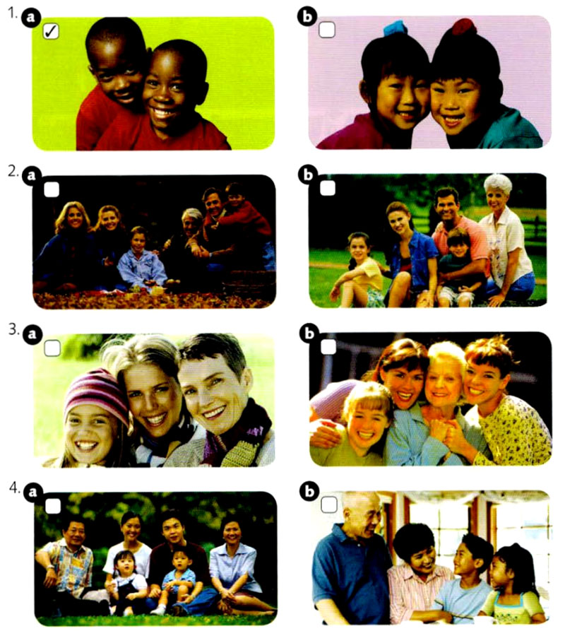

B circle the correct information
1) The woman likes to take them to eat hamburgers / pizza.
2) His parents live nearby / far away
3) The picture was taken at her niece's / mother's birthday party.
4) The granddaughter likes / doesn't like school.

Listening task 2: Family ties
A Listen. Jason is talking about his family. Circle the correct information.
1) Morgan is Jason's daughter / niece.
2) Austin is Jason's son / nephew.
3) Nick is Jason's brother / cousin.
4) Frank is Jason's uncle / father.
5) Katherine is Jason's wife / sister.
6) Janice is Jason's mother / aunt.

B Listen again. Are the statements true or false? Check (✓) the correct answers.

Statements | True | False
1) Morgan plays on a soccer team
2) Morgan and Austin go to the same school
3) Nick cooks a lot at home
4) Frank doesn't like to cook much
5) Katherine likes to read

Grammar. Articles.
Task 1. Put in the, A or AN where necessary.
1. Can you tell me way to Bolshoi theatre, please.
2. Take _________ second left.
3. He is working in _________bookshop now.
4. He is travelling at________ moment.
- She has some problems at home.
- You have bad cough.
- He drinks milk in morning.
- Do you often get colds?
- It's really bad pain.
10. He wants to become _______ doctor.
11. She has had accident.
- He likes to go to cinema.
- Are you in hurry?
- Write letter to your friend.
- Look at map of Great Britain?

Test 2. Put in A, THE or AN where necessary.
- This shop is in opposite direction.
- Have you ever been to United Kingdom?
- Have you ever been to USA?
- Do you enjoy learning languages?
- What nice weather!
6. In Britain ____weather is changeable.
7. sun often shines in autumn.
- There is sometimes fog in summer.
- They have Maths 3 times week.
- Sometimes wind speeds reach over 50 kilometers ______hour.
- Would you like to come to match on ______ Sunday?
12. National Picture Gallery is in Trafalgar Square
13. I wanted to go to opera when I was in __________ London.
14. It’s _________small town but it has its own history.
15. He is going to study Maths at school.

Unit 3. MODERN FAMILY. FAMILY PROBLEMS (B 1)

Grammar: Articles (Definite\Indefinite) \ Pronouns\ Past simple (revision)
Vocabulary: Family conflicts

Reading & Speaking.
a) Talk to a partner. What’s the difference between…?
1. a father and a parent
2. a mother and a stepmother
3. a brother and a brother-in-law
4. a stepsister and a half-sister
5. a grandfather and an great-grandfather
6. an adopted child an only child
7. brothers and sisters and siblings
8. your immediate family and your extended family

b) Read the article about modern British family life. In pairs, try to complete the gaps with the numbers from the list.
___________________________________________
2 10% 14% 17% 30 32 40% 45%
___________________________________________
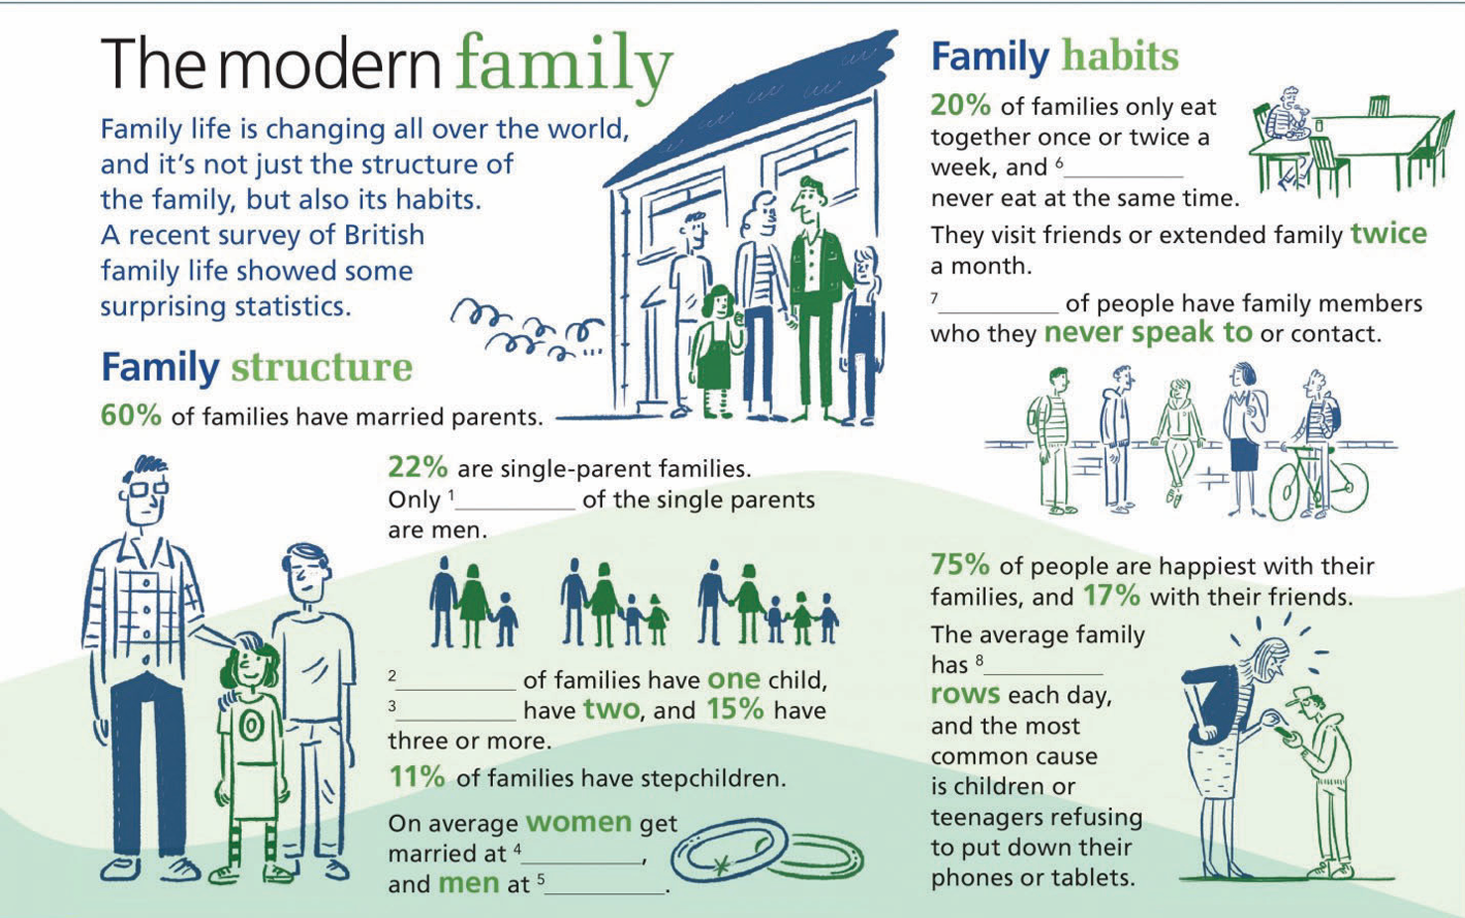

c) Read the question and think about your answers. Then ask and answer in pairs or small groups.
- Do you have a big family? Who do you live with? How often do you…?
– have a meal with your family
– go out for a meal or to the cinema, etc.with a family member
– see your extended family
- Do you spend more of your free time with family or friends? Why?
- Are there any members of your family who you have very little contact with? Why?
- What do you and your family mainly argues about?
- Do you ever argue about phone or tablets?

Grammar. \ to be in the past
Study the rule.

Случаи использования

Действия, события и факты в прошлом, не связанные с настоящим | He left home yesterday and didn`t return.  We met the other day.  She saw this movie a few days ago but it wasn`t interesting, she was very bored.  It snowed a lot last night.
Последовательность действий и событий в прошлом, обычные повторяющиеся действия | I came home in the evening, turned on the TV set and decided to watch a new program.  He called us home every week last year.
Действие, которое длилось определенное время, но закончилось и осталось в прошлом, важен лишь факт, а не процесс | Yesterday we walked in the downtown for 3 hours and then went to cinema to watch a new film.  My cousin studied hard for many years to enter the university in California.
Подсказки (Prompt): yesterday, the day before yesterday, 2 days ago, last week\month\year, the other day, every day (time) last year
Practice.
Task 1. Write Past Simple of the following verbs.
1. stop 6. Teach 11. win
2. write 7.cry 12. make
3. go 8. buy 13. plan
4. study 9. open 14. bring
5. travel 10. speak 15. Stay

Task 2. Put the verb into the correct positive or negative form.
1 It was warm, so I took off my coat. (take)
2 The film wasn't very good. I didn't enjoy it much. (enjoy)
3 I knew Sarah was busy, so l________ her. (disturb)
4 We were very tired, so we________the party early. (leave)
5 The bed was very uncomfortable. I________well. (sleep)
6 The window was open and a bird ________into the room. (fly)
7 The hotel wasn't very expensive. It________ much to stay there. (cost)
8 I was in a hurry, so l________time to phone you. (have)
9 It was hard carrying the bags. They ________very heavy. (be)

Task 3. Put the verbs in brackets in Past Simple – positive, negative, question.
- «You (have)____ a nice weekend?» «Yes, I (play)____ tennis with my friends»
- We (go) ___to the cinema but the film wasn't very good. We (not enjoy)___ it.
- «You (phone) ____Ann?» «No, I'm afraid I (forget)____»
- Tom (buy) ___some new clothes yesterday.
- «It (rain) ___yesterday?» «No, it was a nice day»
- The party wasn't very good, so we (not stay)____ long.
- «You (go)____ shopping yesterday?» «No, I (not have)____ time»
- «Is Peter here?» «Yes, he (arrive)____ five minutes ago»
- «I cut my finger this morning» «How you (do)____ that?»
10. Paul wasn't well last week, so he (not go) ____to school.
- At the beginning of last year, Jane (fly) ____to London.
- I (spend)___ my summer holidays in the country.
- I like your new bicycle. Where you (get)____ it?
- «Mary (come) ____to your party?» «No, we (invite)___ her, but she (not come) »
- Yesterday I (get up) ___ early and (have) ___a shower.

Task 4. Speaking. Adverbs of frequency.
- How often do you eat fast food? (did you eat when you were a child\ younger)
- How often do you do homework? (did)
- How often do you watch movies? (did)
- How often do you play sports? (did)
- How often do you go to bed late? (did)
- How often do you use social media? (did)
- How often do you read in English? (did)
- How often do you do you go to the cinema? (did)

Reading Comprehension 1. Discuss in small groups.

2025 REPORT
A new report on life in 2025 was published yesterday. This report predicts big changes, not just in technology but also changes in the way we live. These are some of the predictions for work and family life.
Family life
– One in five fathers will be househusbands, while the mothers go out to work.
– People will live near other people who have the same interests as them, for example in golf villages
– There will often be three generations living in the same house, e.g. grandparents, parents, and children.
– People will live until their mid-eighties, but women will still live slightly longer than men.
Work and study
– One in five school classes will be on-line via the Internet. Pupils will also often have video classes with a «superteacher» from another city or country.
– Most workers will only have short term contracts. They will have to learn to do lots of different jobs because they will change jobs frequently.
– Most people will work a twenty-five hour week. This will usually mean working five hours a day, although some people may work three eight- hour days and have four days off.

a. Read the article about 2020. Tick (✓) the predictions that you think would be a good thing.
b. Read the article again. Mark the sentences T (true), F (false), or DS (doesn't say).
According to this report, in 2025...
1. 20% of fathers will stay at home and look after the children.
2. People will live near other people who like the same things they do.
3. Grandparents will look after their grandchildren.
4. Men and women will live until they're 80.
5.Superteachers' will sometimes travel to give classes.
6. Many people will work in the same job all their life.
7. Everybody will work five hours a day.

Reading comprehension 2. Practice. Family conflicts. Read and do the exercises below.
- Answer the questions.
- At what age do young people usually leave home in your country?
- What do you think is the right age for a young person to leave home? Why?
- Read the paragraphs and put them in order from 1-5.
- Now read the whole article again and choose the best description.
- Mr. and Mrs. Serrano argued with their children and their son decided to leave home.
- Mr. and Mrs. Serrano argued a lot. Their children were very unhappy and left home.
- Mr. and Mrs. Serrano argued with their children a lot. They told their sons to leave home
- Write out new phrases.
- Do you think Mr. and Mrs. Serrano were right or wrong? Why? Do you think the story has a happy ending?

Problems with your teenage children?
Why not throw them out?

A
What did the Serrano’s boys do? In fact, they didn’t go very far from home. The oldest boy David went to live with his girlfriend and has just started work in her father’s construction company. The youngest son has rented a flat near the family home (his mother paid the first month’s rent only).

B
So Maria and Mariano asked their sons to leave the family home in Zaragoza in Spain. But the two boys didn’t want to go. Then Mr. and Mrs. Serrano took an unusual decision – they went to court.

C
Do you have rude and moody teenage children living in your house? Have you ever secretly wanted to throw them out? A Spanish couple, Mr. and Mrs. Serrano, from Zaragoza in Spain, have done exactly that.

D
Maria and her husband Mariano lived with their two sons, David, 20 and Mariano, 18. «The situation was impossible» said Maria. “We were always arguing, our children were treating our house like a hotel, and they weren’t contributing anything. Also they weren’t studying or looking for work. They were complaining all the time and insulting us. They didn’t respect us. I love my children, but in the end it was ruining our lives.”

E
Normally, under Spanish law parents do not have the right to make their children leave home. But in this case the judge decided that the situation in the Serrano family was “intolerable”. He gave Mr and Mrs Serrano the right to tell their children to go.

Vocabulary. Discussion
Family budget

What are the steps to save much money? To have a good budget?
1. Calculate your family income
The first step is adding up how much you and any other family members bring in each month. Look at both the reliable fixed income you can always count on, plus any extra earnings from things like freelance work.
2. Note down your monthly costs
Write down a list of your family's monthly spending, including your needs and your wants, keeping in mind that these will be different for every family. Your needs are likely to include housing costs. childcare, food costs, health insurance, transportation costs or car payments, utilities, and inter-net/phone fees. Your wants are extras that you'd rather not go without. This could include frequent dinners out, new clothes, or trips to the cinema.
3. Evaluate the net income
By subtracting your monthly costs from your income, you'll arrive at what we call your net income. Is there any money left over? If so, these funds can be put towards savings or any debts to be paid off
4. Decide a savings strategy
Once you know what's left over each month, decide on a savings strategy for the extra funds. Here there's no right or wrong maybe you want to put money away for retirement or a down payment on a house? Perhaps you want to save up for a family holiday or a blow-out birthday party for your child. The important thing is that you feel in control of your finances and what's happening on your account each month.
5. Review and streamline
Now that you have a clear overview of your income, spending, and goals, it's time to set your budget You may want to review what costs can be cut to optimize your saving goals.

Task 1. Answer the questions.
  - How can we calculate our earnings?
  - What are examples of needs?
  - What are examples of wants?
  - What does “down payment” mean?
  - Which step do you think is the most essential?

Unit 4. MY DAILY ROUTINE

Grammar: the verb «TO BE» \ Present Simple
Vocabulary: be phrases, HAVE\ DO\ MAKE – collocations
It usually takes me…. Construction

Warm – up. Answer the questions
Are you busy on weekdays? At the weekends?
Do you like to get up early? Why yes\not? What is your favorite day of the week?
What is your typical day like?

Grammar. Collocations
1. Complete the phrases with the verbs below.
arrive get go have (x3) leave wake do (x3) make (x5)
1) _____ up 9) _____ a shower
2) _____your best 10) _____the bed
3) _____breakfast (lunch\ dinner) 11) _____a shave
4) _____at school (at the airport\ at the party) 12) _____ dressed
5) _____friends(дружить\заводить) 13) _____ plans
6) _____a mess 14) _____school\ university\ academy
7) _____sports 15) _____housework\ homework
8) _____to bed 16) _____ a sandwich (a cake\a pie\ \ a snack)

Task 1. Complete the daily routine phrases in the text. Write one word.
I often 1) _____ up at 7.20 a.m. during the week, and get up at 7.30. First, I 2) _____ a shower and then 3) _____ dressed. Next, I 4) _____ my breakfast and 5) _____ the house. I don’t take the bus because I usually walk to school. It usually 6) ____ me half an hour to get there but if I am late I always catch a taxi. I 7) _____ at school at 8.30 a.m. My classes are over at 2.30 p.m. and after that I 8)___ homework and see friends.
3 times a week on Mondays, Wednesdays and Fridays I usually 9)_____ sports and go to the gym, I enjoy it very much because it helps me to be in good shape. I 10) _____ to bed early because I have to go to school the next day.

Present Simple Tense. Study the rule.

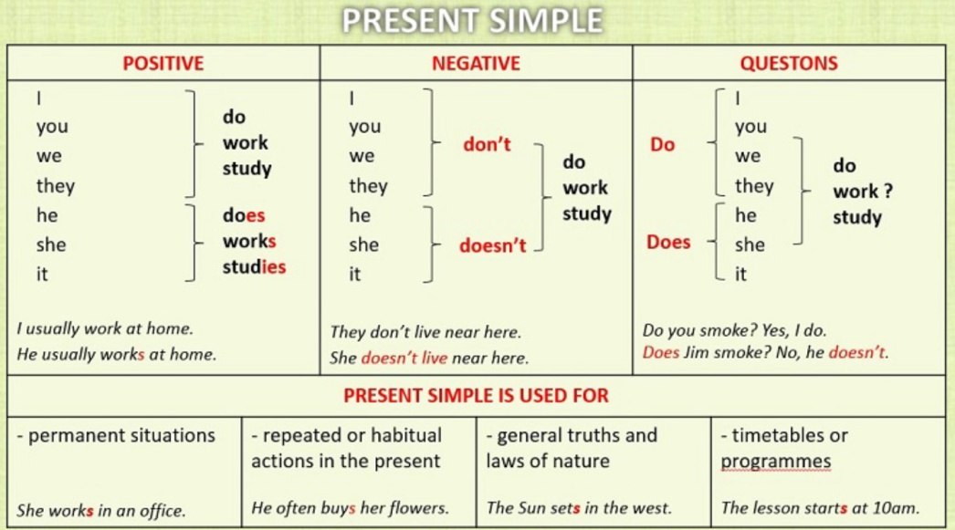

Случаи употребления | Примеры
Регулярно повторяющиеся действия в настоящем, факты, пословицы, общеизвестные истины | We have classes every single day.  Astana is the capital of Kazakhstan.  Tastes differ. Time flies. Live and learn.  Teachers educate people.  All is well that ends well.  The sun rises in the east and sets in the west.
С глаголами умственной и чувственной деятельности: see,  believe, have, know, hear, mean, think, understand, suppose, possess=own, prefer, like\dislike, hate | I see and hear you well.  We understand everything and believe you.  She realizes that she knows a little.  He owns this house, it belongs to him.  Thank you, It means a lot to me.  I like your offer.
Будущее действие в соответствии с расписанием | The play begins in 5 minutes. Hurry up!  The plane arrives at 7 pm tomorrow.  What time does the exam start tomorrow?
Подсказки (Prompts): every day\ week\ month\ year, as a rule, in the mornings\ evenings,
Often, usually, always, rarely=seldom, sometimes, on weekdays, at weekends, once a week, twice a month\ year….

Task 1. Put the words or phrases in brackets in the correct position.
1. He leaves home at nine o'clock. (usually)
2. She can't play tennis well. (very)
3. There is a queue of people at the supermarket check-out. (often)
4. The journey takes us an hour. (about)
- I don't like sweets. (at all)
- He likes swimming. (also)

Task 2. Add -s or -es to the verbs in the sentences where necessary.
- He work in a bank.
- They live in England.
- I watch TV every day.
- My brother watch TV every day, too.
- She go to school.
- My mother teach children.
- We play tennis every weekend.
- He speak English very well.
- The film finish at 10 o'clock.
- They go on holiday in summer.
- My sister do her homework every day.
- We start work at 8.30.
- He eat cheese for breakfast.
- I enjoy playing darts.
- He hate cooking.

Task 3. Put the following sentences into negative and interrogative forms. (– & ?)
1) Good weather makes me happy. 2) Irene helps her mother very often. 3) I take my dog out for a run every morning. 4) She prefers tea to coffee. 5) Students spend a lot of money on books. 6) It takes a long time to become clever. 7) Old people like to wear T-shirts and jeans. 8) He goes on business trips every month. 9) We have extra-curricular activities 3 times a week. 10) It rains a lot in autumn here.
11) It seldom snows in winter in the south of the country. 12) It takes me half an hour to get to my work. 13) My mom waters flowers in her garden twice a week. 14) Children enjoy playing computer games. 15) We agree with you.

Task 4. Make up questions looking at the example below.
You ask Lisa questions about herself and her family.
- You know that Lisa plays tennis. You want to know how often. Ask her.
How often do you play tennis?
- Perhaps Lisa`s sister plays tennis too. You want to know. Ask Lisa
_____ your sister _______________________________________?
- You know that Lisa reads a newspaper every day. You want to know which one. Ask her.
_____________________________________________________?
- You know that Lisa`s brother works. You want to know what he does. Ask Lisa.
_____________________________________________________?
- You know that Lisa goes to the cinema a lot. You want to know how often. Ask her.
_____________________________________________________?
- You don`t know where Lisa`s grandparents live. You want to know. Ask Lisa.
_____________________________________________________?

Task 5. Look at the sample and complete the sentences below with the right negative form.
I like apples, but I don’t like oranges.
She speaks French, but she doesn’t speak it well.
1. He does business, but he __________ it successfully.
2. Tom’s parents give him pocket money, but they __________ him much.
3. That shop sells office equipment, but it __________ computers.
4. We know Sharon, but we __________ her parents.
5. I feel sad, but I __________ unhappy.
6. He makes grammar mistakes, but he __________ spelling mistakes.
7. He earns a lot of money, but he __________ millions.
8. She speaks English, but she __________ any other foreign language.
9. He works hard, but he __________ on weekends.
10. This hotel attracts a lot of tourists, but it __________ them in winter.
11. It takes me two hours to get to my house, but it __________ me so long to get to my work.
12. He knows all about computers, but he __________ anything about real life.
13. She likes the book, but she __________ the film.
14. I like dogs, but I __________ cats.
15. She loves him, but she __________ his friends.
16. He has a car, but he __________ a garage.
17. She’s got a dishwasher, but she __________ a bread maker.
18. Teenagers like mostly pop music, but they __________ classical music.
19. He wears caps, but he __________ hats.
20. Most people like summer, but they __________ winter.

Task 6. Open the brackets using the correct verb form of Present Simple.
Roberto (1) __________ (start) his day at 8.00. He (2) __________ (have) breakfast in the kitchen with all the family. Roberto (3) __________ (like) orange juice, toast and milk. He always (4) __________ (have) an apple. After breakfast Roberto (5) __________ (make) his bed and (6) __________ (tidy) up his bedroom. He (7) __________ (get) ready for lessons. He mustn’t be late, as mother (8) __________ (be) very strict.
At 9.00 the Hanson kids (9) __________ (start) their lessons. At midday they (10) __________ (have) lunch. Then it’s sport time: they (11) __________ (love) playing basketball, in-line staking and skate-boarding.
Roberto and his brothers (12) __________ (not/have) dinner with their parents as their father is always late. Their mother (13) __________ (not/like) it very much. So, at weekends they
(14) __________ (be) always together.

Task 7. Раскройте скобки, используя Present Simple.
Mary (1) __________ (wake) up at 7.00. Then she (2) __________ (get) up at 7.30 and she
(3) __________ (go) to the bathroom. She (4) __________ (have) a shower, (5) __________ (brush) her teeth and (6) __________ (comb) her hair. Afterwards she (7) __________ (have) breakfast. Ten minutes later she (8) __________ (take) her bag, (9) __________ (kiss) her mother and (10) __________ (catch) a bus to school with her friend Diana. They (11) __________ (start) school at 9.00. They (12) __________ (not/have) lunch at the school canteen. At three o’clock they
(13) __________ (return) home.
In the afternoon, she (14) __________ (study) her lessons and (15) __________ (ride) her bicycle. In the evening she (16) __________ (help) her mother prepare the dinner. After dinner she
(17) __________ (watch) TV, her mother (18) __________ (read) a magazine and her father
(19) __________ (go) to bed earlier since he (20) ________ (be) always the first in the family to get up.

Task 8. Speaking activity. Find someone who… Walk around the classroom.
Make questions.
Ex. Do you get up before..? If he says «Yes» write his name
Name
- gets up before 6 a.m.
- plays a musical instrument
- goes to the gym regularly
- speaks more than two languages
- drinks coffee every day
- watches TV shows in English
- walks to school or work
- has a pet at home
- helps with house chores
- studies English every day

Vocabulary.
READING COMPREHENSION
Greg’s Daily Routine
Greg is an American boy. He lives in Arlington, Texas. He lives with his family in a modern house. He is 17 years old and he has got an older brother, Alex, and a younger sister, Emma.
He starts his day at about half past six. He gets up, goes to the bathroom, takes a shower, brushes his teeth and gets dressed. After having his breakfast, at a quarter to seven he leaves home and catches the bus to school. It doesn`t take him much time, only 15 minutes.
Classes usually begin at half past seven. He usually has lunch at the school canteen at half past twelve. During breaks he often has some snack, it can be chocolate or fruits. After school, at a quarter past five, he goes home. It often takes him half an hour to get home on foot. After coming home he has some rest and does his school homework and when he finishes it, he helps his mum to lay the table. While having dinner together they talk about everything: they discuss the news and make jokes.
Greg is a very helpful boy, so he helps his mother to do housework, he likes vacuum-cleaning most, he doesn’t usually do the washing – up. His sister often does it.
In the evenings he usually watches TV for a while after dinner and at about ten o’clock the most he brushes his teeth and goes to bed.
He has a few hobbies, for example he is fond of learning foreign languages and watching actions. Also, he enjoys doing sports and hanging out with friends at weekends. They always have a great time and fun all together. Greg does judo and goes swimming 3 times a week because he wants to be healthy and stay in good shape.

Task 1. Choose the correct answer True / False / Not Given
- Greg spends more time walking home from school than getting there by bus.______
- Greg has lunch at home after school with his family. ______
- Greg’s older brother helps more with household chores than his sister. ______
- Watching action movies is one of Greg’s hobbies. ______
- Greg prefers doing homework in the evening right before dinner. ______
- Greg rarely talks with his family during meals. ______
- Greg's interest in sports helps him stay physically fit. ______

Task 2 Multiple Choice (Choose the correct answer)
1. Where does Greg live?
a) New York
b) Austin
c) Arlington
d) Dallas
2. How long does it take Greg to get to school by bus?
a) 30 minutes
b) 15 minutes
c) 10 minutes
d) 45 minutes
3. What time does Greg usually start his classes?
a) 7:00
b) 7:15
c) 7:30
d) 8:00
4. What does Greg usually do right after finishing his homework?
a) Goes for a walk
b) Plays video games
c) Helps his mum lay the table
d) Goes to bed
5. Why does Greg do judo and swimming?
a) To meet new friends
b) Because he wants to be strong and healthy
c) Because his parents told him to
d) For a school competition

1. Telling the time. What time is it? What is the time?

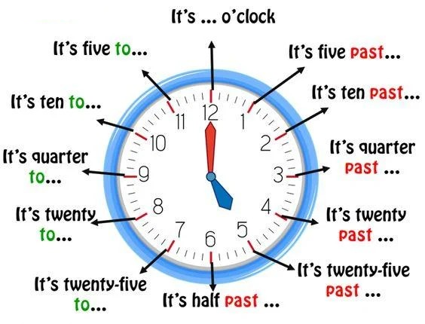

Practice. Say in English.
9.30, 9.45, 8.10, 8.15, 11.55, 11.25, 3.30, 3.20, 12.12, 12.40, 2.50, 2.10, 1.05, 1.55, 5.40, 5.20

1. Study the construction.
It usually takes me half an hour to get to the downtown by car.
Мне обычно требуется (нужно) полчаса на машине, чтобы добраться до центра города.
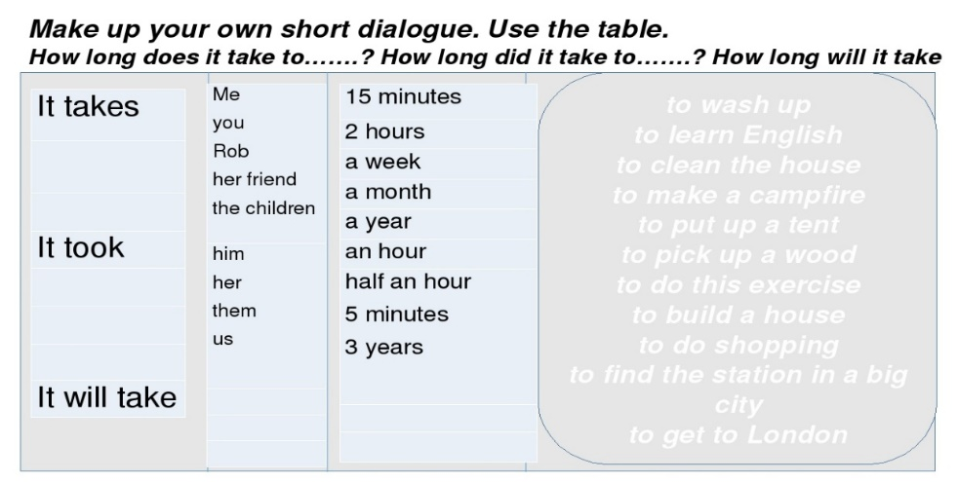

Chunks:
1.It takes me \ It doesn`t take me…..
It took me\ It didn`t take me….
It will take\ It won’t take me…..

General q-n:
Does it take you 10 or 20 minutes to get home? –
It depends. It often takes me 20 min on foot.

Special q-n:
How long does it take you to make breakfast? – It usually takes me half an hour.

Practice giving your own sentences in Present. Make dialogues

Unit 5. FOOD & DRINKS

Grammar: modal verb – can\ Countable & uncountable nouns\ Pronouns
Vocabulary: cooking verbs and collocations

Vocabulary. Speaking.
Do you eat enough fruits and vegetables? Can you cook? What do you usually cook?
Do you think it is necessary to be able to cook something? What is your favorite dish?

Reading comprehension
Eat and drink – but at the right time
In our supper-busy 21st century lives, most of us try to do as much as we can in 24 hours. However, we usually do things whenever it suits us, and expects say that this is disrupting our body’s natural cycle, making us feel tired at times when we should feel awake, and vice versa. Science shows that by doing things at the right time, we can be happier and healthier.
Have breakfast at 8.00 am
In a recent study, researchers found having breakfast at this time is good for our blood sugar levels, so the food you eat now will give you the energy you need. It’s also important not to skip breakfast. Another research team, from Sweden, suggested that people who ate a regular breakfast as teenagers were 32% less likely to be at risk of heart disease as adults.
Don’t drink coffee in the morning. Have one at 3.00 pm
Most coffee drinkers make a cup as soon as they wake up. However, researchers have suggested that early morning is the worst time to drink coffee, because it stops the body from producing the stress hormone cortisol, which we need at this time to help us more mentally alert, according to a study carried out by the University of Sheffield a few years ago.
Have lunch Between 12.00 and 2.00
This is when our body digests food best, because this is when the stomach produces most acid. So it’s the ideal time to have your main meal of the day. An experimentally by nutritionists at the University of Surrey found that blood glucose levels after an evening meal were much higher than when people had the same meal earlier in the day, and high levels of glucose can cause diabetes.
Have dinner at 7.00 pm.
Have your evening meat early. It should be delicious- our sense of smell and taste are at their best at this time- but light. And if you want a small glass of wine, have it before dinner, as 6.30 is when the liver is most efficient at dealing with alcohol.
More good times for your body
– Ideally, you should get up when the sun rises. When we see daylight, we stop producing the sleep hormone melatonin and start getting ready for the day ahead.
– Do yoga or go for a walk before breakfast.
– Do important tasks at 11. 00 Am., when your brain is working best.
– Weightlifting session are best done at midday – that’s when your muscles are strongest.
– The best time to run or cycle is 5.00 p.m., when your lung capacity – important for endurance sports – is at its greatest.
– Go to bed between 9.00p.m., and 11.00 p.m. This is when your body temperature starts to go down and the brain begins producing melatonin.
Read the article again. Answer the questions with a partner.
1 Why is it important to have breakfast every day when you're a teenager?
2 What effect does caffeine have on us if we drink it between 2.00 and 5.00 p.m.?
3 What's the difference between having steak and chips for lunch and having it for dinner?
4 Why should an early evening meal be
'delicious'?
5 What's the best physical activity to do
a) early in the morning, b) in the afternoon?
6 Why does the body produce melatonin?
Search the text and find six parts of the body. Which do we a) have one of,
b) two of, c) more than two of?
1 he_____
4 br_____
2 st_____
5 mu_____
3 li_____
6 lu_____

Answer the questions with a partner.
1 Do you believe all the information in this article? Why (not)? Give examples from your own experience.
2 Would you consider changing any of your habits based on this information?
Vocabulary

Do the exercise below.
Use the verbs from the opposite page to complete sentences about yourself and your country and compare with others.
is\are more common than ……
is\are more expensive than …..
A mixed salad usually has …..\......\ and …..
We don`t often grow ….
We don`t often eat …..
is\are my favourite ….

What do you need for cooking something?

Grains
– Bread, pasta, rice, cereals
Dairy
– Cheese, milk, butter, margarine, eggs, cream, yoghurt / yogurt
Drinks
– Water, milk, juice, squash / cordial, pop (fizzy drink), cola, lemonade, hot chocolate, tea, coffee, milkshake

Task 1. Cross out the wrong word in each sentence. Write the correct word at the end.
1. The paella was very tasteful tasty
2. My brother is a very good cooker. _________
3. Don’t forget to heat up the fry pan before you add the aubergine. ________
4. This chocolate is very sour. ____________________
5. I'm afraid my mother has never been very good in cooking. ________
6. You can buy this ice cream in five different tastes . __________

Task 2.

Grammar. Study the rule.
Plural Form of English Nouns

Rules of Forming Plural Nouns
Способ образования | Примеры | Примечания
1. -s | a book – books  a desk – desks  a path – paths | [s]
 | a car – cars  a computer – computers | [z]
a) -es после -s, -sh, -ch, -x | a bus – buses  a bush – bushes  a watch – watches  a box – boxes | [iz]
Также | a potato – potatoes  a tomato – tomatoes  a hero – heroes
Исключения | photos, pianos, radios, zoos, discos, videos, cuckoos
b) -y → -ies (после согласной) | a cry – cries  a party – parties  a story – stories  a country – countries  a dictionary – dictionaries
Исключения | boys, toys, plays, days, monkeys, joys, keys | -ay, -ey, -oy → -ys
c) -f / -fe → -ves | a shelf – shelves  a half – halves  a life – lives  a knife – knives  a wolf – wolves  a leaf – leaves  an elf – elves  a calf – calves
Исключения | roofs, chiefs, cuffs, cliffs, handkerchiefs, scarfs (scarves)
2. Чередование корневой гласной | a man – men  a woman – women  a child – children  a foot – feet  a goose – geese  a louse – lice  a mouse – mice  a tooth – teeth | an ox – oxen
3. Совпадающие формы ед. и мн. числа | a deer – two deer  a fish – three fish  a sheep – four sheep  a swine – many swine | fish – fishes (редко, разные виды)
Национальности на -ese, -ss | a Swiss – ten Swiss  a Chinese – many Chinese  a Japanese – five Japanese  a Portuguese – a lot of Portuguese
4. Составные существительные | a grown-up – grown-ups  an office-block – office-blocks  a merry-go-round – merry-go-rounds  a forget-me-not – forget-me-nots  mothers-in-law  passers-by  women-drivers  menservants

Practice. Task 1. Write plural form of the noun.
A tomato – a toy -
A hero – a play -
A party – a lottery -
A life – a euro -
A goose – a sheep -
A Swiss – a foot-
A wolf – a video -
A fireman – a knife -
A woman – a shelf -
A mother-in-law – a mouse -

Study Uncountable Nouns.

The following nouns are usually uncountable:
Accommodation behavior damage furniture luck permission luggage traffic weather
Advice baggage bread chaos information news progress scenery work

You cannot use a/an with these nouns:
– I'm going to buy some bread. or a loaf of bread. (not a bread)
– Enjoy your holiday! I hope you have good weather. (not a good weather)

These nouns are not usually plural (so we do not say 'breads', furnitures' etc.):
– Where are you going to put all your furniture? (not furnitures)
– Let me know if you need more information. (not informations)
News is uncountable, not plural:
– The news was very depressing. (not The news were)

The general list of Uncountable Nouns: love, happiness, patience, food, milk, bread, water, sugar, salt, gas, hair, freedom, peace. knowledge, money, friendship, time, iron, practice, grass, etc.

Remember! Find an equivalent in your language.
– Time is money. Money makes money
– No news is good news. All that glitters is not gold.
– Practice makes perfect. All is well that ends well.
– The grass is always greener on the other side. Honesty is the best policy.
– Strike while the iron is hot. Bad news travels fast.

Task 2. Complete the sentences with a / an / some / much / many / a few / a little / any.
1. I need ___ information about the city.
2. We don’t have ___ milk left.
3. How ___ sugar do you take in your tea?
4. There are ___ chairs in the room.
5. Would you like ___ coffee?
6. She gave me ___ advice about learning English.

Task 3. Complete the sentences using the following words. Use plural –S where necessary.

advice information chair job experience luggage experience
permission furniture progress hair work

I didn`t have much luggage – just 2 small bags.
- They will tell you all you want to know. They`ll give you plenty of ______.
- There is room for everybody to sit down. There are plenty of ____.
- We have no ___, not even bed or a table.
- «What does Alan look like?» «He`s got a long beard and very short ___»
- Carla`s English is better than it was. She`s made ___.
- Mike is unemployed. He can`t get a ____.
- Mike is unemployed. He can`t get ____.
- If you want to leave early, you have to ask for ____.
- I didn`t know what to do. So I asked Chris for _____.
- I don`t think Dan should get the job. He doesn`t have enough ______.
- Nicola has done many interesting things. She should write a book about her _____.

Task 4. Choose the correct alternative.
- Remember to buy _______envelope for the air – mail
- an
- –
- Something has gone wrong with ___electricity.
a) an
b) –
- Mrs. Spencer was fond of wearing ___ jewellery.
  - a
  - –
- She finished school with ___ gold medal.
  - a
  - –
- We bought ___ new furniture for our new flat.
  - a
  - –
- To my mind, ____ education should be free.
a) an
b) –
- A lot of __________ are grown in Australia.
  - sheep
  - sheeps
- Two _____ of oranges, please.
  - kiloes
  - kilos
- Education ______ very expensive nowadays.
  - is
  - are
- Put your luggage on the ______.
  - scale
  - scales
- They hire only _________.
  - man-servants
  - men-servants
- It costs three _______ pounds.
  - hundred
  - hundreds
- __________ of dollars were spent on new equipment.
  - Thousand
  - Thousands
14. Knowledge _____ power.
a) is
b) are
15. I like these ___________.
a) handkechiefs
b) handkerchieves
16. I saw a few _______.
a) passers-by
b) passer-bys
17. There was so ________ snow last year.
a) much
b) a lot of
18. The government (правительство) _____ trying to control the situation.
a) is
b) are
19. It costs ____money to buy this coat.
a) many
b) a lot of
c) much
20. They saw interesting things in the museum.
a) many
b) a lot of
c) much
21. They didn't ask him_______questions.
a) many
b) a lot of
c) much
22. There isn't __milk in the fridge.
a) many
b) a lot of
c) much

Task 5. Speaking Practice. Discuss in pairs. Use uncountable nouns.
Questions:
– What advice would you give to someone learning English?
– What’s your favorite kind of music and why?
– Do you think money brings happiness?
– How do you usually get information?
– What is happiness for you?

Unit 6. I ENJOY SHOPPING

Grammar: Present Continuous verse Present Simple\giving definitions
Vocabulary: Types of shops

Warm – up. How often do you go shopping? What types of shops do you use regularly?

Vocabulary.
General Store Types:
– Supermarket: A large self-service store that sells a wide variety of groceries and household items.
– Department store: A large retail store that offers a wide range of products, including clothing, accessories, home goods, and more.
– Convenience store: A small store that is open for extended hours and sells everyday items like snacks, beverages, and basic necessities.
– Boutique: A small shop that specializes in fashionable clothing, accessories, or unique items.
– Outlet store: A store that sells products directly from the manufacturer at discounted prices.
Specialty Stores:
– Bookstore: A store that sells books, magazines, and other reading materials.
– Electronics store: A store that specializes in selling electronic devices, such as smartphones, laptops, and televisions.
– Pharmacy/Drugstore: A store that sells prescription and over-the-counter medications, as well as health and personal care products.
– Pet store: A store that sells pet-related products, such as pet food, accessories, and grooming supplies.
– Sports store: A store that specializes in sporting goods and equipment.
Food and Beverage Stores:
– Bakery: A store that sells bread, pastries, and other baked goods.
– Butcher shop: A store that sells fresh meat and meat products.
– Fish market: A store where fresh fish and seafood are sold.
– Coffee shop/Café: A place where coffee and light refreshments are served.
– Grocery store: A store that sells food, drinks, and other household items.
Clothing and Fashion Stores:
– Clothing store: A store that sells a variety of clothing items for different age groups and styles.
– Shoe store/Footwear store: A store that specializes in selling shoes and footwear.
– Fashion boutique: A store that offers stylish and trendy clothing, often from independent designers.
– Accessories store: A store that sells fashion accessories like jewelry, handbags, belts, and scarves.
– Thrift store/Secondhand store: A store that sells used clothing and other items at discounted prices.
Technology and Electronics Stores:
– Computer store: A store that specializes in selling computers, laptops, and computer accessories.
– Mobile phone store: A store that sells smartphones, tablets, and mobile accessories.
– Electronics warehouse: A large store or warehouse that offers a wide variety of electronic products.
– Appliance store: A store that sells household appliances like refrigerators, washing machines, and televisions.
– Camera store: A store that specializes in selling cameras and photography equipment.

Discuss. How do supermarkets make us¹ spend more money? Study new vocabulary.
They put fresh² bread, as it smells lovely, near the entrance³ to make us feel hungry – and hungry shoppers spend more. They also rearrange things and put them in different places; this makes us spend more time in the store and that means spending more money. They put sweets and chocolate near the checkout, so it is easy to add bars of chocolate to our basket or trolley while we are waiting in the queue. And they put the most expensive items on the middle shelves where you are more likely to see them. And be careful of special offers 7, e.g. three for the price of two. People often buy more than they need and throw away half of it.

Practice. Task 1. TRUE or FALSE? If it`s false, change it to make true.
- If you have a lot of things to buy, you need a basket.
False. If you have a lot of things to buy, you need a trolley.

- Supermarkets arrange things to make us spend more money.
____________________________________________
- Expensive items are on top shelves.
____________________________________________
- If something is fresh, it has just been made.
____________________________________________
- The checkout is where you pay for things.
____________________________________________
- There are often lovely smells near the entrance.
____________________________________________
- Sweets are often near the checkout.
____________________________________________
- It`s always a good idea to buy things on special offer.
____________________________________________

Task 2. Complete the sentences with an appropriate word.
- I took the shoes back to the shop, but they didn`t give me a refund.
- It _____ me angry when shops refuse to give you a refund or ____ things.
- I often buy bananas but forget to eat them, and then I have to ____ them away.
- When I got to the checkout, there was a long ____ of people waiting.
- There is a special ____ on melons – buy one, get one free!
- The vegetables are near the ____, where we came in.
- I like that supermarket because they have a wide ____ of meat and cheese.
- In my local street market there is a really nice ____, it`s very busy but everyone is friendly.

Task 3. Over to you. Speaking. Work in pairs.
- How often do you shop in supermarkets? What do you think of them?
- How often do you go to shopping centers? Do you like them? Why?
- How often do you go to street markets? Why?
- Do you haggle for things when you are shopping?
- Have you ever asked for a refund?
- Do you like window-shopping?

Listening Comprehension: Anna is staying with her friend, Robert. Today, Robert has to work. Listen to their conversation. Complete the sentences with one of the words in the word box. You will not need them all. (https://www.examenglish.com/A2/A2_listening_shopping.htm)

market delicatessen jeweller's toy shop department store bank pharmacy greengrocer'snewsagent supermarket post office florist’s bakeries

1. Robert suggests that Anna goes to the ______ to buy presents for her Mum and Dad.
2. In the market, there are ______ and delicatessens.
3. Robert recommends the ______ for a gift for Anna’s sister.
4. There isn’t a ______ in the town.
5. Robert suggests Anna goes to the ______ for her brother’s gift.
6. Anna needs to buy something for herself from the ______ .
7. Robert asks Anna to buy something from the butcher’s and the ______ .
8. Robert has to go to the______

Listening comprehension: Which ones are they going to buy? Check (✓) the correct pictures.

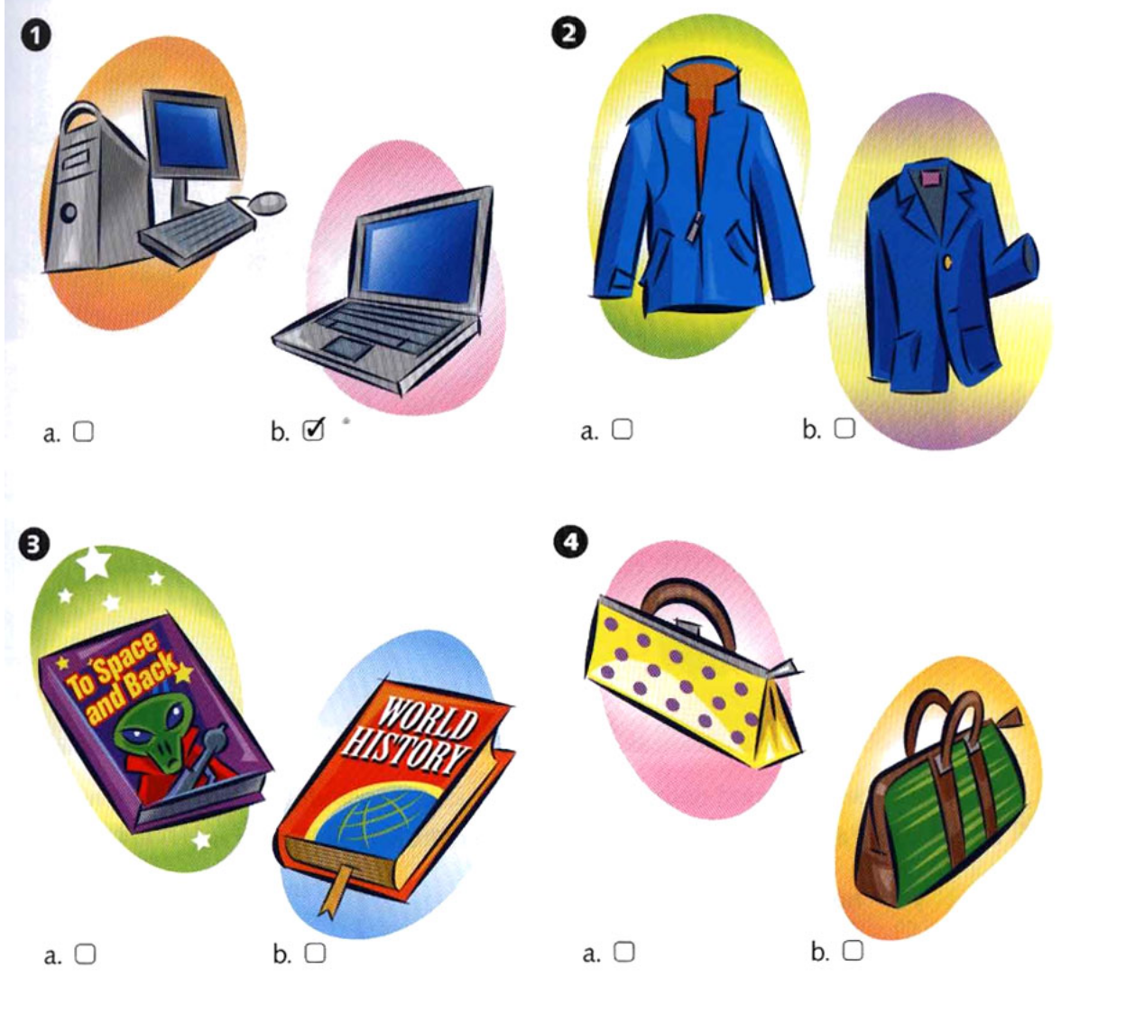

A Listen. People are at a department store. Where are they? Number the departments from 1 to 5. (There is one extra department.)

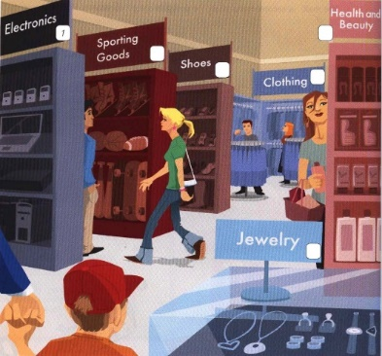

Grammar. Present Simple or Present continuous.
Study the rule.
Compare

There are verbs which are not used in Continuous because they do not show aby actions, they are called «State verbs» That`s why they are used in Present Simple.
A list of some STATE VERBS

Like want need prefer know realize suppose think mean understand believe
Remember belong fit contain consist seam look have hear taste smell see

– Look! I know those people. (Not «I am knowing»)
– I really want to talk to him now. (Not «I am wanting»)
BUT! The underlined verbs are considered to be exceptions out of exceptions (исключения из исключений) because they can give different meanings. They can show both ACTION & STATE.

Present Continuous Tense

Task 1. Put the verb into the correct form, present continuous or present simple.
1. Are you hungry? Do you want (you / want) something to eat?
2. Don’t put the dictionary away. ____ (I / use) it.
3. Don’t put the dictionary away. _____ (I / need) it.
4. Who is that man? ______(he / want)?
5. Who is that man? ______ (he / look) at us?
6. Alan says he’s 80 years old, but nobody _______ (believe) him.
7. She told me her name, but I ______ (I / not / remember) it now.
8. I ______ (I / think) of selling my car. Would you be interested in buying it?
9. I ______(I / think) you should sell your car. You _____ (you / not / use) it very often.
10. Air ______ (consist) mainly of nitrogen and oxygen.

Task 2. Present Simple or Present Continuous?
Dear Julia,
I (1) (live)_____ in a large flat in Moscow. I've got a sister. Her name is Olga. We (2 ) (get) up _______at 7 o’clock every morning. I (3) (leave) ______home at 8 o’clock but my sister (4 ) (leave) _____home at 7. 30. She is a student. She (5) (finish)_____ classes every day and (6) (come)____ home at 6 p.m. In the evening we usually (7) (go)____ for a walk together. Today is Saturday. At the moment, I (8) (have) _____breakfast in the kitchen of our flat, my parents (9) (drink) _____ coffee, and my sister (10) (have)____ a shower. On Saturday afternoons I usually (11) (play)____ tennis with my friends but today I'm going to see a new English film. You (12) (like)_____ films? I (13) (like)____ English films, but I always (14) (not understand)_____ the words. And how you (15) (spend)_____ your weekend?
Please write to me soon. \ Best wishes, Anna

Task 3. Are the underlined verbs right or wrong? Correct them where necessary.
- Water boils at 100 degrees Celsius . OK
- The water boils. Can you turn it off? Is boiling
- Look! That man tries to open the door of your car. _______
- Can you here those people? What do they talk about? _______
- The moon goes round the earth in about 27 days. _______
- I must go now. It gets dark. _______
- I usually go to work by car. _______
- «Hurry up!» It`s time to leave. – «Ok, I come» _______
- I hear you have got a new job. How do you get on? _______
- Paul is never late. He is always getting to work on time. _______
11) They don`t get on well. They’re always arguing. _______

Task 4. Put the words or phrases in brackets in the correct position.
1. He leaves home at nine o'clock, (usually)
2. She can't play tennis well, (very)
3. There is a queue of people at the supermarket check-out. (often)
4. The journey takes us an hour, (about)
5. I don't like sweets, (at all)
6. He likes swimming, (also)

Task 5. Translate from Russian into English.
1. Он великий путешественник. Как раз сейчас он путешествует по Востоку. 2. Я не понимаю, что ты говоришь. Говори медленно, пожалуйста. 3. Он считает, что она чудесная девушка. Он постоянно думает о ней. 4. Моя мама часто печёт пироги. Сегодня она делает торт, потому что вечером приезжают наши друзья. 5. Я внимательно вас слушаю. Что вы планируете делать? 6. – Где дети? – Они в гостиной. – Опять смотрят мультики? – Нет, они играют в какую-то игру. 7. Идёт сильный дождь, хотя в декабре дождь никогда не идёт. 8. – Кто эти люди и что они здесь делают? – Никто не знает этого. 9. Какая сегодня погода? – Морозно, и ярко светит солнце. 10. Приближается Новый год Люди готовятся к нему и покупают подарки. 11. Этой зимой часто идёт снег. Вот и сейчас идёт снег. 12. – Кого ты ждешь? – Жду подругу. Уже 7 часов. Боюсь, что она опаздывает. 13. Сейчас я сижу за столом в своём офисе. Мой менеджер работает на компьютере. Секретарша просматривает электронную почту. 14. Мы слушаем концерт сейчас. Многие известные певцы принимают в нём участие. 15. В настоящее время он работает в книжном магазине. 16. Он уличный музыкант'. Он поёт в Лондонском метро. 17. Какую книгу ты читаешь? – Новый детектив. Он очень интересный. А ты любишь детективные романы? – Иногда да. 18. Почему ты всегда критикуешь людей? Это плохо. 19. Не могу поверить, что в данный момент мы идем по улицам Лондона и наслаждаемся всеми знаменитыми местами. 20. Он подумывает о том, чтобы купить новую машину, и поэтому работает с утра до ночи, чтобы заработать деньги.

Unit 7. HELTH IS ESSENTIAL

Grammar: Quantifiers \ adverbs of frequency
Vocabulary: health and lifestyle

Reading comprehension.
- Read the Introduction to the article and answer the questions.
    - Is your body age the same as your calendar age?
    - How can we calculate our body age?
    - What should we do if our body age is older than our calendar age?

- Answer the questions.
    - Is Tariq in good shape? Why?
    - Does he go to the gym?
    - Is he an optimistic person?
    - He has a lot of free time, doesn`t he?
    - Does he drink enough water?

HOW OLD IS YOUR BODY?
How old are you? How old is your body? The answer to these two questions isn't always the same. Our body age can be much younger or much older than our calendar age (even eighteen years different!). We can now calculate our body age by answering questions about the way we live. If our body age is older than our calendar age, we should change our lifestyle.

EXERCISE
I know I'm too fat because I don't do enough exercise. I spend too much time sitting in studios. All I do is play squash, but I don't play very often – about once a month. I would go to a gym if I had more time.

DIET
I eat quite a lot of fresh food and a lot of fruit, but I probably eat too much meat. My girlfriend says I don't drink enough water. I drink a little alcohol – just a glass of red wine with my dinner. But I don't drink any beer. I drink a lot of coffee. It goes with the job.

LIFESTYLE
Like everybody, I'm too busy! There aren't enough hours in the day. I love my job but I work too much (sometimes I spend 14 hours a day in the studio – that's too many). I often feel a bit tense and irritable. I smoke a few cigarettes when I go out, but I'm not a regular smoker. I only wear sunscreen when I go to the beach. My skin is quite dark so I don't think it's a problem.

PERSONALITY
I'm quite pessimistic. I always think that things will go wrong – and they usually do, especially at work.

SOCIAL LIFE
I don't have much free time but I have a few close friends and I try to see them regularly. If I'm too busy then I phone them.

DOCTOR'S VERDICT
Tariq should do more exercise – for example, he could walk to work. This would help him to control his stress. His diet is quite healthy but he should drink more water and less coffee. He must give up smoking. Although his skin is quite dark he should wear sunscreen all year round, even in winter. And he should try to be more positive.
Body age: ?????
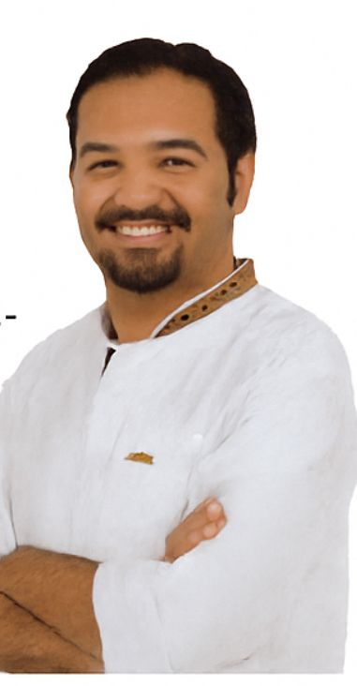Tariq, a record producer, calendar age 32

Speaking \ Writing – Talk about your lifestyle using new vocabulary

Vocabulary.

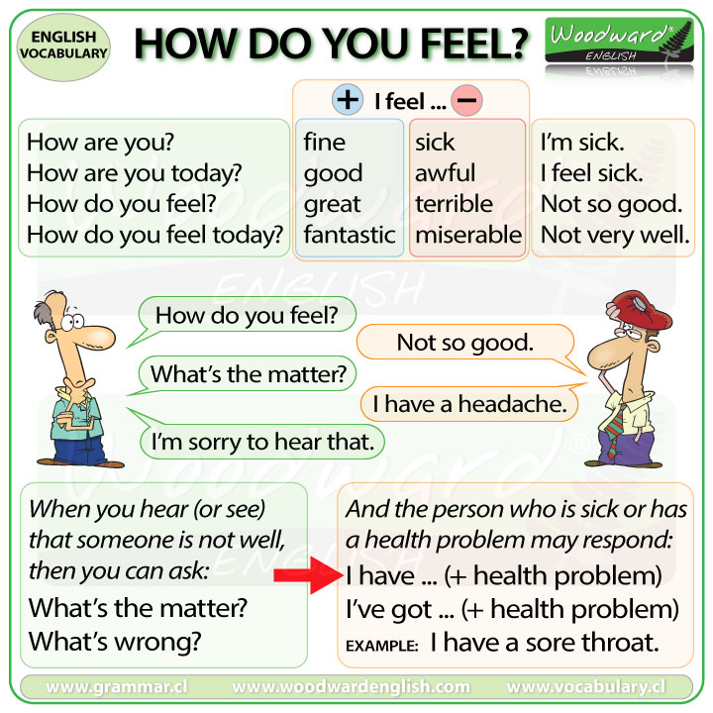

Health collocations Remember the proverbs.

- To stay healthy (opp. unhealthy) The first wealth is health.
- To be in good shape Good health is above wealth.
- To have a balanced (healthy) diet Prevention is better than cure.
- To look after health = to care An apple a day keeps the doctor away.
- To have (un)healthy habits such as…. The less you eat, the longer you live.
- Take up sports A healthy mind in a healthy body.

Grammar. Quantifiers. Study the rule.

MUCH \ MANY \ A LOT OF \ PLENTY OF

LITTLE \ FEW
Little= not much few= not many
Gary is very busy with his job. He has little time for other things. (=not much time,less time than he would like)
Vicky doesn’t like living in London. She has few friends there.(=not many,not as many as she would like
You can say very little and very few:
Gary has very little time for other things.
Vicky has very few friends in London.

ENOUGH \ TOO

Enough normally goes before nouns:
- I can’t run very far.I don’t have enough energy.(not energy enough)
- Do we have enough petrol, or should we stop and get some?
- We’ve got enough money. We don’t need any more.
- Some of us had to sit on the floor because there weren’t enough chairs .
We also use enough alone (without a noun)
- We don’t need to stop for petrol. We’ve got enough.
Compare to much/many and enough
- There’s too much furniture in this room. There’s not enough space.
- There were too many people and not enough chairs

Task 1. Fill in much or many.
- How apples are there in the basket?
- How money have you got?
- How boys are there in your class?
- How lemonade is there?
- How stamps have you got?
- How sugar do you want?
- How people can you see?
- How butter do you want?
- How children can you see?
- How fish do you want?
- How water is there in the bottle?
- How trees are there in the garden?
- How milk does the baby drink?
- How friends have you got?
- How furniture is there in the room?

Task 2. Cross out the wrong form.
How much \ many meat do you eat?
- I drink too \ too much coffee.
- She eats too much \ too many biscuits.
- I don`t drink enough water \ water enough.
- I can`t go. I am too \ too much busy.
- You work too much \ too many.
- We only drink a few \ a little coffee.
- I don`t have enough time \ time enough.
- He is enough rich \ rich enough.
- He has a few \ a little friends.

Task 3. Complete the sentences with TOO, TOO MUCH, TOO MANY or ENOUGH.
You eat too much chocolate, it isn`t good for you.
- My father is not fit because he doesn`t do ____ exercise.
- I can`t walk to work, it`s ___ far.
- There are ___ cars on the road today.
- I don`t sleep ___ – only 5 or 6 hours, but I really need 8.
- We were ___ exhausted to go out last night.
- There were ___people at the party, so it was impossible to dance.

Task 4. Fill in a lot, a lot of, much or many.
- Do you drink milk?
- I like reading. I've got books.
3. There isn't milk in the fridge.
4. It costs money to buy this coat.
5. Please be quick! I haven't got time.
6. How foreign languages do you know?
- They didn't ask him questions.
- There was food at the party but they didn't eat .
9. They saw interesting things in the museum.
- He knows about writers.
- It didn't cost to buy this TV set.
- «Did you enjoy the party?» No, not .
13. Most of the town is modern – there aren't ______old buildings.
14. Do you go to the cinema ?

Task 5.

Unit 8. ARE YOU FRIENDS WITH SPORTS?

Grammar: do\go\play collocations\ Gerund & Infinitives
Vocabulary: sports

Answer the following questions first.
1.Who are your sporting heroes or heroines? Work in pairs, use the key words to talk about them
Positive : brilliant, fast, intelligent, skillful, strong
Negative: awful, boring, over-rated, slow, terrible, useless, weak

Example: In my opinion Eldos Smetov is a brilliant judoka

  - benefits of physical activity
– Better mood. ...
– Better brain function. ...
– More money in your wallet. ...
– Lower risk of heart disease and stroke. ...
– Staying positive and motivated
– Lower risk of some cancers. ...
– Longer life. ...
– Stronger bones and muscles.

2. Read the article and answer the questions:
1. Why are the sisters unusual?
2. What kind of background are they from?
3.Who helped them to succeed ?
4. How do the two sisters get on at home?

Last week, Venus and Serena Williams played each other in the final of a tennis tournament. Venus is now fourth in the world, and her younger sister Serena has moved to ninth.
The two sisters have already come a long way from the poor area in Callifornia where they were born. It was full of violence and drugs, and the girls’ father Richard, wanted to move to a safer place. They moved to a safer place. They moved in 1991 and they have never looked back.
Richard started to train Venus when she was four, and says: «The first time I took Venus to the tennis court, I told my wife» «We have a champion», She played in her first big tournament in 1996 . She has won Wimbledon and the US Open twice. Serena has continued to improve and she has made fantastic progress. In 1999, she won the US Open, but she hasn’t won the singles at Wimbledon yet.
Has tennis ever caused problems between the sisters? «We’ve played each other before and it hasn’t worried us – yet!» says Venus» If she wins, «Serena jokes», «Mama says she has to do the dishes!»
Sport collocations. Make up sentences about yourself.
Keep fit
Stay = be in good shape
Take up sports
Do sports= go in for sports
Stay = be motivated and disciplined

Vocabulary.

Task 1. Make up your own sentence using new collocations.

Collocations Go\\ Do\ Play

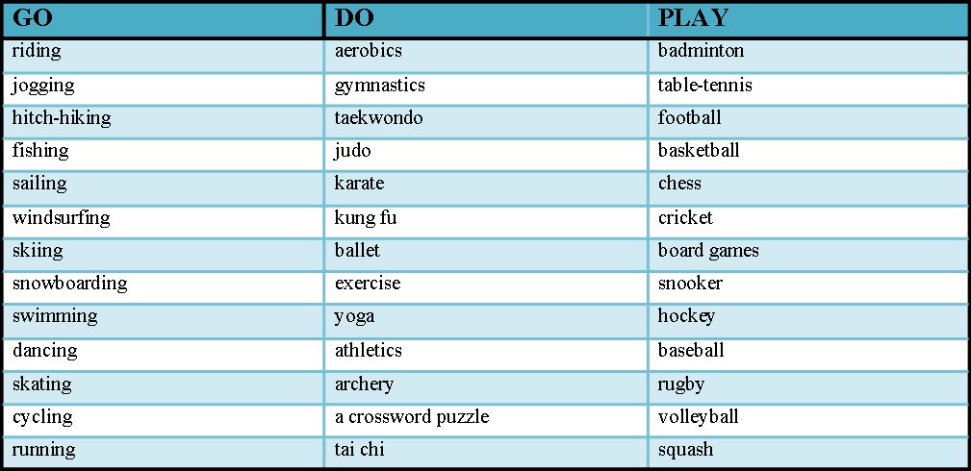

In football, you can talk about the score( the number of goals a team has) like this
Spain played Poland and they won the game  Spain won 2-0 (spoke as two nil).  Spain beat Poland (2-0)(NOT Spain won Poland)  Spain defeated Poland (2-0) | =Poland lost the game.  =Poland lost 2-0  =Poland were defeated(2-0) by Spain
Spain and Italy drew 1-1 ( spoken as one all) OR It was a 1-1 draw between Spain and Italy.

A competition is an organized event which people try to win smth by being the best, the fastest. Individuals, such as tennis players Serena Williams or Rafael Nadal, and teams such as Manchester United, take part in different types of competition. Tennis players and golfers enter
tournaments such as the French Open, football and hockey teams also play in league completions, where they play against other teams. Lots of teams also play in cup competitions, e.g. the FC cup or the World Cup, which ends with 2 teams playing each other in a final. The winners (opp. The losers) are the champions.

Task 1. Complete the sentences with the correct verb.
- We play football in the winter at my school.
- Do you ____ much exercise?
- I _____ basketball in the summer & winter.
- We always ____ in the winter, as long as there is enough snow.
- I ____a bit of yoga when I was young.
- We used to ____ camping in the mountains.
- I ____a lot of swimming in the summer.
- If you want to ____ fit, you need to run three or four miles every other day.
- I used to ____ in the gym, but I`m getting a bit old for that now.

Task 2.

Speaking. Express your opinion on the following statements.
Use opinion phrases:
I think that…..
I am sure that….\ I am not sure that….
In my opinion…..
From my point of view……..

1. «Teamwork makes the Dream Work»
2. No pain, no gain.
3. «You don`t find will power, you create it.»
Grammar. Gerunds and Infinitives. Study the forms of the verbs below.

Verb+ ing = Gerund

Gerund is used after some verbs\ prepositions or at the beginning of the sentence as a subject.

Verbs followed by Gerund

- Enjoy We really enjoy spending time all together.
- Like Do you like swimming or boxing more?
- Hate I hate playing table tennis. It`s too boring for me.
- Love + Gerund (Ving) We love playing board games.
- Finish I will call you when I finish cleaning.
- Fancy I don`t fancy going out tonight. (not enthusiastic)
- Avoid You should avoid talking to arrogant people.
- Suggest He suggested going to the cinema.
- Spend My friend spends hours chatting with her boyfriend.

More examples:
1. I am keen on (interested in) skating.
2. We do enjoy swimming and hiking.
3. Playing chess is my favorite leisure activity.
4. Sam likes\loves reading psychology books.
5. Go on speaking, I am listening to you.
6. Being with people I like makes me feel good.
7. My best friend is good at dancing.

to+ verb = Infinitive

Infinitive is used after some verbs\ adjectives and also at the beginning of the sentence.

Verbs followed by Infinitive

- Want We want to have a rest a little.
- Help They will help to solve this problem.
- Offer They offered to give me a lift to the bank.
- Decide We decided to study abroad.
- Try Try to read more in English.
- Promise + Infinitive (to + verb) I promise to call you every weekend.
- Agree (not to +Verb) He agreed to move to Australia.
- Plan We are planning to visit them soon.
- Manage I managed to finish everything in time.
- Forget She forgot to book the tickets in advance.
- Fail I failed to attract her attention.

More examples:
- My friend always helps me to decorate the house.
- Saule offered me to join her at the completion.
- Try to do sports a few times a week.
- I sometimes find it difficult to take up a new sport.
- My groupmates decided to take part in the contest.
- I think it is very important to keep fit.
- We want to go jogging 3 times a week.

Task 1. Give you own sentences on structures above.

Task 2. Complete with 'to + a verb'.
Do not drive go learn leave not take meet

1. A: Hi, I'm Dagmara.
B: I'm Renata. Nice ______ you.
2. What do you want ______ this evening?
3. I need ______ to the bank. I don't have any money.
4. Try ______ a noise. Your father's asleep.
5. I'd really like ______ a new language.
6. Be careful ______ too fast on the way home.
7. She's decided ______ her husband.

Task 3. Match the sentence halves.
1. They want to go to Australia | A. to celebrate getting the job.
2. He’s going to have a party | B. to get some petrol.
3. You’ll need a visa | C. to book our tickets.
4. Don’t forget to phone the restaurant | D. to visit their family there.
5. I stopped at the garage | E. to tell them where we are.
6. She’s gone to the supermarket | F. to go to China.
7. I went to the travel agent’s | G. to book a table.
8. I’ll send them a text message | H. to get some food for tonight.

Task 4. Gerund or Infinitive?
- ____ yoga is good for your health. (do)
- We`ve decided _____ to the party. (not go )
- ____ teenagers is very hard work. (teach)
- We can`t sing well without ____ to breathe properly. (learn)
- You can borrow the car if you promise ____ carefully. (drive)
- ____ by train is much cheaper than plane. (go)
- We won`t take the car. It`s impossible ____ .(park)
- I am not very good at ___ . (sing and dance)
- I`m sorry but I didn`t manage ____ all the issues. (finish)
- My sister spends days and nights ___ for her exams. (prepare)

Reading comprehension.
17-year-old Alexandra Kosteniuk is sometimes called the Anna Kournikova of the chess world. The International Chess Federation have asked her to be the new face of the game, which traditionally has had an image of middle-aged men wearing glasses.
Alexandra started playing chess when she was five. She learnt to play from her father, and became a grandmaster when she was only 14. Experts say that her game is one of the most exciting they have seen for a long time.
Chess is not as popular as it should be, and I think I could help it;' Kosteniuk said last week. 'It is an honour for me to be described as the face of the game.' She has her own website with pictures, poems, and the opportunity to play chess against her.
Making the game faster is another part of the campaign to make chess more popular. There are now strict time limits for making moves. Games that before lasted for hours can now take place in five minutes. The longest international tournament games, which sometimes took days, now last only four to seven hours.
Nigel Short, the British grandmaster, says, ‘There are a lot of attractive women in chess, but Alexandra Kosteniuk has made a very big impression. She is obviously very talented. Any sport needs attractive personalities, and I have no problem with marketing the game through her.'

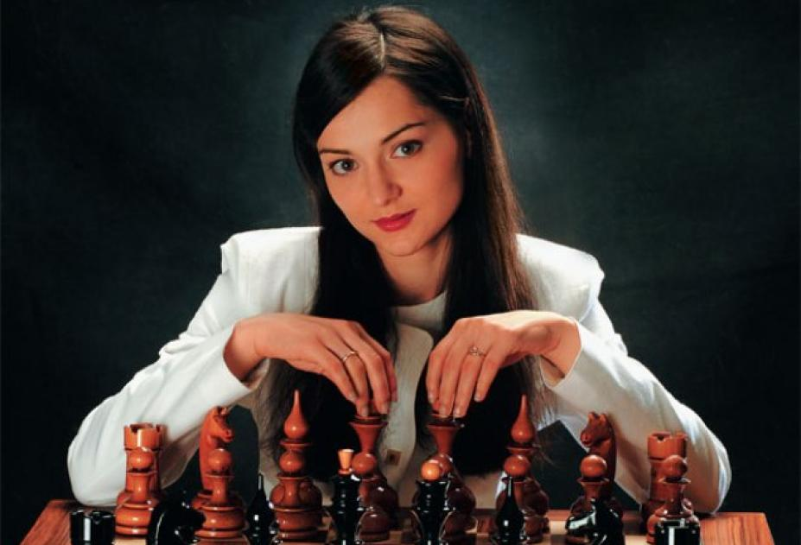

CAN YOU UNDERSTAND THIS TEXT?

a Read the article. Is Alexandra Kosteniuk..?
1. beautiful but not very good at chess.
2. not very beautiful but good at chess.
3. beautiful and good at chess.

b Read the article again and mark the sentences T (true), F (false), or DS (doesn't say).
1. The International Chess Federation wants chess to have a more modern image.
2. Alexandra never wears glasses.
3. Alexandra's father taught her to play chess.
4. She became a grandmaster after playing chess for five years.
5. She thinks that chess should be more popular.
6. If you have Internet access, you can play chess with Alexandra.
7. Nigel Short has an attractive personality.

Unit 9. LEISURE ACTIVITIES

Grammar: Gerunds & Infinitives\ Present Continuous versus Present Simple
Vocabulary: hobbies\ leisure activities

Speaking. What makes you feel good?
Do you have any hobbies? What are they? Do you think it is necessary to have interests?

Reading.
  - Read the article once. How many people mention…?
    - The weather
    - Holidays and travelling
    - Housework
    - Nature
    - Other people

  - Read again and tick 3 things you agree with most. Say why

Leisure activities

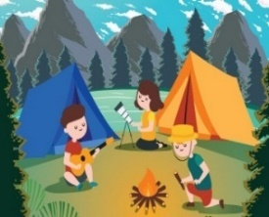 | 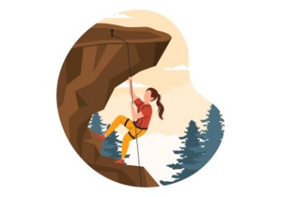 | 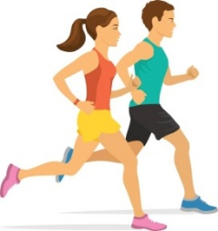 |  | 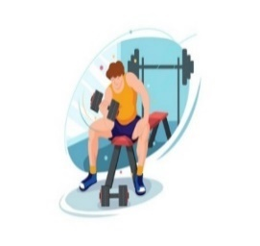
We often go camping in the summer, and we usually do a bit of rock climbing as well.
My best friend does a lot of yoga. She works out in the gym two or three times a week as well.
My brother enjoys jogging, and it keeps him fit (helps his body to stay in good condition).
My mum does a bit of jogging as well – just for fun (because she enjoys it; synonym: for pleasure).
I’m afraid I don’t do any exercise at all.

Grammar Practice.
Task 1. Verb +Gerund\ Infinitive
Avoid | a) going
Want | b) to go
Consider | c) applying
Plan | d) to become
Enjoy | e) working
Hope | f) to speak
Task 2. Choose the right verb form: Gerund or Infinitive
- I enjoy ______ (work) with people.
- He decided ______ (join) the police academy.
- They promised ______ (help) us with the training.
- I don’t mind ______ (stay) late at the office.
- She hopes ______ (get) a promotion next year.
- We finished ______ (study) at 10 p.m.
- He agreed ______ (give) a statement.
- The officer suggested ______ (check) the documents again

Task 3. Fill in the gap with the right verb form.
- I decided ______________________ (become) a police officer because...
- I enjoy ______________________ (train) with my team.
- I hope ______________________ (graduate) with honors.
- I avoid ______________________ (use) my phone during training.
- I suggest ______________________ (practice) English every day.
Task 4. Correct mistakes in the sentences.
- She suggested to take the fingerprints again.
- We decided joining the training session.
- He enjoys to work with civilians.
- They promised helping with the investigation.
Конец формы

Revision and consolidation.
Task5. Choose the most suitable answer.
1. – What’s my job? – ______________,
a) You is student b) You’re student c) You’re an engineer d) You are engineer.
2. – Where are you now? – ____________
a) Fine, thanks! b) A student c) I’m in the classroom d) I’m Paulo
3). – How are you? – _____________
a) 23 years b) In a school c) a fine d) I’m fine e) Not now.
4). – Are you from Japan? – ____________
a) Yes, I do b) No, I am not c) Thank you! d) No, I are not e) No, I do not.
5). – Is John single? – _____________
a) Yes, it is. b) No, it isn’t. c) No, John is away. d) Yes, he is.
6. I have got one brother and three _______________.
a) parents b) girls c) sisters d) women e) woman.
7. I have cats and you have dogs. These are my cats and those are ______ dogs.
a) your b) you’re c) yours
8. 10+4 is __________.
a) four b) fourteen c) forty d) fifteen e) fourteen.
9. – Have you got ______ children? – Yes, we have got two.
a) any b) one c) lots d) the e) a
10. – What is she like? – _________
a) She likes chocolate. b) She’s pretty. c) Yes, she likes. d) She is so helpful and friendly.
11. – What color are Sue’s eyes? – ________
a) Red. b) Yellow. c) Brown. d) Orange. e) Pink.
12. There isn't __milk in the fridge.
a) many b) a lot of c) much
13. – Do they live in Sao Paulo? – _______________
a) Yes they live. b) Yes, they do. c) No, they live not. d) No, they do live.
e) Yes, they are.
14. – What time is it? – It’s 1:20. So, it’s _____________.
a) one and twenty b) twenty to one. c) one to twenty. d) twenty past one.
15. They saw interesting things in the museum.
a) many b) a lot of c) much
16. ____________ she go to work by bus?
a) Does b) Is c) Do d) Has e) Have
17. I don’t like _________ on Sundays.
a) study b) studing c) to have study d) studying e) to do study
18. – Is there a garden in that house? – _____________
a) No, there is. b) No, there are. c) No, there aren’t. d) Yes, there is. e) Yes, there are.
19. – Are there any biscuits? – No, ____________.
a) there aren’t some. b) there aren’t any. c) there isn’t. d) there is any.
20. Today is 22 Aug. 1999. So it is ___________ of August, 1999.
a) the twenty-two. b) twenty-twoth. c) the twenty second.

Task 6. Put questions to the following answers.

1. –________________________? – I usually get up at 8.
2. – ________________________? – For breakfast I have fried eggs with some salad.
3. – ________________________? – I usually go to work by car but yesterday I took a taxi.
4. – ________________________? – I took a taxi because my car broke down.
5. –________________________? – It usually takes me half an hour.
6. – _______________________ ? – I work in the city center.
7. – ________________________? – Because I have always wanted to become an officer.
8. – ________________________? – After work I go home or see my friends.
9. – _______________________ ? – Yes, I do. I like my job a lot.
10. –_______________________? – No, I wouldn’t like to change my lifestyle.

Task 7. Translate from Russian into English.
- Что он обычно делает после обеда? Он обычно изучает законы и готовится к урокам.
- Где ты был, когда я звонил тебе вчера? – я был в библиотеке, решил подготовиться к экзаменам.
- Весна. На улице тепло.
- Бесполезно (useless) давать ей советы (to advise), она никогда им не следует. (follow)
- Мне требуется 2 часа, чтобы подготовить презентацию. (novel)
- Это наше общежитие, мы проводим там все свое свободное время.
- Он ходит в спортивный зал дважды в неделю и есть только здоровую еду.
- 10 минут достаточно, чтобы добраться до центра города.
- Где Сара и Джек? – Сара сейчас делает уроки, а Джек смотрит телевизор в гостиной.
- Моя сестра знает английский, но, к сожалению, не знает китайский.
- Сколько в группе детей? – Я не уверена, но думаю, что в группе 15 детей.
- Вчера погода была лучше? – Да, было теплее.
- На этой улице много старых зданий (buildings).
- Наслаждаюсь пешими прогулками потому что это помогает мне отдохнуть и перезарядиться. (recharge my batteries)
- Мы хотим стать хорошими офицерами в будущем.
- Важно закончить расследование до конца недели.
- Свидетели пообещали рассказать все в суде. (witnesses\ in the court).

Unit 10. KAZAKHSTAN IS MY MOTHERLAND

Grammar: Present Continuous for future meaning\ be going to…..
Vocabulary: phrasal verbs – Look, topical vocabulary
Answer the questions:
Where is Kazakhstan situated?
Who is the president of Kazakhstan? When was he elected?
What is the official language of Kazakhstan?
What cities have you already visited? What were they like?

Reading comprehension.

Astana is the capital of Kazakhstan
The Republic of Kazakhstan is a unitary state with the presidential system of government. Under the Constitution, Kazakhstan is a democratic, secular, legal and social state which recognizes the man, his life, rights and freedoms as the supreme values of the country. Kazakh language is the official language of Kazakhstan. The Russian language has the status of the language of interethnic communication. The unit of currency used in Kazakhstan is tenge.
Astana (the former Akmola) was founded in 1830. In 1862 Akmola got the status of a town. In March 1917 the Soviet Power was established in Akmola. In 1961 Akmola was renamed into Tselinograd and became the centre of Tselinny Krai.In 1992 the city got its name Akmola again and since October 1997 Akmola has become a new capital of the Republic of Kazakhstan. Later on it got its present name Astana.
Astana occupies the north-western part of the Sary Arka, on the river Ishim. The climate is extreme continental. The scorching summers bring dust storms and hot, dry winds. It is a modern growing city, a political, financial, economic, scientific and socio-cultural centre of the state. In 1999 Astana was awarded with the medal and little of City of Peace by UNESCO
There are a lot of magnificent beautiful buildings, higher educational establishments, colleges and secondary schools, hotels, banks and other commercial structures in Astana, the new capital of the Republic of Kazakhstan. From everywhere you can see Baiterek, the symbol of prosperity and happiness.
The Baiterek Tower has become the city's symbol and its visiting card. The height of the structure is 105 meters. At the height of 97 meters there is an observation deck providing a bird's eye view of the city. The figure of 97 was not chosen at random. It symbolizes the year of the movement of the capital from Almaty to Astana. The Baiterek Tower accommodates an art gallery, a large aquarium and a restaurant.
The Republic of Kazakhstan is a member of eleven international organizations including United Nation, UNESCO, UNICEF, IMF and others. The main symbols of our country are the Flag, the Emblem, the National Anthem

Task 1. Comprehension Questions
When was the city of Astana founded?
What name did the city receive in 1961?
When did Astana regain the name Akmolа?
What status was granted to Akmolа in 1862?
What are the climate conditions characteristic of Astana?
What does the height of 97 meters in the Baiterek Tower symbolize?
What can you see in Baiterek Tower?

Task 2. Fill in the Blanks
Use the words from the list to fill in the blanks in the sentences:
(Astana, capital, Baiterek, 1999, Tselinograd)
In 1) ________, the title «City of Peace» was awarded by UNESCO. The city of 2) ________ was founded in 1830. In 1961, the city was renamed 3)________. Since October 1997, 4)________ has become the new capital of Kazakhstan. The
5) ________ is a symbol of the city and stands 105 meters tall.

Speaking\ Discussion.
Do you agree with:
East or west, home is best.
There is no place like home.
«Home is a shelter from storms, all sorts of storms»
«Our power lies in our love of our homelands»
Reading\ Grammar

Airport stories
Heathrow airport near London is the busiest international airport in the world. Every day thousands of travellers arrive at Heathrow from many different countries. Every one of them has a different story to tell. We spent an afternoon in the Arrivals Hall at Heathrow last week talking to travellers arriving from abroad.
We asked them: Why are you here?

a. Read the magazine article. Complete it with these questions.
- ____Do you know anybody here?
- ____Are you going to stay for long?
- ____Is this your first visit?
- ____What are you planning to do?
- ____When are you leaving?
- ____Does he know you’re coming?
- ____How are you going to get there?
- ____How long are you going to get there?
- ____Where are you staying in London?

LOOK FOR A JOB  Rima, 23, from Vilnius in Lithuania  Why are you here?  I'm going to look for a job. Maybe as an au pair,  looking after children. And I want to improve my English too, so I can get a better job when I go back home. I hope I can find some work quickly, because I don't have much money.  1 Is this your first visit?  Yes, it is. I'm really looking forward to living here, but I'm a bit nervous too.  2___________________  Six months or a year. It depends how things go.  3___________________  Yes, I have a friend who's working here in a restaurant. I'm going to stay with her for a few weeks until I can find my own flat.  Well, good luck! | A FAMILY REUNION  Jonathan, 35, just arrived from Melbourne, Australia  Why are you here?  I'm going to see my Dad in Wales.  It's his seventieth birthday tomorrow.4 _____________  No. It's going to be a big surprise for him. And it's going to be very emotional too. I moved to Australia in 1990, and the last time I saw my Dad was five years ago. It's too expensive to visit very often and my father can't fly - he had a heart operation last year.  5________________  By train. All the family are waiting at my parents' house. We're going to have a big party there tomorrow night.  6________________  Yes, for a month. It's too far to come for a short time - and I want to see all my old friends here as well as my family. | ON THEIR HONEYMOON  Maki, 25, and Koji, 27, from Nagasaki, Japan  Why are you here?  We're on our honeymoon. We got married last Saturday.  Congratulations!  7 _______________  We're staying at the Hyde Park hotel.  We're just here for a few days.  8_______________  Everything is organized for us.  Tomorrow we're doing a tour of London on a double-decker bus, and in the evening we're seeing a show. Then on Tuesday we're going to Oxford and Cambridge and on Wednesday we're flying to Edinburgh.  9_______________  On Friday. We're going to Paris next, and then to Rome...  Well, have a good time!

Vocabulary – look (a phrasal verb)

a) Look at Rima’s interview again. Find and underline three expressions with look. Match them to their dictionary definitions.
- ______ – try to find something
- ______ – wait with pleasure for something which is going to happen
- ______ – be responsible for or take care of somebody or something

b) Complete the sentences with after, for, or forward to:
- A nurse is a person who looks ____ people who are ill.
- She’s going to New York next month. She’s really looking _____ it.
- I can’t find my keys. Can you help me to look ____ them?
- I’m not looking _______ the exam – it’s going to be very difficult.
- Our house is a bit too small. We’re looking _____ a new one.
- Could you look ______ our dog this weekend? We want to go away

Listening comprehension New English File (Pre-Intermediate, recording 3.1)

c)Listen to Rima talking six months later. Mark the sentences T (true) or F (false).
- She’s working in an Italian restaurant.
- It was easy to find a job.
- She isn’t living with her friend now.
- She isn’t going to English classes.
- She doesn’t know if she’s going to go back to Lithuania.
- She’s leaving the restaurant next month.
- Her boyfriend is a waiter.
- Her family are very happy that she’s getting married.

d)Listen again for more details. Correct the false sentences.
New English File (Pre-Intermediate)

Grammar. Study the rule. BE going to + VERB or Present Continuous

Be going to do smth – собираться что-то сделать  + I’m going to work in a restaurant.  She’s going to meet me at the airport.  – We aren’t going to stay very long.  He isn’t going to like the weather.  ? Are you going to find a job?  When is your brother going to visit you?  1.Use (be) going to + infinitive to talk about future plans (intentions – наме) and predictions.  I am going to do something = I’ve decided to do it. (but perhaps not arranged to do it.)  - I’m going to work in the UK for six weeks. (intention, I have decided it)  - Your shoes are dirty. «Yes, I know. I’m going to clean them» (I have decided to clean them, not arranged)  - I’ve decided not to stay here any longer. Tomorrow I’m going to look for somewhere else to stay. (intention)  2.Use (be) going to + infinitive to show predictions, smth that is obvious to happen because you can see it.  - Be careful, it`s broken, you are going to fall from the ladder! (prediction упадешь)  - Look at those dark clouds, I think it’s going to rain this afternoon. (prediction)  - She isn`t preparing for an interview, she is going to fail.  When you use going to go, you can omit to go.  - I’m going to go to university next year. or I’m going to go to university next year.  COMPARE  We are going to meet them after classes. (intension, not a plan) | Present Continuous for future arrangements= plans  + I’m seeing some friends tonight.  We’re having dinner at their house tomorrow.  – She isn’t leaving until Friday.  They aren’t coming to the party.  ? What are you doing this evening?  Is she meeting us at the cinema?  1. You can also use the present continuous for future arrangements which we have planned for a fixed time or place.  - Don’t use the present simple for this. NOT I see some friends tonight.  - I`m seeing my friends tonight.  - We are leaving tomorrow. (we have already bought tickets)  - What time are you meeting Jane today?  - The present continuous is especially common with the expressions tonight, tomorrow, this weekend, etc. and with these verbs go, come, meet, see, leave and arrive.  Present Continuous is stronger than BE going to because it is about something already planned  We are meeting them after classes. We have arranged it beforehand, so don`t be late please.  (a strong plan)

Task 1. Write a question with going to for each situation.
- Your friend has won some money.
(what/do with it?) What are you going to do with it?
- Your friend is going to a party tonight.
(what / wear) ______________________________?
- Your friend has just bought a new table.
(where / put it) _____________________________?
- Your friend has decided to have a party.
(who / invite) ______________________________?

Task 2. What is going to happen in these situations? Use the words in brackets.
- There are a lot of black clouds in the sky.
(rain) It’s going to rain. _________________.
- It is 8:30. Tom is leaving his house. He has to be at work at 8:45, but the journey takes 30 minutes.
(late) He _____________________________.
- There is a hole in the bottom of the boat. A lot of water is coming in through the hole.
(sink) The boat ________________________.
- Lucy and Chris are driving. There is very little petrol left in the tank. The nearest petrol station is a long way away.
(run out) They__________________________.

Task 3. Tom wants you to visit him, but you are very busy. Look at your diary for the next few days and explain to him why you can’t come.
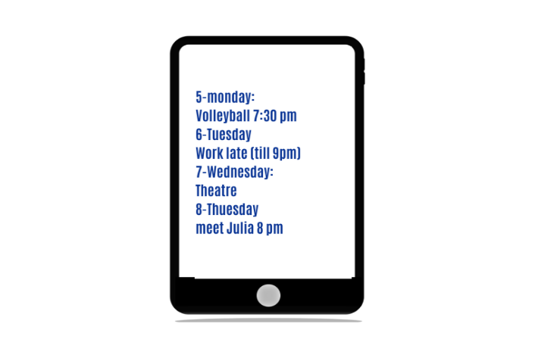 | TOM: Can you come on Monday evening?  YOU: Sorry, but I'm playing volleyball. (1)  TOM: What about Tuesday evening then?  YOU: No, not Tuesday. I_________________ (2)  TOM: And Wednesday evening?  YOU: ___________________(3)  TOM: Well, are you free on Thursday?  YOU: I’m afraid not._________________ (4)

Speaking activity.
a) Read the adverts and choose a holiday. Decide:
Where are you going? __________________________
How are you getting there? _____________________
When are you leaving? _________________________
Where are you staying? _________________________
When are you coming back? _____________________

  FIJI  Spend two or four weeks in the South Pacific with tropical beaches, sun, water sports, etc.  An unforgettable experience.  Departure: 1 June  Return: 15th or 30th June  Fly: British Airways (via London) or Air France (via Paris)  Hotels: Blue Lagoon (small beach hotel), Tropics (modern luxury hotel) | 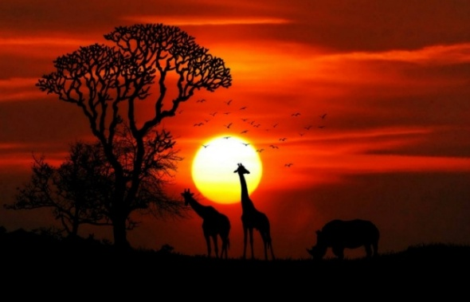  KENYA  Go on a two-or four week safari for the experience of a lifetime. In a 4*4 you will see lions, zebras, and elephants in their natural habitat.  Departure: 1st June  Return 15th or 30th June  Fly British Airways (via Amsterdam)  Accommodation in luxury campsites or in hotels

b) Now find a partner who has planned exactly the same holiday as you and discuss:
- Where are you going?
- To Fiji?
A. Me too. How are you getting there?
B. I’m flying with Air France.
A. I’m flying with British Airways, so we can’t go together.

Unit 11 WHY DO PEOPLE TRAVEL?

Grammar: Past Simple\ Regular & Irregular verbs\ Future Simple\ be going to…
Vocabulary: phrases with GO\ topical vocabulary

Answer the questions. Compare to others.
– How often do you travel?
– Where do you usually go to? What type of holidays do you prefer?
– Where do you like to stay when you travel?

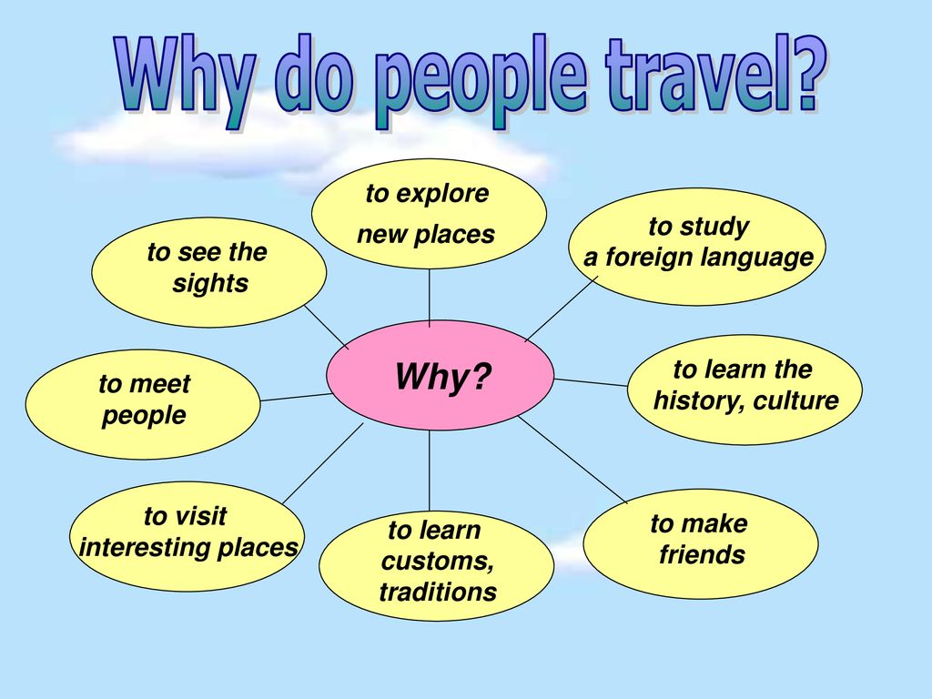

Types of holidays & Online booking
Types of holidays: Match with pictures
- Skiing holiday
- Family holiday
- Beach holiday
- Adventure holiday
- Go on a cruise
- City break

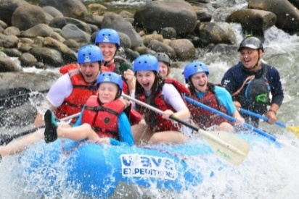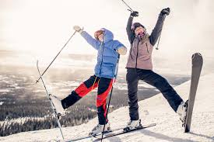

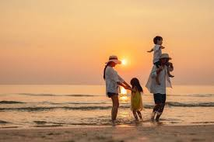

Online booking:
Many people book their holiday accommodation¹ on the Internet. To book online² you need to search for your destination³ and the dates when you plan to travel. You can look for hotels or B&Bs⁴. Often websites have low prices, especially in winter. It is helpful to read the online reviews⁵ before you book the accommodation. A popular option for a weekend break⁶ is to rent an apartment in an interesting city. But if you want to make life easy, you might like a package holiday, which includes the flight, hotel room and sometimes meals.
- a place where you stay
- to make a reservation using the Internet
- a place where you plan to travel
- bed and breakfast: a small hotel where breakfast is included in the price
- a description of a hotel, restaurant, etc., written by people who’ve been there
- a short holiday during a weekend

Things to visit abroad (= overseas)

Practice. Task 1.
HOLIDAY PHRASES
Phrases with GO

a) Match:
1. go abroad a) пойти на прогулку (гулять)
2. go away for the weekend b) кататься на лыжах
3. go by bus (or car, plane, train) c) осматривать достопримечательности
4. go camping d) уехать на выходные
5. go for a walk e) уехать заграницу
6. go on holiday f) выйти вечером куда-то
7. go out at night g) поехать в поход с палатками
8. go sightseeing h) заниматься плаванием…..
9. go skiing (or walking, cycling) i) ездить на автобусе …
10. go swimming (or sailing, surfing) j) поехать в отпуск

2. Other Holiday Phrases
a) Complete the verb phrases

Book buy have hire rent spend stay sunbathe take

  - ____ in a hotel / at a campsite / with friends
  - ____ a car, a bicycle (or skis), an apartment
  - ____ photos
  - ____souvenirs
  - ____money (or time)
  - ____ a flight online (or a hotel)
  - ____ on the beach
  - ____ a good time

Rent or hire?
Rent and hire mean the same, but:
– Use rent for a longer period of time (e.g. rent a flat or apartment)
– Use hire for a short time (e.g. hire skis, bike, boat)
– With a car, you can use either rent or hire

b) ADJECTIVES
Match the questions with adjectives:
1. What was the weather like?
2. What was the hotel like?
3. What was the town like?
4. What were the people like?

Use the following adjectives to describe:
  - comfortable, luxurious, cosy, spacious basic, dirty, uncomfortable
  - friendly, helpful, hospitable unfriendly, unhelpful, inhospitable
  - beautiful, lovely, cosmopolitan awful, noisy, crowded
  - warm, sunny miserable, cloudy, windy

Speaking. Which do you prefer? Explain why
– Going abroad or holiday in your country?
– Going by car, bus, plane, or train?
– Staying on the beach or going to a city?
– Hotel (or apartment) or camping?
– Sunbathing, sightseeing, or going for walks?
– Hot, sunny weather or cool, cloudy weather?
– Holiday with friends or with family?

Reading comprehension

IN THE RIGHT PLACE… BUT AT THE WRONG TIME!

Last week we asked you to tell us about a holiday when the destination was perfect but, for some reason, the time wasn’t right... Here are some of your replies.
a. Read the three letters to The Holiday Magazine and match them with the photos.
b. Complete the sentences with Tim, Gabriela, or Kelly.
______ wanted to go somewhere hot.
______ wanted to go somewhere cool.
______ had great food.
______ wanted to forget somebody.
______ had problems sleeping.
______ wanted to go on holiday with different people.

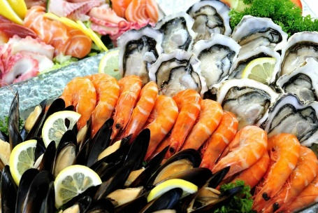 | 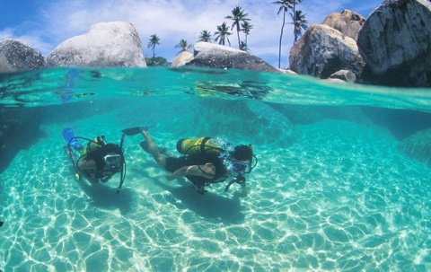 | 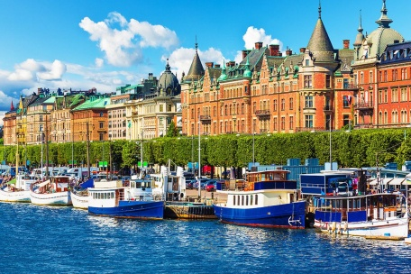

1. Tim, 20, student from Manchester  When I was a teenager I went on holiday with my parents to Brittany in France. My parents rented a lovely house on the beach, and the weather was great. But I was 17, and I didn’t want to be on holiday with my mum and dad and my little brother. I wanted to be with my friends. We went to the beach every day and sunbathed and we went to a fantastic seafood restaurant for my birthday. But I was miserable and I hated every minute of it. I didn’t speak to them for two weeks. What really made me furious was that my parents let my older sister, who was 19, go to Spain with her friends | 2. Gabriela, 28, marketing manager from Rome  I’m from Rome and the summer here is really hot. So last year my husband and I decided to go to Sweden, to escape from the heat. We booked a 10-day holiday in Stockholm, where the temperature in the summer is normally about 20 degrees. But when we got to Stockholm there was a heatwave and it was 35 degrees every day. It was awful because there was no air-conditioning anywhere. We couldn’t sleep at night – it was boiling in the hotel, and in the shops and museums too. We didn’t want to go shopping or go sightseeing or do anything – we were too hot. We just sat in cafés and argued all day. We didn’t need to go to Sweden to do that! | 3. Kelly, 26, TV journalist from Belfast  Three years ago I broke up with my boyfriend and I decided to go on holiday on my own to the Seychelles. My travel agent told me that it was a wonderful place. But he didn’t tell me that it was also a very popular place for people on their honeymoon. Everywhere I looked I saw couples holding hands and looking romantically into each other’s eyes! The travel agent also said it was always sunny there – but the weather was terrible – it was cloudy and very windy. To pass the time I decided to do a diving course (one of my lifetime ambitions). But it was a complete disaster because the first time I went under the water I had a panic attack. I couldn’t escape from the island so I spent an incredibly boring (and expensive) two weeks in «paradise»
SPEAKING. Make up the questions. Work in small groups.
Think about your answers to these questions.
- Your last holiday
- Where/ go ? When ?
- Who /go with?
- How/ get there?
- Where/stay?
- How long/ be there?
- /have good weather?
- What/do during the day?
- What/do at night?
- /have a good time?
- /have any problems?
Study the rule. Grammar.

Past Simple (V2\ ed\ didn`t + V1\ Did….? )
We use the past simple to talk about finished actions that happened once or more than once in the past.
There are Regular / Irregular Verbs in English (a list of verbs)
Regular | Irregular
+ We stayed at a hotel last summer. | +I went to Turkey twice last year.
– He didn’t stay with friends. | – She didn’t go to France.
? Did you stay for the weekend? | ? Did you go to Madrid?
– Yes, I did. | – No, we didn’t.
Where did you stay? | Why did you go?

Spelling rules for regular verbs
Infinitive | Past | Spelling
work | worked | (add – ed)
like | liked | (add – d if verb finishes in e)
study | studied | (– y → – ied after a consonant)
stop | stopped | (if verb finishes in consonant–vowel–consonant, double the final consonant)
 | Утвердительная форма | Вопросительная форма | Отрицательная форма
Ед.ч. | I  He  She was  It | I  He  was She  It | I  He  Was not  Wasn’t  She  It
Мн.ч. | We  You were  They | We  were You  They | We  Were not  Weren’t  You  They
Примеры употребления | He was right.  You were on time | Was the right?  Were you on time? | He was not (wasn’t right)  You were not(weren’t)on time
Verbs in the Past.

Действия, события и факты в прошлом, не связанные с настоящим | He left home yesterday and didn`t return.  We met the other day.  She saw this movie a few days ago but it wasn`t interesting, she was very bored.  It snowed a lot last night.
Последовательность действий и событий в прошлом, обычные повторяющиеся действия | I came home in the evening, turned on the TV set and decided to watch a new program.  He called us home every week last year.
Действие, которое длилось определенное время, но закончилось и осталось в прошлом, важен лишь факт, а не процесс | Yesterday we walked in the downtown for 3 hours and then went to cinema to watch a new film.  My cousin studied hard for many years to enter the university in California.
Подсказки (Prompt): yesterday, the day before yesterday, 2 days ago, last week\month\year, the other day, every day (time) last year

Task 1. Put these sentences into negative and interrogative forms.
1. I was born in April. 2. We were at the theatre on Sunday. 3. He was a Hollywood star. 4. I was late for the bus. 5. You were angry at my words. 6. She was a great actress. 7. I was happy. 8. He was very busy last week. 9. I was very poor at that time. 10. They were good students. 11. I was on duty on that day. 12. We were on holiday in August. 13. I was eager to make a career. 14. She was in great shock. 15. I was in love with that girl. 16. He used to be my best friend at school. 17. This building used to be a factory.

Task 2. Put these sentences into negative and interrogative forms.
1. Miss Honey taught me to read and to write. 2. We went to a karaoke club on Saturday. 3. We sang a lot of songs. 4. They had great fun at the party. 5. He did his work very well. 6. She heard some noise behind the door. 7. I read this book in my childhood. 8. It started raining in the morning. 9. We had dinner at Maxim's. 10. It snowed a lot last winter. 11. The children ran to the river. 12. Martin wrote a program for the computer. 13. Susan said goodbye and left the room. 14. That dictionary cost me a fortune. 15. I saw it with my own eyes. 16. My mother used to end her story on a happy note. 17. He used to work very long hours. 18. The old man would come to us every Sunday and we would talk and talk and talk. 19. When I was a kid, I used to love table tennis. 20. She used to love going to parties.

Task 3. Put the verbs in brackets in the Past Simple.
Two summers ago we had 1___(have) a holiday in Scotland. We 2___ (drive) there from London, but our car 3___ (break) down on the motorway and we 4 ___ (spend) the first night in Birmingham. When we 5___(get) to Edinburgh we 6 ___ (go) to our hotel, but they 7 ___ (not can) find our reservation, and they 8 ___ (be) full. We 9 ___ (not know) what to do, but in the end we 10 ___ (find) a Bed and Breakfast and we 11 ___ (stay) there for the week. We 12 ___(see) the castle and 13___ (buy) a lot of souvenirs. We 14___ (want) to go to Loch Ness, but we 15___ (not have) much time and it 16___ (be) quite far away. The weather 17___ (not be) very good - it 18___ (start) raining on the day we 19___ (leave) London, and it never 20___ (stop)!

Task 4. Complete the questions in the Past Simple.
– Where did you go on holiday last year?
– We went to Vancouver.
  - Wow! _________a good time?
Yes, we had a great time.
  - _______________with?
I went with my family.
3._______________?
We stayed in a hotel.
  - __________ the plane tickets ___?
They cost about £2,000.
  - ______the weather like?
It was hot and sunny.
  - __________ in the evening?
We usually went out for dinner.

Task 5. Put the verb into the correct form, positive or negative.
1. It was warm, so / took off my coat. (take)
2. The film wasn't very good. | didn't enjoy it much. (enjoy)
3. 1 knew Sarah was busy, so I ________her. (disturb)
4. We were very tired, so we_________ the party early. (leave)
5. The bed was very uncomfortable. I ________well (sleep)
6. The window was open and a bird _________into the room. (fly)
7. The hotel wasn't very expensive. It________ much to stay there. (cost)
8. I was in a hurry, so I________ time to phone you (have)
9. It was hard carrying the bags. They________ very heavy. (be)

Task 6. Speaking activity. Find someone who…
Name
- traveled somewhere last month _____________________
- watched a movie yesterday _____________________
- woke up late this morning _____________________
- forgot homework last week _____________________
- helped a friend recently _____________________
- studied for an exam last night ______________________
- went shopping last weekend ______________________
- cooked something special last week _____________________
- visited relatives recently ______________________
- read a book in English last month ______________________

Future Simple Tense (will + Verb 1\ won`t)
- For spontaneous actions
- Sorry, I forgot to bring books, I`ll go and take them
- I`m having a party next week. – I will help you
- She forgot her pen – Don`t worry, I will give you mine

- After:
Maybe…\ Perhaps…\ I think…\ I don`t think….\ I`m sure ..\ I am not sure…\ + WILL
- I don`t think I will have a lesson on holiday
- Will you invite Sam on your birthday party? – Maybe I will
- My friend is sure that we will win the competitions
- Perhaps I will have no time

- For making promises – обещания
- Don`t worry, I will do everything myself
- I will call you every day
- Can you lend me money? I will pay back in time

- For asking people to do smth
- It`s becoming dark outside. Will you please turn on (off) the light?
- Will you please cook dinner? (something special tonight)

- When we ask what we have to do next? (instructions) – In ?? we use SHALL with
(I \ WE)
- Shall I help you? – Вам помочь?
- Shall we give you a lift? Вас подбросить?
- Shall I retell the text to you? Мне пересказать текст?

- For making predictions
- Let`s watch Spiderman tomorrow – You will like it\ you will not enjoy it
- He is having his exams tonight – He will pass them successfully\ He won`t pass them because he isn`t getting ready

- In 1st Conditionals. (Real situation in the Future)
If
When + Present Simple (if – clause), Future Simple (main clause)
As soon as
    - If it rains today, we will stay at home.
    - When the weather is better, they will have team-building activities.
    - Will Assel forgive you if you apologize?
    - We will call you as soon as we get to our destination.
    - Where will you go if you have a holiday?
    - If it doesn`t snow, we won`t ski.

Practice. Task 1. Which is correct?
1.Did you phone Lucy?' 'Oh no, I forgot. I phone / I’ll phone her now.» (l’ll phone is correct)
2.I can't meet you tomorrow. I'm playing / I’ll play tennis. (I’m playing is correct)
3.I meet /I’ll meet you outside the hotel in half an hour, OK? ‘Yes, that’s fine’
4.‘I need some money!’ ‘OK, I’m lending/ I'll lend you some. How much do you need?"
5.l’m having / I’ll have a party next Saturday. I hope you can come.
6.‘Remember to get a newspaper when you go out’. OK, I don’t forget / I won’t forget’
7.What time does your train leave / will your train leave tomorrow?
8.I asked Sue what happened, but she doesn't tell /won't tell me.
9.‘Are you doing / Wil you do anything tomorrow evening?’ ‘No, I’m free. Why?'
10.I don't want to go out alone. Do you come /Will you come with me?

Task 2. Read the situations and write sentences with I think I'll ... or I don't think I'll ....
- It's a bit cold. The window is open and you decide to close it. You say
I think I'll close the window.
2. You are feeling tired and it's getting late. You decide to go to bed. You say:
I think__________
3. A friend of yours offers you a lift in his car, but you decide to walk. You say:
Thank you, but_________
- You were going to have lunch. Now you decide that you don't want to eat anything. You say:
I don't think________
- You planned to go swimming. Now you decide that you don't want to go. You say:
I don't think________

Task 3. Present Simple or Future Simple?
- If I (have) ___ enough money next year, I'll travel round the world.
- If she (pass) ___her exams, she'll study biology.
- If you don't invite Ann to the party, she (be) ___ angry.
- We'll be able to catch the first train if we (get up) ___ early.
- It (make) ___her ill if she (keep) eating chocolate.
- If you (press) ____that button, a bell (ring)____.
- If he (come) ____in time, he (visit)____ you.
- I (tell) ____you if she (need)___ help.
- He (be) ___surprised if she (arrive)___ before six o'clock.
- I (phone) ____him if I (be)____ in the town.
- If you (eat) ____fast, we (have) ___time to go for a walk.
- If she (get up)___ early, she (go) ___swimming.
- If I (win)___ a million dollars, I (buy) ___a fast car.
- If he (have)___ time, he (learn) ___the piano.
- What you (say) ___if I (ask) ___you to visit me?

Task 4. Speaking. Find Someone Who... (Future Forms)
❓ Ask questions using: be going to / will / present continuous. E.g.: Are you going to study tonight? / Will you visit your grandparents? / Are you meeting your friend this weekend?

- Find someone who is going to visit someone this weekend ___________
- Find someone who will study for an exam tomorrow _____________
- Find someone who is meeting a friend this evening _______________
- Find someone who is going to clean their room today _____________
- Find someone who will watch a movie tonight _______________
- Find someone who is going to buy something new soon _____________
- Find someone who is travelling next month _______________
- Find someone who will help their parents this weekend ____________
- Find someone who is going to cook something special ______________
- Find someone who will take part in a competition next week ______________

Task 5. Activity. Speaking in pairs.

Task 6. Practice vocabulary

Unit 12. PLANNING HOLIDAYS. PLACES OF INTEREST
(Достопримечательности)

Grammar: Degrees of comparison\ There is… \There are... \Gerund\ Modal verbs
Vocabulary: Adjectives for describing cities

Warm – up.
What is the most beautiful city in Kazakhstan in your opinion? (the cleanest\the most expensive\ the hottest\the coldest, the biggest)
What cities have you already visited? What did you see there? What was it like? Why are big cities different from small ones?

READING & LISTENING
a. Read the introduction to the article. In pairs, answer the questions.
- What are the three tests?
- Do you think they are good ones?
- Which city do you think will be the friendliest / most unfriendly?

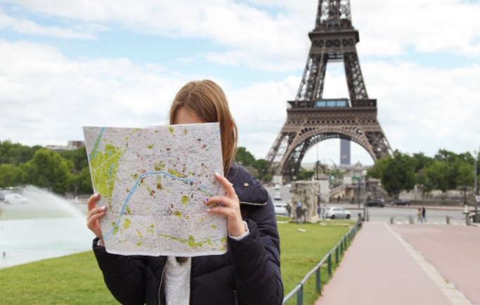
Big cities often have a reputation for being rude, unfriendly places for tourists. Journalist Tim Moore went to four cities, London, Rome, Paris, and New York, to find out if this is true. He went dressed as a foreign tourist and did three tests to see which city had the friendliest and most polite inhabitants. The three tests were:
1 The photo test
Tim asked people in the street to take his photo (not just one photo, but several –with his hat, without his hat, etc.). Did he find someone to do it?
2 The shopping test
Tim bought something in a shop and gave the shop assistant too much money. Did the shop assistant give back the extra money?
3 The accident test
Tim pretended to fall over in the street. Did anybody come and help him?

 |  | New York | Paris | Rome
The photo test | I asked an office worker who was eating hes sandwiches to take a photo of me. ‘of course I’ll take your picture. Again? Sure! Again! No problem. Have a nice day!’ |  | I asked some gardeners to rake some photos of me in front of the Eiffel Tower. They couldn’t stop laughing when they saw my hat. | I asked a very chic woman in sunglasses. She took a photo of me with my hat on, then without my hat. Then with my sunglasses. The she asked me to take a photo of her!
The shopping test | I bought an I love New York T-shirt and drinks from two different people. I gave them too much money but they all gave me the extra money back. |  | I bought some fruit in a greengrocer’s and gave the man a lot of coins. He carefully took the exact amount. | I bought a copy of The Times from a newspaper seller near the railway station. It was three euros. I gave the man four and he didn’t give me any change.
The accident test | I fell over in Central Park. I didn’t have to wait more than thirty seconds. ‘Oh dear’ a man said. ‘Is this your camera?’ I think it’s broken |  | I fell over in the Champs Elysees. A minute passed before someone said ‘Are you OK? And he was Scottish!’ | When I fell over about eight people immediately hurried to help me.

b. Read about what happened in New York, Paris, and Rome. Answer the questions with NY,P,R
1. Which city do you think was the friendliest in the photo test? ___
2. In which city did he take a photo too?___
3. In the shopping test, where didn’t he get the right change? ____
4. Where did he buy a souvenir? ___
5. In the accident test, where did he wait longest for help? ___
6. In which city were people most helpful? ___

Vocabulary. Describing a city. WHAT IT LIKE?
a. Match the adjectives to sentences 1–6.
Adjective | Opposite
1. Boring | exciting
2. crowded | empty
3. dangerous | safe
4. modern | old
5. noisy | quiet
6. polluted | clean
- There are a lot of bars and clubs with loud music.
- The air is very dirty.
- There are too many people.
- The buildings were all built quite recently.
- There’s nothing to do. (boring)
- You have to be careful, especially at night.

b. Match these adjectives to their opposites in a.
clean, empty, exciting, historic, interesting, quiet, safe

What is there to see?
a. Put the words in the correct column.

bridge, canal, castle, cathedral, church, city walls, department store, harbour, hill, lake, market, mosque, museum, palace, ruins, shopping centre (mall), statue, synagogue, temple, town hall

Religious buildings | Places where you  can buy things | Historic buildings and monuments | Others
Cathedral | department store | castle | bridge

Listening comprehension. (New English File – Pre- Intermediate, old edition, recording 4.10)
 | London
The photo test | 1. Who did he ask first?
 | 2. What did the man say?
 | 3. Who did he ask next? What happened?
The shopping test | 4. What did he buy? Where?
 | 5. How much was it?
 | 6. Did he get the right change?
The accident test | 7. Where did he do the accident test?
 | 8. Did anyone help him?
 | 9. What did the man say?

Grammar. Study the rule.

It is – There is
It употребляется в безличных предложениях для обозначения:
№ | Назначение | Примеры
1 | времени (уақытты білдіру үшін) | What time is it? – It’s 12 o’clock.  It’s late (early, noon, night).  It’s lunchtime. It’s dinnertime.  It’s time to start the class.
2 | дней, месяцев, времен года (күн, ай, жыл мезгілдері) | What day is it? – It’s Monday.  It’s November. It’s autumn.
3 | расстояния (қашықтықты білдіру үшін) | It’s far from here to the park.  It’s a long way.  – How far is it to the metro station?  – It isn’t far.
4 | природных явлений (табиғи құбылыстар) | It’s fine weather today.  It’s a foggy day today.  It snows in Russia in winter.  It rains a lot in autumn.  It looks like rain (snow).  (Похоже, будет дождь/снег.)
5 | состояний (жағдай/баға/эмоция білдіру) | It’s nice to be young.  It’s easy to be polite.  It was good to visit you.  It’s cool to be a bodyguard.  It was awful to lose the game.  It’s interesting to travel.

What time is it? What day is it?
How far is it to…? – It’s not far from here.
Запомните
It looks like rain (snow) – Похоже будет дождь(снег)
It’s a small world. – Мир тесен
It’s up to you to decide – Тебе решать

Impersonal sentences. (Безличные предложения)
Осень. Вечер. 10 часов. Пятница. Ветрено и прохладно. На улице темно. Ноябрь. Приятно гулять осенью. По выходным обычно не многолюдно.
It`s autumn. It`s evening. It`s 10 pm. It`s Friday. It`s windy and cool. It`s dark in the street. It`s November. It is pleasant to have a walk in autumn. It is not crowded at weekends.
It is (not) necessary TO read a lot
It`s important TO do sport (to go in for sport)
It`s dangerous TO play with fire
It`s safe TO swim in the pool with the trainer
It`s difficult for me (easy) TO + VERB study Maths
It`s useful (useless) TO jog in the morning
It`s useless TO advise him because he doesn`t listen
It`s (im)possible TO book tickets beforehand

Task 1. Rendering.
    - Я считаю важно соблюдать сбалансированную диету.
    - Мы уверены, что жить заграницей одному сложно, потому что никого нет рядом.
    - Безопасно ли гулять по ночам в этой местности?
    - Я уверен в том, что необходимо изучать иностранные языки, потому что это расширяет кругозор. (= broaden my mind= expand my outlooks)

There is\there are

Эта структура используется во всех 3-х временах и всегда переводится с конца.
    - There are many places of interest (= tourist attractions) in my city. (В моем городе много достопримечательностей)
    - Were there many people at the cinema? – No, there were very few. (В кино было много людей? – Нет, там было очень мало людей.)
    - There wasn’t anyone in the library when I came (Когда я пришел, в библиотеке никого не было.)
    - There will be no time for discussing it, that`s why let`s decide what place we will visit next. (У нас не будет времени обсуждать это, поэтому давай решим сейчас куда мы пойдем дальше)
    - There won`t be any problems with public transport here as it`s very cheaper and much more comfortable. (Здесь не будет проблем с общественным транспортом так как он очень дешевый намного удобнее.)
    - Is there anything left in the fridge? – There is only bread and some fruits left. (Осталось ли что-нибудь в холодильнике? – Остался лишь хлеб и немного фруктов.)
    - There is no place like home. (Нет места лучше, чем дом)

Proverbs and sayings to remember.
It`s never too late to study
There is no place like home= East or West, home is best
It`s no use crying over spilled milk (no use to complain\ regret)
It`s on the tip of my tongue.
Where there is a will, there is a way
If there is no pain, there is no gain (No pain, no gain)
Where there is much talk, there is little work.

Practice. Task 1. Fill in are or is.
- There a table in the room.
- There bread on the table.
- There a woman near the window.
- There three birds on the tree.
5. there children in the park?
6. there swings in the yard?
- There meat in the shop.
- There cream in the bottle.
9. there milk in the glass?
10. There a dog outside.
11. there apples on the tree?
- There _________ lots of flowers in the garden.
- There chocolate in the fridge.
14. there cheese on the plate?
15. There butter in the fridge.

Task 2. Fill in are or is.
1. There some big trees in the garden.
2. there any news for me today?
- How many players there in the team?
- There a train at 9.30.
5. there any money in the box?
6. there any clothes on the chair?
7. There a university near our house.
8. there a restaurant near there?
9. How many students there in your class?
- There something in my eyes.
- There a good film on TV today.
- There seven days in a week.
- There twelve months in a year.
- There 60 seconds in an hour.
15. there any snow outdoors?

Task 3. Fill in is, are, was or were.
1. There ____three people in the photo.
2. There ____a woman, a man and their child in our garden now.
3. There ____an exhibition in our town last month.
4. I didn't like the hotel because there ____a lot of furniture in the room.
5. He was thirsty but there ____no drinks in the fridge.
6. The furniture was very old, there ____two chairs and a table in the room.
7. She is at her office now. There ____a lot of people to see her.
- Today there a lot of snow on the ground.
- There some chicken and fish in the fridge now.
10. there any furniture in the room?
11. There ____somebody in the kitchen now.
12. There ____no one on the roof of the house at the moment.
13. There ____ no flowers in our garden last summer.
- There ____a sports centre near our house.
- There ____26 letters in the English alphabet.

Task 4. Fill in was, wasn't, were or weren't.
- 1. There a good film on TV yesterday.
- We stayed at a big hotel. There 200 rooms there.
3. He was hungry but there anything to eat.
4. They stayed at a nice hotel. There a swimming-pool there.
5. there any post cards for me yesterday?
- He found a wallet but there any money in it.
- When she arrived at the theatre there a long queue outside.
- There an accident last night.
- He didn't visit the museum. There enough time.
- There some rain yesterday.
- The suitcase was empty. There any clothes in it.
- There a party last night but I didn't go.
- She was late because there a lot of traffic.
14. There a lot of people at the party last Sunday.
15. The telephone wasn't working because there any batteries in it.

Task 5. Put in am/is/are or do/don't/does/doesn't.
- Excuse me, you speak English?
- «Where Ann?» «I know»
- What's funny? Why you laughing?
- «What your sister do?» «She a student»
5. It _________raining. I want to go out in the rain.
- «Where you from?» «Canada.»
- Linda is a good tennis player but she play very often.
8. I like chocolate. And you? you like chocolate?
9. What Paul doing? I can't find him.
- I like coffee but I drink it very often.
- I ________ spending a wonderful time in England now.
- Mark is a vegetarian. He eat meat.
- Mary and Jane like milk.
- I ________ hungry. Can I have an apple?
- What this word mean?

Task 6. Correct mistakes.
a) There is Sunday tomorrow. I need to get up early.
b) This wine is much more cheaper than that one.
c) The news were bad.
d) There was very dark in the room.
f) In the fridge many fruits and vegetables.
g) My sister don1t know Arabic because very difficult language.
h) At the theatre were many tourists.
i) Do you know the man which lives next door?
j). What you usually buy in the supermarket?
k) Put any salt in the soup, tasteless.
l) There wasn’t some bread at the baker’s.

The Adjective. Degrees of comparison.
Study the rule.
Positive form | Comparative form (than) | Superlative form (самый)
short adjectives
easy | easier | the easiest
hot | hotter | the hottest
large | larger | the largest
fast | faster | the fastest
cheap | cheaper | the cheapest
long adjectives
modern | more modern | the most modern
expensive | more expensive | the most expensive
easy-going | more easy-going | the most easy-going
challenging | more challenging | the most challenging
loudly | more loudly | the most loudly
slowly | more slowly | the most slowly
exceptions
much\many | more | the most
little | less | the least
Good (well) | better | the best
bad (badly) | worse | the worse
few | fewer | the fewest
old | older (elder) | the oldest (eldest)

Study the sentences.
  - Alina is taller than me.
  - We are more talkative than our friends.
  - He is the most hospitable person I have ever met.
  - When I was in California I realized that Los Angeles is the most expensive city I have ever been to.
  - Astana is one of the coldest cities he has ever lived in.
  - Who is the best student in the group?

Study the structure: The…., the….. (Чем…, тем…)
The more you study, the better you know.
The sooner you come, the earlier we will leave.
The less you know, the better you sleep.
The more interesting the task is, the more involved we are.
Task 1. Choose the correct form of the adjective.
1. Alaska is than Spain.
a) more colder b) colder c) more cold
2. The Nile is the river in the world.
a) longest b) longer c) most long
3. It's the country I've ever visited.
a) most hot b) hottest c) hottest
4. This test is than that one.
a) difficult b) difficulter c) more difficult
5. She is as her mother.
a) pretty b) prettyer c) prettier
6. Mary is than Mike.
a) happyer b) happier c) more happy
7. The Mona Lisa is the painting in the world.
a) famousest b) more famous c) most famous
8. Film stars are than teachers.
a) rich b) more rich c) richer
9. Steve is than Jane.
a) hungriest b) hungrier c) more hungry
10. That was the dictation I've ever written.
a) most easy b) easiest c) easiest
11. My new car is than my old one.
a) good b) goodder c) better
12. Jane is than her sister.
a) more thinner b) much thinner c) most thinner
13. Your eyes are not than mine.
a) grey b) greier c) more grey
14. The plane is the way of travelling.
a) more expensive b) much expensive c) most expensive
15. Kyle is the pupil in our class.
a) worst b) bad c) baddest

Task 2. Fill in suitable form to complete the sentences.
1. Your TV is a lot (good) ___ than ours.
2. This is the (bad) ___ film he's ever seen.
3. His accent is (correct) ____than yours.
4. The woman seems to get (young) ____every year.
5. Mike is the (fat) ____person in his family.
6. This is the (tasty)____ meal I've ever eaten.
7. She has a friend who's much (pretty) ____ than her.
8. She's the (beautiful) _____ in the class.
9. A friend of mine married a girl who is much (young) _____ than him.
- Everest is the (high) ____ mountain in the world.
11.The (bad) ____thing in the world is dishonesty.
12. I think she is the (good) ____ person who ever lived.
13. She is (tall) ____ than her sister.
14. What is the (fast) ____ car in the world?
15. Her flat is (small) ____ than ours.

Task 3. Use the comparative forms of the words in the box. Use than where necessary.

big interested crowded peaceful early reliable easily serious high simple
important thin
- I was feeling tired last night, so I went to bed earlier than usual.
- I’d like to have a more reliable car. The one I have keeps breaking down.
- Unfortunately, her illness was _____ we thought at first.
- You look ______. Have you lost weight?
- I want a _____ apartment. We don’t have enough space here.
- He doesn’t study very hard. He’s _____ in having a good time.
- Health and happiness are ______ money.
- The instructions were very complicated. They could have been _____.
- There were a lot of people on the bus. It was ____ usual.
- I like living in the country. It’s _____ living in a town.
- You’ll find your way around the town _____ if you have a good map.
- In some parts of the country, prices are _____ in others.

Task 4. Complete the sentences using the structure « … and...»
1 It’s getting more and more difficult to find a job. (difficult)
2 That hole in your sweater is getting______ (big)
3 My bags seemed to get _______ as I carried them. (heavy)
4 As I waited for my interview, I became _______(nervous)
5 As the day went on, the weather got_______(bad)
6 Health care is becoming________(expensive)
7 Since Anna went to Canada, her English has got______ (good)
8 As the conversation went on, Paul became_______ (talkative)

Task 5. Translate the sentences from Russian into English.
1. Это лето будет более интересным, чем прошлое.
2. Я думаю, что поездка на море дешевле, чем в горы.
3. Этот отель удобнее, чем тот, в котором мы жили в прошлом году.
4. Мы выбрали более тёплое место для отдыха.
5. Каникулы с друзьями всегда веселее, чем с родителями.
6. Я хочу побывать в более красивом городе этим летом.
7. Автобус медленнее, чем самолёт, но дешевле.
8. Погода в июне обычно лучше, чем в мае.
9. Отдых в деревне тише и спокойнее, чем в городе.
10. Чемодан Анны тяжелее, чем мой.
11. Интересно узнавать о новых странах и культурах.
12. Полезно отдыхать хотя бы раз в году.
13. Необходимо бронировать билеты заранее в высокий сезон.
14. Приятно путешествовать с друзьями.
15. Легко найти жильё через интернет.
16. Трудно выбрать, куда поехать, когда столько вариантов.
17. Неудобно путешествовать с тяжёлым багажом.
18. Возможно сэкономить деньги, если бронировать заранее.
19. Опасно купаться в море во время шторма.
20. Необязательно тратить много денег, чтобы хорошо отдохнуть.

UNIT 13. WELCOME TO MY HOMETOWN. MY HOUSE

Grammar: Future forms\ Past Simple\ There is\ there are\ It is..\Degrees of comparison
Vocabulary: House

House
Fill in the gaps with appropriate words

But from has got near outside on there is there are there
House block of flats there are walls are more comfortable bigger

Some people in a private 1______ or in a 2_____I live in a private house 3___ a quiet street. It’s not far 4______the town centre and it’s a twenty-minute walk to the train station. There is a bus stop 5___ the house. The house 6___ a living room with a large sofa and a television. There 7_____ many bookshelves with books and a big table in the centre of the room. The living room is 8______ than the dining room.
In the kitchen, 9_____a washing machine, a dishwasher and a fridge-freezer. 10_______, there’s a small garden behind the house.
Upstairs, 1_____two bedrooms. The main bedroom is 12_______ than the guest room. It has got a double bed, a desk and a wardrobe. The guest bedroom has a single bed. There’s one bathroom,
13 ___it doesn’t have a bath. It just has a shower.
Next to the kitchen, there is a sitting-room and a dining-room. On the left, you can see the dining-room. There is a glass table and four black iron chairs. There is a piece of furniture with glasses and DVDs, and 14_____ some pictures on the 15____. On the right, you can find the sitting-room. It has a burgundy sofa and two green armchairs. Opposite the sofa 16 ____is the TV set. I go to sleep in front of the TV after lunch! There are some plants and there is a big window. This room has a lot of light. I love it!

Topical vocabulary

English word | Translation
armchair | кресло
bathroom | ванная
attic [ˈætɪk] | чердак
chimney | труба, дымоход
Cellar\ basement [ˈselə(r)] | подвал,цокольный этаж, погреб
bedroom | спальня
(book)shelf (мн.ч. -shelves) | (книжная) полка (мн.ч. -полки)
chair | стул
carpet | ковер
classroom | класс, классная комната
clock | часы
coffee table | кофейный столик
cooker | кухонная плита
cup | чашка
cupboard | шкаф (для посуды), сервант
dining-room | столовая
dishwashing machine | посудомоечная машина
fire | огонь, камин
fork | вилка
flower | цветок
fridge | холодильник
glass | стакан, стекло
kitchen | кухня
knife (мн.ч. -knives) | нож
lamp | лампа
living-room, sitting room, lounge | гостиная
newspaper | газета
magazine | журнал
mirror | зеркало
rug | ковер
carton of milk | Пакет молока
shower | душ
sofa | диван
spoon | ложка
stereo | стерео
table | стол
television | телевизор
washing machine | стиральная машина
bucket | ведро
lawn | газон
garage | гараж
oven | духовка
fence | забор
curtain | занавеска
study | кабинет
fireplace | камин
bookcase | книжный шкаф
chest of drawers | комод
stairs, staircase; ladder | лестница
tape recorder, cassette recorder/player | магнитофон
furniture | мебель
microwave (oven) | микроволновая печь
freezer | морозильник
(rubbish) bin, dustbin, litterbin | мусорный ящик
wallpaper | обои
blanket | одеяло
window sill | подоконник
pillow | подушка
central heating | центральное отопление
drawer | ящик
dust | пыль
linen | белье
mud; dirt | грязь
spacious, roomy | просторный
to hang | вешать/повесить
to turn/switch on; to plug in | включать
to turn/switch off; to unplug | выключать
to wipe (clean); | вытирать
to iron, to press | гладить
to close/draw the curtains | задёрнуть занавески
to go to sleep; to fall asleep | засыпать/заснуть
to vacuum, to hoover | пылесосить
to do the washing/ laundry | стирать/выстирать бельё
to tidy the room | убирать/убрать комнату
to make the bed | заправлять постель

Reading comprehension. Speaking and Writing.
a) Read the text and match the questions with paragraphs 1-5.
☐ What’s it famous for?
☐ What’s the weather like?
☐ What’s the best thing about it? Do you like living there?
☐ Describe your home town.
☐ Where do you live? Where is it? How big is it?

b) Complete the text with these words.

atmosphere / beach / city / festival / museums / population / river / streets / tourist / weather

c Find one grammar mistake in each highlighted phrase. Correct it.

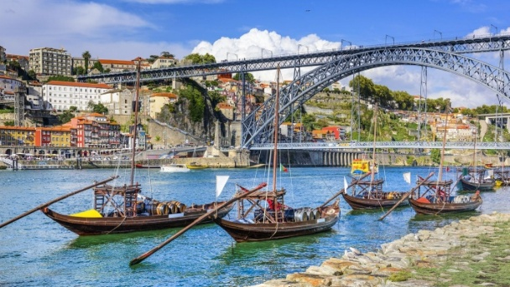 | 
The place where I live  - I live in Porto, which is a ¹ city on the coast in the north of Portugal. It has a ² ________ of 300,000 people and it’s the second bigger city in Portugal. biggest  - It’s a beautiful city, and it’s great for walking around. There are lots of narrow ³ ______, and it’s full of churches, ⁴ _______, and markets. There’s an area called Foz where there is a lot of outdoor bars and restaurants – people go there at the weekend to sit in the sun, drink coffee, and watch the Atlantic.  - The ⁵______ here is very different from the south of Portugal. The winter can be very wet, and it sometimes rain for days. The summer is wonderful – it’s sunny but not usually too hot, and it’s great for going to the mountains or to the | - Porto is famous for port wine, who is only produced here (but I don’t like it much!). The biggest ⁷ ______ attraction in Porto is probably the ⁸ ______– there are some beautiful bridges, including one designed by Eiffel, and lots of tourists goes on boat trips. There’s a ⁹ ______ in June called São Joao, with a lot of fireworks and people in the streets, and everybody spends most of the evening hitting each other with plastic hammers!  - But I think the best things about Porto are the people and the ¹⁰ ________. It’s quite small and it’s very safe and friendly. It’s a working city and it has a real sense of history, and that’s the main reason why I like live here so much.

Writing.
Write a description of the place where you live. Write five paragraphs.

Grammar. Practice.
Task 1. Fill in the correct prepositions at, behind, by, in, in front of, near, on, out of, under, of, to or for.
1. She met her friend a dance.
2. They live very Sam and Jane.
3. I wish she wouldn't drive so close me.
4. Please take your thumb your mouth.
5. "Where is my book?" " your bag."
6. Can I sit you?
7.At the theatre somebody tall always comes and sits me.
8.She's travelling the seven o'clock bus.
9. Have you looked table? It's really dirty.
- They usually travel train.
- He goes to school foot.
- They are afraid the dogs.
- What has happened her?
- They left Kiev Moscow.
- He arrived London at nine p.m. yesterday.

Task 2. Choose the correct variant.

1. _____ a sofa in the living room.
A) There are
B) There is
C) It is
2. There ______ two windows in my bedroom.
A) is
B) are
C) be
3. The TV is ______ the table.
A) next
B) on
C) between
4. The fridge is ______ the oven and the sink.
A) under
B) between
C) in
5. _______ a mirror in the bathroom?
A) Are there
B) Is there
C) Do there
6. _______ a large sofa in the living room.
A) There are
B) There is
C) It is

13. There _______ some flowers on the windowsill.
A) is
B) are
C) be
14. The kitchen is _______ than the bathroom.
A) big
B) bigger
C) the biggest
15. The bookshelf is ______ the desk and the wardrobe.
A) between
B) under
C) behind
16. _______ a mirror in the hallway?
A) Are there
B) Is there
C) Does there
17. My room is the _______ in the house.
A) comfortable
B) more comfortable
C) most comfortable
18. There ______ any pictures on the wall.
A) isn’t
B) aren’t
C) doesn’t
7. The carpet is _______ the table.
A) on
B) in
C) under
8. The guest room is _______ than the master bedroom.
A) small
B) smaller
C) more small
9. There are five chairs _______ the dining table.
A) around
B) under
C) next
10. _______ a washing machine in the kitchen.
A) There is
B) There are
C) It is
11. The windows in the living room are _______ than the ones in the bedroom.
A) large
B) more large
C) larger
12. The cat is hiding ______ the sofa.
A) in front of
B) behind
C) between
19. This is the _______ part of my home — the balcony!
A) best
B) better
C) most good
20. There _______ a garden, a garage, and a swimming pool in her house.
A) is
B) are
C) has
21. The windows in the living room are _______ than the ones in the bedroom.
A) large
B) more large
C) larger
22. The cat is hiding ______ the sofa.
A) in front of
B) behind
C) between
23. This is the _______ part of my home — the balcony!
A) best
B) better
C) most good
24. There _______ a garden, a garage, and a swimming pool in her house
A) is
B) are
C) has

Unit 14. ENVIRONMENTAL PROTECTION

Grammar: It is...\ Modal verbs\ Degrees of comparison\ Phrasal verbs
Vocabulary: Environment

Reading comprehension.
Read the text and do the exercises below.

Ecology is a science which studies the relationship between all forms of life on our planet and the environment.
Since ancient times Nature has served Man, giving him everything he needs: air to breathe, food to eat, water to drink, wood for building and fuel for heating his home. For thousands of years people lived in harmony with the environment and it seemed to them that the resources of Nature had no end or limit.
With the industrial revolution our negative influence on Nature began to increase. Big factories pollute the air we breathe, the water we drink, the fields where our crops are grown. Big cities suffer from smog. Cars with their engines have become the main source of polluting in industrial countries.
Vast forests are cut down everywhere for the needs of industries. As a result, many kinds of animals, birds, fish and plants are disappearing nowadays.
The pollution of the air and the world’s oceans and the thinning the ozone layer are the other problems arising from men’s careless attitude to ecology.
Climate has a very important influence on plants, animals and humans and is different in different parts of the world. But recently the climate has changed a lot, especially in Europe. Scientists think that the reason is greenhouse effect. It is caused by carbon dioxide (углекислый газ). Carbon dioxide is produced when we burn things. Also people and animals breathe in oxygen and breathe out carbon dioxide. As you know, trees take this gas from air and produce oxygen. But in the last few years people have cut down and burn big areas of rainforest. This means that there are fewer trees and more carbon dioxide.
This gas in the atmosphere works like glass in a greenhouse. It lets heat get in, but it doesn’t let much heat get out. So the atmosphere becomes warmer.
Greenhouse effect is sometimes called global warming.
Active measures should be taken to save the life on our planet because we are the caretakers of the earth. There is an international organization called
Greenpeace which is doing much to preserve the environment. The world knows about the Green Peace action to stop hunting whales or killing baby seals. They block the way to the ships that try to dump waste, and work hard to create a nuclear-free world.
- negative influence – негативное влияние
- to increase – повышаться
- main source of polluting – основной источник загрязнения
- carbon dioxide – углекислый газ
- oxygen – кислород
- heat – тепло
- to get in – пропускать
- to get out – выпускать
- active measures – быстрые меры
- to protect (N.protection) – защищать

Task 1: Multiple Choice questions. Choose the correct answer.
1. What does ecology study?
a) Only plants and animals
b) The history of mankind
c) The relationship between life and the environment
d) Natural disasters
2. What happened as a result of the Industrial Revolution?
a) People began to live in harmony with nature
b) Nature became stronger
c) Pollution increased greatly
d) Factories stopped working
3. What is the main source of pollution in industrial countries today?
a) Airplanes
b) Cars
c) Forests
d) Animals
4. Why is the greenhouse effect dangerous?
a) It makes the earth colder
b) It causes oxygen to disappear
c) It increases the earth’s temperature
d) It reduces rainfall
5. What is one of the activities of Greenpeace?
a) Building factories
b) Supporting hunting
c) Protecting whales and baby seals
d) Encouraging pollution

Task 2: True or False.
1. Ecology is a science that studies how humans can build more factories.
2. People used to believe that natural resources were unlimited.
3. Smog is a result of air pollution, especially in large cities.
4. The greenhouse effect is caused by oxygen.
5. Cutting down rainforests helps to reduce carbon dioxide.
6. Greenpeace works to protect the environment and stop harmful activities.

What can common people do to protect nature?
– stop pollution (use filters, recycle waste, develop new technologies)
– save natural resources
– take care of nature (not to cut down forests, etc.)
People must do something! For example, to protect water people make special filters and air purifiers. People must collect waste properly so it does not get into water or land and also recycle. There is a good formula of RRR. It is Reduce, Reuse and Recycle.
But I think the best solution is to develop technologies which produce no waste. There are also some alternatives to cleaners and pesticides, soda, for example. Also solar energy can be used instead of fossil fuels (ископаемое топливо).
People also should not cut down forests and other plants. To protect animals they must organize National parks and Wildlife reservations.
Nuclear bombs testing must be stopped to prevent radioactive contamination of the atmosphere.
2. What can you personally do to help nature?
To protect nature people should change their attitude to it. Man should stop taking everything he needs. It is good that at last people start to realize that they should keep air and water clean. Efforts are made to reduce pollution from automobile engines. What can we common people do? I think the first and the simplest thing is to keep our environment clean, clear away the rubbish after yourselves, be careful with the fire. The other thing that we should cultivate a sense of duty in our children, in our youth to take care of our nature, our planet.
We can reduce the usage of electricity and drinking water. For example, when you clean your teeth and let the water run, you lose two or three liters of water. Now multiply 3 liters by the number of people in our city and you will see that it is a lot. But we can stop it if we switch off the water. We can reduce the usage of packing and buying things in plastic packs. It is important because it is very difficult to recycle plastic. If we reuse plastic bags, the factories will produce less of them and will harm Nature less.
In short: I can reduce the usage of gas, electricity and water. I can reuse many things (clothes, for example), paper, bottles.

Practice. Consolidation.
It is (not) necessary TO take steps to protect our environment
It`s important TO to minimize pollution
It`s dangerous TO play with fire
It`s difficult (easy) TO + VERB to paraphrase the words
It`s useful (useless) TO to develop technologies
It`s useless TO to argue with them
It`s (im)possible TO to save our planet if we take care

Grammar. Modals. Study the rule.
(уметь, навыки ) CAN (could) – Past
(должен) MUST + VERB (without to)
(следует, совет) SHOULD
(разрешение) MAY

Practice. Task 1. Fill in should, must, mustn't, shall, can, can't
- He_______ be more careful.
- That be Sam's book.
- He _______ be her brother. He is too old.
- You play in their garden.
- You eat so much.
7. _____I open the window?
8.We ________ go shopping with our parents today.
9. ____she really be 40 years old?
10 He ______study harder.
- You leave the camp on your own.
12. You wait for them.
13. _______ I post this letter for you?
14. He doesn't feel well, you call a doctor?
15. ______I help you ?
16. ______you wash up, please?
17. we go climbing? No, let's go swimming.
18. You brush your teeth after meals.
19. Where we go on holiday this year?
        - A fish swim but it fly.
21. She _______read when she was six but she _________ not swim.
22. You be late for dinner tonight. We're having guests.
23. She's got a cold. She stay in bed for ten days.
24. She hasn't got any money. you lend her some?

Unit 15. TYPES OF HOUSES. MODERN DESIGN

Grammar: There is\ there are\ It is..\ Modal verbs \Pronouns\ Tenses
Vocabulary: houses\ design

Discussion. What types of houses are common for our country? Why do people prefer living in a block of flats? Private houses? Skyscrapers?

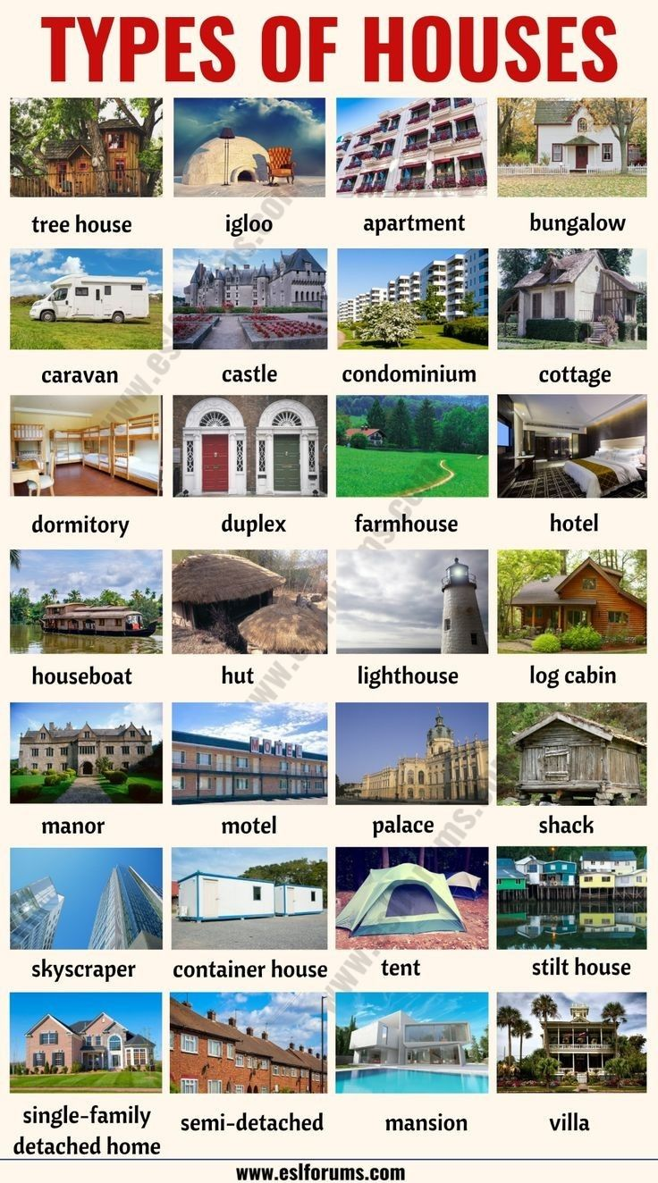

Vocabulary.
apartment building – многоквартирный дом (Am.E.)
block of flats – многоквартирный дом (Br.E.)
bungalow – бунгало
castle – замок
chalet – шале
condominium – кондоминиум
cottage – коттедж
detached house – особняк
flat/apartment – квартира
hotel – гостиница
housing – жилище
igloo – иглу
log cabin – бревенчатый дом
mansion – хоромы, усадьба
palace – дворец
penthouse – пентхаус
semi-detached house/ duplex house – двухквартирный дом; дом, поделенный на две части
tent – палатка
terraced house/rowhouse – таунхаус
tower block/apartment tower – многоэтажка
villa – вилла

Reading.

British people and their homes
British people love their homes and consider their home to be their castle. In the UK there are a lot of TV programmes about houses. One programme, called ‘Changing rooms’ is very popular. One family or couple takes a room in another family’s house and they change the look of the room. Sometimes they change it completely, changing the furniture and the style. Sometimes the people who live there are very happy with the new room, sometimes it does not suit their taste and they don’t like the changes at all.

Types of housing
There are various types of housing in Britain. These range from the traditional thatched cottages to modern blocks of flats in the cities. Houses are often described by the period they were built in, for example, Georgian, Victorian, 1930’s or post-war. They are also described by the type of house they are. A terraced house is a house joined to another house. A semi-detached house is two houses joined together. A detached house is a house which has no houses attached to it. A bungalow is a one story house, and the word comes from hindi, the Indian language. The word was introduced into Britain during the British occupation of India. British houses are also described by the number of bedrooms they have, e.g. 3 or 4 bedrooms.

British houses
British houses are usually built of brick. Semi-detached houses are usually in the suburbs, which are near the town centre. Terraced houses and blocks of flats are mostly in the town centre. These are often the inner city areas which have the poorest people and the highest crime. Although not always, it depends on whether it is a working class area, or a middle class area. Also the area may have changed over time from an area of rich people to an area of poor people. In such cases (for example, New Cross in London), the big Georgian and Victorian houses have been divided up into lots of flats. Where one large house would have had one family and some servants, it may now have 5-10 families. Most British people love gardens, and this is one reason why so many people prefer to live in houses rather than flats. Actually, about 80% of British people live in houses. About 67% of British people own their houses or flats. The rest are ‘renting’ i.e. living in rented accommodation.

Task 1. Match the beginning of each sentence in column A with its correct ending in column B.

A | B
1. British people love their homes and consider their home to be... | a. ...the period they were built in, for example, Georgian, Victorian, or post-war.
2. The programme ‘Changing rooms’ involves changing... | b. ...a detached house, which has no houses attached to it.
3. A terraced house is... | c. ...very popular in the UK and involves one family or couple changing another family’s room.
4. A bungalow is... | d. ...a house joined to another house.
5. British houses are often described by... | e. ...their home to be their castle.

Task 2: Complete the table
Complete the table with the correct information from the text.

Type of House | Description | Example
Terraced house
Semi-detached house
Detached house
Bungalow

Task 3: True or False?
- British people prefer living in flats rather than houses because of the gardens.
- The programme ‘Changing rooms’ is about changing the furniture and style of a room in a family’s house.
- Most British houses are built with wood.
- About 67% of British people own their homes or flats.
- British houses are always described by the number of bedrooms they have.

Task 4. Speaking+ Writing.
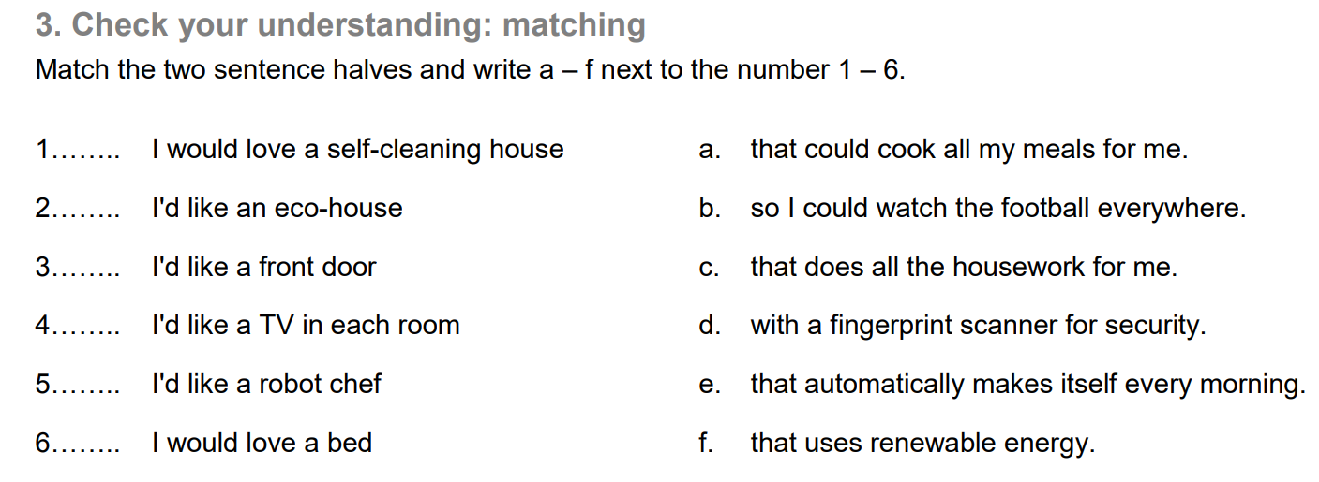

Imagine you can create your own dream house, think about the design and where it would be. What would your dream house be like? What gadgets would you like to have in it? Who would your ideal housemates be?
Present it to the class.
Task 5.
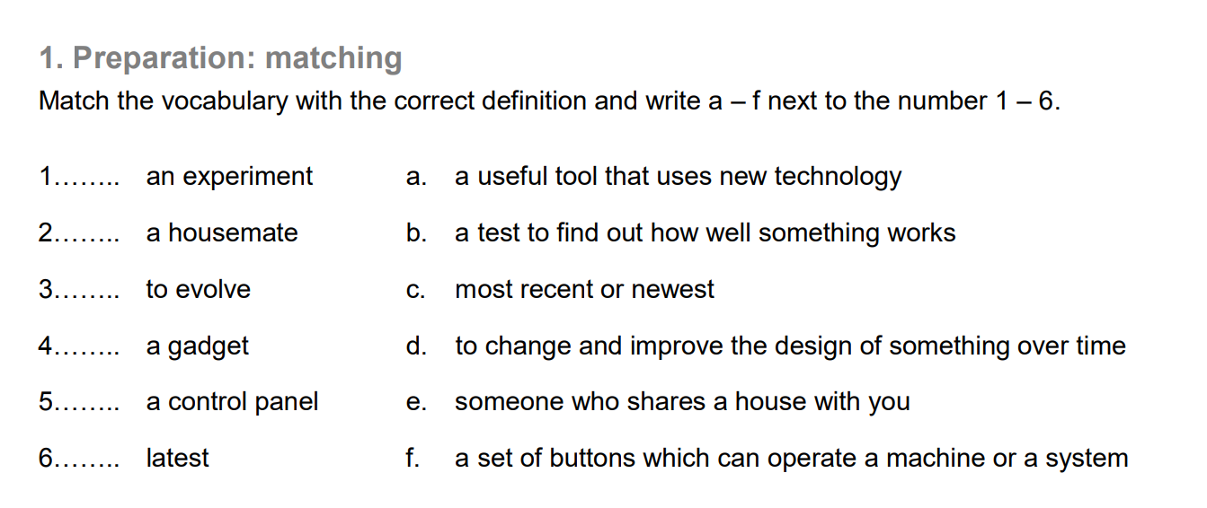

Grammar. Personal \ Possessive \ Reflexive \ Demonstrative\Relative and Indefinite Pronouns.
Practice.
Task 1. Complete the sentences. Choose the correct variant (a, b, с or d).
1. This is Laura. 's from New York.
a) I b) She c) You d) He
2. My name is Tom. ______ 'm from Scotland,
a) You b) She c) He d) I
3. This is John. 's a teacher.
a) He b) His c) She d) Her
4. I like fantasy tales. are so interesting.
a) I b) She c) They d) Their
5. Hi! I'm Irene and this is Yuri! are from Russia.
a) I b) He c)We d) You
6. I hate porridge. is not tasty at all.
a) She b) He c) I d) It
7. Is Tom from Oxford? No, isn't.
a) she b) he c) his d) it
8. «Where are from?» «We are from the USA»
a) you b) your c) we d) they
9. Emily Dickinson is a poet. is an American poet.
a) He b) She c) Her d) It
10. What do you like? like English songs.
a) You b) They c) I d) He

Task 2. Fill in the correct personal pronouns.
1. Where is my bike? I can't see ____________
2. Where's Nora? I've got a toy for _________
3. My best friend is Charles. I like _______ a lot.
4. Give me my dolls. I want _______back.
5. Our teacher is nice. She doesn't give a lot of homework.
6. I can't do this exercise. Can you help?
7. David, there is some apple juice for_________
8. I've got a sister. Everybody calls «Sweet»
9. Where are Ann and Sam? I've got some sweets for ______
10. Where's my book? I can't find _______

Task 3. Fill in the correct personal pronouns.
1. He wants to buy a present for ____(Wendy).
2. I want to buy a comic for_____ (Bob).
3. She eats ______(vegetables) every day.
4. What can I give _____(Sandra) to eat?
5. Dan's dog wants _____(the sausages) too.
6. He can't find______ (Ann).
7. I want to watch TV with _____ (David and Peter)
8. Can you help _____(Steve)?
9. She looks at _____(the boys) and smiles.
10. What is _______(the word) in English?

Task 4. Fill in the correct reflexive pronouns.
- The girl decorated the room.
- The winner looked very proud of.
- She brought up her children by.
- The cat is washing.
- The children enjoyed when they visited Disneyland.
- She was afraid of spiders, so she didn't go into the room by.
- She decided to do all the cooking .
- He was asked to behave at school.
- He shouted loudly to make understood.
- Cats are very clean animals: they are always washing.
- Doctors advised us that we have to exercise regularly in order to keep healthy.
- In your problem is nothing to worry about.
- She loves looking at in the mirror.
- If you don't behave , I shall put you all to bed early.
15. The music was so loud that I had to shout to make.
16. The teacher tried to make understood but she failed to get the class to understand.
- We painted the room .
- She was very pleased with when she got such a good job.
- I think I'd go back to France. We really enjoyed there.
- I don't feel today. I don't know what's wrong with me.

Task 5. Fill in that, who, whom, whose or which. (relative pronouns)
1. A journalist is someone writes for a newspaper.
2. A swimsuit is something you wear when you go swimming.
3. With are you talking?
4. I know did it.
5. eats must pay.
- She told everybody had happened to her.
- He is curious to know you were given.
- All was left for him to say was goodbye.
- We had a river in we could swim.
- I didn't hear she said.
- He laughs best laughs last.
- The night is so dark he can't see anything.
- A folk museum is a museum exhibits historic items of everyday use.
14. A shamrock is a plant _____is the national emblem of Ireland.
15. Show me _____you have in your hand.
16. A newsagent is someone _____sells newspapers.
17 Shepherd's pie is a hot dish _____contains meat, potato and carrots.
18. He knows someone can speak five languages.
19. This is a boy ____sister took part in the tennis championship.
20. A druggist is someone _____sells medicine in a shop.

Task 6. Underline the correct item. (indefinite pronouns)
- He didn't say (anything/nothing) to the police.
- (No one/ Anyone) was at home when I called.
- There was hardly (no one/anyone) at the party.
- 1 need (any/some) more milk for this cake.
- He can't find his sister (anywhere/nowhere).
- Are you going (nowhere/anywhere) for your holiday?
- John goes to sleep at 10 p.m. (any/every) evening.
- Call round (any/some) time you like.
- He needs (any/some) time to work out the answer.
- (Anybody/Nobody) told me you were leaving.
- (Anybody/Everybody) congratulated us.
- She goes to school (every/some) day. 13
- . Is there (everything/anything) good on at the cinema?
- Will you give them (nothing/some) homework tonight?
- I think there's (anything/something) wrong with his car.
- Ann isn't going (anywhere/nowhere) this weekend.
- He doesn't want (anything/nothing) in particular for his birthday.
- Shall I go and buy (some/anything) cheese?
- There is (nowhere/everywhere) in the world I'd like to visit more than England.
- She didn't buy (some/any) milk.

Task 7. Fill in this, that, these or those. (demonstrative pronouns)
1. I put ___________ book here.
2. is our teacher's car over there.
3. Look here. In newspaper there is a picture of my favorite sportsman.
4 The exercises on page here are not very difficult.
5. Please bring me T-shirts over there.
6. man over there is Ann's dad.
7. is a picture of my friend Ronnie here.
8. Let's play with balls here.
9. are buses over there.
10. ____ animals in cages here are wild.

Task 8. Fill in the correct demonstrative pronoun.
- Which flowers do you want? or ?
- Excuse me, is your bag?
3. They talked about ______and __________.
4. Which shoes do you like most? ______or_______?
5. _____'s why they accepted his proposal.
6. is Ann speaking.
7. After they decided not to come.
8. Do you recognize ___ man over there?
9. I'll take books.
- He's been waiting three weeks.
- She went to doctor and , no result.
12. day was the worst of his life.
13. I'm tired out. 's why I'm going home early.
- George likes Mary, but she doesn't like him. _____'s what annoys him.
- The engine starts and the light goes on. _____'s when you press the button.
- «They're getting engaged in April» « 's marvellous»
17. _____was the biggest mistake in his life.
18. «We're moving to London.» « 's fantastic!»
19. _____ is what I think.
20. Look! _____ are my classmates. We have been friends for more than 10 years.

Task 10. Fill in the correct possessive pronouns.
- This book belongs to me. This is book.
- The man put hand into pocket.
3. The cat ate food.
4. She took out purse and gave it to me.
5. My husband never wears glasses.
6. This is their car. That other car is too.
- May I introduce to you one of colleagues?
- There were a lot of people coming back from work.
9. Every season is beautiful in own way.
10. They would like a house of own.
11. I'll try best, I promise.
12. Each country has own customs.
13. He cut finger this evening.
14. Lend me pen, I've lost ______.
- They're going to London with some students of ______________
- This is not my pencil, is red.
- I haven't got a pen. Can you give me?
- Take off coat, please.
- I saw them. This is car.
- Ann is married. husband works in a bank.

Unit 16. ADVANTAGES & DISADVANTAGES OF GADGETS

Grammar: Modals\Degrees of comparison\ Adverbs\Prepositions
Vocabulary: Gadgets

How often do you use gadgets? Is it possible to live without them? Why?
What is your favorite electronic device? Why?

Discussion is small groups. What are advantages and disadvantages of using gadgets?
Read the text and study new collocations.
Advantages (= benefits)

Communication
Electronic gadgets have made communication easier and more accessible than ever before. With the advent of smartphones and social media, we can stay connected with our friends and family, no matter where they are in the world.

Convenience
Electronic gadgets have made our lives more convenient in many ways. For example, we can now shop online, pay bills, and book appointments from the comfort of our own homes, thanks to laptops and smartphones.
Smartwatches have added to this convenience by allowing us to track our fitness goals, control smart home devices, and even make payments, all from our wrists.

Productivity
They have also increased our productivity by making it easier to work on the go. Laptops and tablets have made it possible to work remotely, while smartphones have enabled us to stay connected with our colleagues and clients while on the move.
Smartwatches have added to this productivity by allowing us to check our emails and messages, manage our schedules, and even make voice notes, all without having to take out our phones or laptops.
Entertainment
Gadgets have also provided us with endless entertainment options. From movies and TV shows on our smartphones and laptops to playing games on our tablets, these gadgets have made it possible for us to access entertainment whenever and wherever we want.

Health and Fitness
Also, they have played a significant role in improving our health and fitness. Smartphones and fitness trackers have made it easier for us to track our physical activity and monitor our health. Smartwatches have taken this a step further by allowing us to track our heart rate, calories burned, and even monitor our sleep, all from our wrists.

Safety and Security
Electronic gadgets have also helped to increase our safety and security. For example, smartphones and home assistants can be used to call for help in case of an emergency, while smart home devices can be used to monitor our homes and alert us in case of any security breaches.

Disadvantages (= drawbacks)

Digital Addiction
With the constant access to social media, emails, and notifications, it’s easy to become addicted to our electronic gadgets. This addiction can lead to a decrease in productivity, increased stress and anxiety, and a lack of focus and concentration.

Cyberbullying
The rise of social media and electronic gadgets has also led to an increase in cyberbullying. This type of bullying can have a significant impact on mental health and well-being, leading to depression, anxiety, and even suicide in some cases.

Sedentary Lifestyle
While electronic gadgets have made it easier to track our physical activity and monitor our health, they have also led to a sedentary lifestyle.

Environmental Impact
The production and disposal of electronic gadgets have a significant impact on the environment. The use of non-renewable resources and the generation of electronic waste are just some of the ways in which electronic gadgets are contributing to environmental problems.
Despite these concerns, electronic gadgets continue to play an essential role in our daily lives. It’s up to us as individuals to use these gadgets in a responsible and mindful way, ensuring that we don’t fall into the traps of addiction or cyberbullying and that we take steps to minimize the impact on our environment.
Final Words:
In conclusion, electronic gadgets, including smartwatches, have become an essential part of our daily lives, offering us convenience, productivity, entertainment, health and fitness, safety, and security. However, we must also be aware of the challenges and concerns that come with the use of these gadgets, such as digital addiction, cyberbullying, a sedentary lifestyle, privacy concerns, and environmental impact. By using these gadgets responsibly and mindfully, we can enjoy their benefits while minimizing their negative impact on our lives and the environment.

Grammar. Consolidation.
Study the rule.

Positive form | Comparative form (than) | Superlative form (самый)
short adjectives
easy | easier | the easiest
hot | hotter | the hottest
large | larger | the largest
fast | faster | the fastest
cheap | cheaper | the cheapest
long adjectives
modern | more modern | the most modern
expensive | more expensive | the most expensive
easy-going | more easy-going | the most easy-going
challenging | more challenging | the most challenging
loudly | more loudly | the most loudly
slowly | more slowly | the most slowly
exceptions
much\many | more | the most
little | less | the least
Good (well) | better | the best
bad (badly) | worse | the worse
few | fewer | the fewest
old | older (elder) | the oldest (eldest)

Study the sentences.
  - Alina is taller than me.
  - We are more talkative than our friends.
  - He is the most hospitable person I have ever met.
  - When I was in California I realized that Los Angeles is the most expensive city I have ever been to.
  - Astana is one of the coldest cities he has ever lived in.
  - Who is the best student in the group?

Practice. Task 1. Write the corresponding adverb.
1. quick 6. careful 11. hard
2. bad 7. nice 12. slow
3. late 8. correct 13. happy
4. angry 9. fast 14. early
5. good 10. easy 15. Beautiful

Task 2. Adjective or adverb?
- Jane is very (quiet/quietly). She speaks very (quiet/quietly).
- Ann dresses (smart/smartly). She is very (smart/smartly).
- Our team played (bad/badly). It was a (bad/ badly) game.
- My mother is a (good/well) cook. She cooks (good/well).
- Tom is very (serious/seriously). He works (serious/seriously).
- Mike is a (fast/fastly) runner. He runs very (fast/fastly).
- She looked at me (angry/angrily). She was very (angry/angrily).
- Mary is a (slow/slowly) reader. She reads (slow/slowly).
- The bus was (late/lately). I came to school very (late/lately).
10. My sister is a (wonderful/wonderfully) singer.
11. She sings (wonderful/wonderfully).

Task 3. Adjective or adverb?
- Helen drives (careful/carefully).
- I'd like to speak English (good/well).
- Bob won a prize last week. He is very (happy/ happily).
- My dog eats very (quick/quickly).
- Richard is a very (careful/carefully) man.
- Could you speak (slow/slowly), please?
- You can travel from London to Paris very (easy/easily).
- She always speaks very (quiet/quietly).
- She's a very (well/good) dancer.
- He speaks English very (badly/bad).
- I thought that the test was very (easy/easily).
- She's got a (badly/bad) headache.
- Our town is always very (quiet/quietly). Nothing happens.
- My parents are very (healthy/healthily).
- Ann writes (correct/correctly).

Task 4. Adjective or adverb?
- Use this chair if you want to sit (comfortable/comfortably).
- It's not (easy/easily) to play football.
- These flowers smell so (strange/strangely).
- He talked so (polite/politely) and danced so (beautiful/beautifully).
- The apples taste (sweet/sweetly). Help yourself!
- I always feel (happy/happily) when the sun is shining.
- Let's discuss this idea (serious/seriously).
- «How are you?» «I am very (good/well), thank you»
- His English is (perfect/perfectly). He always speaks (correct/correctly).
- You look (upset/upsetly). What's the matter?
- The driver was driving too (fast/fastly).
- «I feel like going to a disco tonight» «That sounds (great/greatly)! Let's go»
- It rained very (heavy/heavily) in London last night.
- (Quiet/Quietly) he opened the door.
- Those oranges look (nice/nicely). Can I have one?

Task 5. Fill each of the gaps below with one of the following adverbs.

Carefully well badly quietly early hard
Fast regularly heavily late easily

1. We had to work very to finish in time.
2. I play the piano, but I don't play it very_______
3. He drove very , but he still arrived too for the meeting.
4. Could you speak , please? The baby is sleeping.
5. You are much better tennis player than me. When we play, you always win.
6. Think ________ before you answer the question.
7. We didn’t go out because it was raining ________.
8. Our team lost the game because we played very ______.
9. Mike keeps fit because he plays tennis________.
10. I was very tired yesterday, so I went to bed __________.

Task 6. Fill in prepositions : at, in, or on.
1. the morning
2. Sunday
8. midnight
1. November 9th
5. 7.30
6. Monday morning
7. Easter
8. 7.15
9. spring
10. 1949
11. noon
12. the 19th century
13. Saturday morning
14. a summer day
15. the weekend

Task 7. Prepositions of time. Complete the sentences with in, at or on.
- They don't go to school weekends.
- My birthday is _____ Thursday.
8. I do my homework _____ the afternoon.
- I have English lessons _____ Tuesdays.
- The British like watching TV _____their spare time.
- It is hot ______ summer.
- I have lunch ______ one o'clock.
8. We don't work a public holiday.
9. My birthday is April.
10. The film starts half an hour.

Task 8. Prepositions of place. Complete the sentences with in, at or on.
- I've got a computer home.
- Mr. Smith has got ten vipers his zoo.
- «Where is the book?» «It's the shelf.»
- Tom lives Scotland.
- There are three pictures the wall.
- A lot of animals live the world.
- My sister is the cinema town.
8. There is a swimming pool my area.
9. Ann wasn't school yesterday.
10. My father's car is the street.

Task 9. Fill in the correct prepositions at, behind, by, in, in front of, near, on, out of, under, of, to or for.
1. She met her friend a dance.
2. They live very Sam and Jane.
3. I wish she wouldn't drive so close me.
4. Please take your thumb your mouth.
5. «Where is my book?» « your bag»
6. Can I sit you?
7. At the theatre somebody tall always comes and sits me.
8. She's travelling the seven o'clock bus.
9. Have you looked table? It's really dirty.
- They usually travel train.
- He goes to school foot.
- They are afraid the dogs.
- What has happened her?
- They left Kiev Moscow.
- He arrived London at nine p.m. yesterday.

Task 10. Translate from Russian into English.
1. Смартфоны стали дешевле, чем десять лет назад.
2. Я считаю, что планшеты удобнее, чем обычные компьютеры.
3. Чем новее устройство, тем оно дороже.
4. Я уверен, что чем больше времени ты проводишь за экраном, тем уставшими становятся твои глаза.
5. Без сомнения, гаджеты делают нашу жизнь легче, но не всегда лучше.
6. Чем умнее телефон, тем быстрее садится батарея.
7. Использование гаджетов стало \ становится более популярным среди подростков.
8. Чем больше функций у телефона, тем он сложнее в использовании.
9. Мне кажется, смотреть видео на планшете веселее, чем читать книгу.
10. Чем чаще мы пользуемся технологиями, тем меньше мы общаемся вживую.
11. Некоторые считают, что ноутбуки полезнее, чем смартфоны.
12. Чем компактнее устройство, тем легче его носить с собой.
13. Современные гаджеты тоньше и легче, чем раньше.
14. Чем лучше интернет, тем быстрее ты можешь найти информацию.
15. Использование смартфона во время занятий – плохая идея.
16. Чем раньше дети начинают пользоваться гаджетами, тем больше рисков для здоровья.
17. Смотреть в экран ночью вреднее, чем днём.
18. Умные часы стали популярнее в последние годы. Я собираюсь купить себе такие.
19. Чем больше приложений установлено, тем больше памяти нужно.
20. Мне кажется, иногда гаджеты делают людей менее внимательными.

Unit 17. CULTURAL HERITAGE OF KAZAKHSTAN. CELEBRATION OF NAURYZ

Grammar: Passive Voice\ Reported Speech\ Tense revision
Vocabulary: topical vocabulary

Read the text and get ready for discussion.
Kazakhstan is one of the most ethnically and religiously diverse countries in the world. This is in part a result of its unique geography, located at the centre of Eurasia, as well as the settlement of European and Asian migrants throughout the 20th century. Ethnic and religious tolerance is deeply embedded into Kazakh culture, and the country's nomadic heritage is based upon principles of hospitality and openness.
Kazakhstan's culture has been greatly influenced by the country's nomadic history. Its rich and diverse past is reflected in local cuisine, music, film, literature, theatre, fashion, arts, religion and traditions.
The aims of cultural heritage are studying, restoration and preservation of historical and cultural heritage of the state, revival of historical and cultural traditions and propaganda of the heritage of Kazakhstan.
Cultural heritage includes tangible culture (such as buildings, monuments, landscapes, archive materials, books, works of art, and artifacts), intangible culture (such as folklore, traditions, language, and knowledge), and natural heritage (including culturally significant landscapes, and biodiversity).
Major cultural values of Kazakhs: respect for elders, peacefulness and tolerance, hospitality and desire to live in harmony with surrounding world. Kazakh traditions require a guest to be filled with tea and well fed.
National heritage is very important as it connects to ancestors and provides a cultural framework that helps to understand the place in the world.
Kazakhstan's diverse society is an integral part of the national identity. The First President and Leader of the Nation Nursultan Nazarbayev has said that “the huge potential for integration into Kazakh culture for every ethnic group of the country may be realized only through the open character of the Kazakh culture itself".

Task 1. Find the phrases below in the text.
  - религиозно-разнообразный
  - этническая и религиозная терпимость
  - кочевое наследие страны
  - местная кухня(еда)
  - восстановление и сохранение исторического наследия
  - материальная культура
  - главные культурные ценности
  - уважение к старшим
  - миролюбие, общительность, гостеприимство
  - в гармонии с окружающим миром
  - связывать с предками
  - национальная идентичность

What is the most important Kazakhstan holiday?
Nauryz remains one of the most important national holidays of Kazakhstan, where Kazakhs celebrate in their own unique way as they seek to preserve as many traditions passed down from their ancestors as possible and it marks the beginning of a New Year. It is celebrated several days starting from 21st of March, the day of the spring equinox. Nauryz means 'new day', it is celebrated in the Great Steppes from ancient times.
This holiday symbolizes fertility, friendship and love. On this special people dress up, visit close friends and family and make good wishes to everyone around them. Thousands of years ago on this day it was customary to clean up the house, clear irrigation canals or water sources, prepare a traditional dish of seven ingredients, gather together under one roof by a large family and have fun until late.

Grammar. Passive Voice.
Study the rule.

BE + Verb3\ed

В страдательном залоге обычно не важно кто совершает действия, важен факт.

Мы всегда приглашаем много гостей на вечеринку.
We always invite many guest for the party.

На вечеринку приглашается много гостей.
Many guests are invited for the party. (by us)

Действительный залог (Active Voice) | Страдательный залог (Passive Voice)
The news surprise me.  The news surprise Nick. (Present Simple)  The news surprise us. | I am surprised by the news .  Nick is surprised by the news.  We are surprised by the news.
The news surprised me.  The news surprised us. (Past Simple) | I was surprised by the news.  We were surprised by the news.
Tanya has posted the letter. (Present Perfect)  Tanya has posted the letters. | The letter has been posted by Tanya.  The letters have been posted by Tanya.
Olga will post the letter. (Future Simple) | The letter will be posted by Olga.
The doctor is examining him now. (Pr.Cont) | He is being examined now (by the doctor)
When we moved to Moscow, they were building a new metro line in the city. (Past Cont) | When we moved to Moscow, a new metro line was being built in the city.

Can
Must + BE + Verb3\ed
Should
May
Compare.
- Я рассказываю – I tell
- Мне рассказывают – I am told

- Вы показываете – You show
- Вам показывают – You are shown

- Дети купят – Children will buy
- Детям купят – Children will be bought

- Мы любим и уважаем – We love and respect
- Нас любят и уважают – We are loved and respected

- Они не помогли – They didn’t`t help
- Им не помогли – They weren`t helped

- Ты должен мыть руки – You must wash hands
- Руки нужно мыть – Hands must be washed

Study the examples.
- English is spoken all over the world. На английском говорят во всем мире.
- A lot of new skyscrapers were built last year. Много небоскрёбов было построено в прошлом году.
- Will you be informed about the changes in the system of education? Вас проинформируют об изменениях в системе образования?
- These books were written by his grandfather. Эти книги были написаны моим дедушкой.
- We will be given high score if we finish in time. Нам дадут высокие баллы если мы закончим вовремя.
- This presentation can be presented in any language. Эту презентацию можно показать на любом языке.

Practice. Task 1. Turn from Active into Passive.
- The gardener watered the flowers a few hours ago.
- They speak English in the USA.
- Bell invented the telephone.
- Will you use this machine for cutting cheese?
- He sent her some roses.
- The police arrested him.
- The Queen opened the new library.
- He will keep the animal in the cage.
- He painted the walls yesterday.
- Baird invented TV.
- Egyptians built Pyramids.
- My friend sent me a greeting card.
- His uncle painted the picture.
- A young actress will play a leading role.
- People play football all over the world.

Task 2. Complete the sentences using a suitable passive form of the verb in brackets.
- You (take) ____around the city tomorrow.
- He (impress) _____by the story at our last meeting.
- In 1980 the Olympic games (hold) _____ in Moscow.
- The examination (hold) ____next Friday.
- The streets (decorate) _____next Saturday.
- The translation (do) _____in time. Everyone was glad.
- We (impress) _____by her acting at her last concert.
- Your shirt must (clean)______.
- Your health can (improve) _____with more exercise.
- The room must (leave) _____immediately.
- The plants should (water) _____every week.
- The letters (send) _____this week.
- Teenagers (discuss) ____this topic next lesson.
- The car (wash) ____in 2 hours?

Task 3. Rewrite these sentences. Instead of using somebody, they, people etc., write a passive sentence.
- Somebody cleans the room every day.
→ The room is cleaned every day.
- They cancelled all flights because of fog.
→ All ________________________
- People don’t use this road much.
→___________________________
- Somebody accused me of stealing money.
→ I ___________________________
- How do people learn languages?
→ How ____________________
- People warned us not to go out alone.
_______________________________
Task 4. Complete the sentences using one of these verbs in the correct form, present or past:

Cause damage hold show invite make overtake surround translate write

- Many accidents __________ by dangerous driving.
- Cheese __________ from milk.
- The roof of the building __________ in a storm a few days ago.
- You __________ to the wedding. Why didn’t you go?
- A cinema is a place where films __________.
- In the United States, elections for president __________ every four years.
- Originally the book __________ in Spanish, and a few years ago it __________ into English.
- Although we were driving fast, we __________ by a lot of other cars.
- You can’t see the house from the road. It __________ by trees.

Task 5. Write questions using the passive. Some are present and some are past.
- Ask about glass. (how / make?)
- Ask about television. (when / invent?)
- Ask about mountains. (how / form?)
- Ask about antibiotics. (when / discover?)
- Ask about silver. (what / use for?)

Reported Speech
- Reported Speech (also called Indirect Speech) is when we report what someone said without
quoting their exact words.

✅ Direct Speech: «I’m tired» she said.
✅ Reported Speech: She said (that) she was tired. (ONE TENSE BACK)

We usually change the tense, pronouns, and time expressions when moving from direct to reported speech.🔄
ONE TENSE BACK
- Present Simple changes into Past Simple
- Present Continuous into Past Continuous
- Present Perfect into Past Perfect
- Past Simple into Past Perfect
- Future simple – Future in the Past (would)
- Can – could
- Must – had to (must)
- May – might
- Will – would

- Direct Speech – «I am happy»
Reported Speech – She said she was happy.
- «I have seen it» – He said he had seen it.
- «I will call you» – She said she would call me.
- «I can help you» – He said he could help me.
- «We have just had our breakfast» – They said that they had just had their breakfast.

Time expressions also change:
- Today – that day
- Tomorrow – the next day
- Yesterday – the day before
- Now – then
- next week – the following week
- last night – the night before

- Reporting Commands / Requests Use asked/told + infinitive
«Sit down» → She told me to sit down.
«Please help me» → He asked me to help him.

Use not to for negative commands:
«Don’t touch that» → She told me not to touch that.

3) Reporting Questions

Yes/No Questions: – Use if or whether
«Do you like coffee?» → She asked if I liked coffee.
«Have you been there?» → He asked whether I had been there.

Wh – Questions: – Use the question word (what, where, why, etc.)
«Where do you live?» → She asked where I lived.
«Why are you late?» → He asked why I was late.
❗ No question word order — the word order becomes like a statement in reported speech.

Practice. Task 1. Rewrite the sentences in reported speech.
1. Anna said, «I am learning English»
2. Tom said, «I watched that movie yesterday»
3. Emma said, «I will call you tomorrow»
4. Jack said, «I have finished my homework»
5. Lisa said, «I can’t come to the party»
6. Mark said, «We are meeting at 6 p.m»
7. Kate said, «I don’t like sushi»
8. Alex said, «They were working late»»
9. Mia said, «I saw you last week»
10. David said, «I must leave now»

Task 2. Rewrite the sentences using reported speech.
1. «Close the window» he said.
2. «Please help me» she said.
3. «Don’t be late» the teacher said.
4. «Call me tonight» he said.
5. «Don’t forget your homework» she said.
6. «Be quiet» the librarian said.
7. «Turn off the lights» he told her.
8. «Please wait here» the receptionist said.
9. «Don’t touch that!» she said.
10. «Take a seat» the manager said.

Task 3. There is one mistake in each sentence. Find and correct it.
1. She said she is tired.
2. He told me that he will come tomorrow.
3. They said they has seen the movie.
4. She asked where did I live.
5. He said me to sit down.
6. She asked if I can help her.
7. He said that he don’t like coffee.
8. I told him don’t be late.
9. She said that she goes to the gym.
10. He asked me what time does it start.

Task 4. Rewrite the questions in reported speech.
1. «Do you like music?» she asked me.
2. «Where do you live?» he asked.
3. «Have you ever been to London?» she asked.
4. «Why are you crying?» he asked her.
5. «Did you finish the report?» she asked him.
6. «What time does the train arrive?» they asked.
7. «Can you help me?» he asked.
8. «When will you be ready?» she asked.
9. «Are you coming to the meeting?» he asked.
10. «How long have you known him?» she asked.

Task 5. Translate into reported speech in English.
1. Она сказала, что устала.
2. Он сказал, что приедет на следующей неделе.
3. Она спросила, люблю ли я читать книги.
4. Учитель сказал нам не опаздывать.
5. Мама сказала, что приготовила ужин.
6. Он спросил, где я был вчера.
7. Она сказала, что не может найти ключи.
8. Он попросил меня выключить свет.
9. Я сказала, что я была занята.
10. Она спросила, поеду ли я в Лондон летом.

Unit 18. STATE STRUCTURE OF THE REPUBLIC OF
KAZAKHSTAN & THE UNITED KINGDOM

Grammar: Active & Passive Voice\ Tense Revision
Vocabulary: topical vocabulary

Political System of the Republic of Kazakhstan

Governmental Bodies | Description
President | Head of state, the highest executive authority, commander-in-chief of the armed forces.
Parliament | A bicameral body: Senate and Mazhilis. It develops and adopts laws and supervises the executive branch.
Government | Executive body led by the Prime Minister. It implements policies based on laws.
Judiciary | The system of courts, including the Constitutional Court, Supreme Court, and local courts. It ensures justice based on the law.
Local Self-Government | Local authorities governing regions and cities.

Political System of the United Kingdom
Governmental Bodies | Description
Monarch | A symbolic head of state with limited powers.
Parliament | A bicameral body: House of Commons (elected representatives) and House of Lords (appointed members).
Prime Minister | Head of government, forms the cabinet and leads the executive branch.
Judiciary | The Supreme Court, civil and criminal courts ensuring rule of law.
Local Government | Local authorities at county and city levels responsible for managing services.

Key Legal Institutions

Republic of Kazakhstan
- Constitution – The supreme law defining the political system, citizens' rights, and the powers of government bodies.
- Judicial System – Independent courts, including the Constitutional Court, the Supreme Court, and local courts.
- Legislation – Laws passed by Parliament and signed by the President.
- Prosecution – The body overseeing the legality of actions and representing the state in court.
United Kingdom
- Constitution – Uncodified, composed of statutes, case law, and conventions.
- Judicial System – Independent courts, including the Supreme Court, appellate courts, and courts of first instance.
- Legislation – Laws enacted by Parliament, including Acts, resolutions, and conventions.
- Prosecution – In the UK, prosecution is more limited, as the system focuses on private legal actions and barristers.

Task 1: Write a brief description of the key governmental bodies in each country. Use the table to compare the functions of each body. Indicate which body is the highest authority in each system.
Governmental Body | Kazakhstan | United Kingdom | Key Functions | Highest Authority
Head of State | President of Kazakhstan | Monarch (King/  Queen) | Represents the state, ceremonial duties, commander-in-chief (Kazakhstan), symbolic head (UK). | President of  Kazakhstan  (Kazakhstan) / Monarch (UK)
Executive Body | Government (Prime Minister and Cabinet) | Prime Minister and Cabinet | Implements laws and policies, oversees government administration. | Prime Minister (UK) / Government (Kazakhstan)
Legislative Body | Parliament (Senate and Mazhilis) | Parliament (House of Commons and House of Lords) | Passes laws, supervises the executive, and represents the people. | Parliament (both)
Judiciary | Supreme Court, Constitutional Court, local courts | Supreme Court, High Court, Crown Court | Interprets and applies the law, ensures justice and fairness. | Supreme Court (both)
Prosecution | Public Prosecutor's Office | Crown Prosecution Service (CPS) | Oversees criminal prosecution, ensures rule of law. | Public Prosecutor’s Office (Kazakhstan) / CPS (UK)

Reading comprehension
The Republic of Kazakhstan
Kazakhstan is a unitary republic with a presidential system. The President serves as both the head of state and the commander-in-chief of the armed forces. The President is elected by popular vote for a five-year term and holds significant executive powers, including appointing the Prime Minister and other key officials.
Kazakhstan’s government is based on the principle of the separation of powers among three branches: executive, legislative, and judicial.
- Executive Branch: Headed by the President, it includes the Prime Minister, deputy prime ministers, and ministers. The executive branch enforces laws and manages internal and foreign policies. The government is responsible for executing national economic and social policies.
- Legislative Branch: The Parliament is bicameral, consisting of two houses:
– Senate: The upper house has 49 members. Some are elected by local representative bodies called mäslihats, while others are appointed by the President. Senators serve six-year terms.
– Mäjilis: The lower house comprises 98 members elected for five-year terms. Elections use a mixed system: 69 members are chosen through proportional representation from party lists, and 29 are elected from single-member districts. The Mäjilis is responsible for initiating legislation and approving the national budget.
- Judicial Branch: The judicial system is independent and protects the rights and freedoms of citizens. The Supreme Court is the highest judicial body in civil, criminal, and administrative cases. The Constitutional Court ensures that laws and regulations comply with the Constitution. Judges are appointed by the President with the approval of the Senate.
The United Kingdom
The United Kingdom (UK) is a constitutional monarchy with a parliamentary democracy. The monarch, King Charles III as of 2025, serves as the ceremonial head of state, while the Prime Minister is the head of government.
The UK's Parliament is also bicameral:
- House of Commons: This is the lower house, consisting of Members of Parliament (MPs) elected by the public in general elections. The leader of the majority party in the House of Commons is invited by the monarch to become the Prime Minister.
- House of Lords: The upper house is made up of appointed members, including life peers, bishops, and hereditary peers. As of 2025, there are ongoing discussions about reforming the House of Lords to enhance its democratic legitimacy.
The UK has a system of devolution, granting certain legislative powers to regional governments in Scotland, Wales, and Northern Ireland. Each has its own parliament or assembly responsible for specific areas like education and health.

Key Differences
– Head of State: Kazakhstan's President holds significant executive power, whereas the UK's monarch has a ceremonial role with limited political authority.
– Government Structure: Kazakhstan operates a presidential system, concentrating executive power in the presidency. The UK employs a parliamentary system where the executive branch derives its legitimacy from the legislature.
– Devolution: The UK has devolved powers to regional governments, allowing for localized decision-making. Kazakhstan remains a unitary state with centralized authority.

Vocabulary
- Unitary Republic – Унитарная республика
- Presidential System – Президентская система
- Bicameral – Двухпалатный
- Proportional Representation – Пропорциональное представительство
- Single-Member District – Одномандатный округ
- Constitutional Monarchy – Конституционная монархия
- Devolution – Передача полномочий

Task 2. Translate the following terms into Russian:
  - Head of State
  - Legislative Branch
  - General Elections
  - Ceremonial Role
  - Regional Governments

Task 3. Complete the sentences:
- In Kazakhstan, the __________ is both the head of state and holds executive power.
- The UK's Parliament consists of the House of Commons and the House of __________.
- Members of the Mäjilis are elected for a term of __________ years.
- Devolution in the UK grants powers to __________ governments.
- The President of Kazakhstan appoints the __________ Minister.

Task 4. Answer the questions:
  - Who is the ceremonial head of state in the United Kingdom?
  - How many members are there in Kazakhstan's Mäjilis?
  - What is the term length for a Senator in Kazakhstan?
  - Which house of the UK Parliament is elected by the public?
  - What system does Kazakhstan use to elect Mäjilis members?
  - What is the role of the Prime Minister in the UK?
  - Does Kazakhstan have a system of devolution like the UK?
  - Who appoints some of the members of Kazakhstan's Senate?
  - What type of government system does the UK have?
  - In which house of Kazakhstan's Parliament can legislation be initiated?

Task 5. Instructions:
– Use the table to describe each governmental body briefly for Kazakhstan and the UK.
– Fill in the column for "Key Functions" by providing a short summary of the roles and responsibilities of each body.
– Indicate in the last column which body is the highest authority in each system.

Practice. Grammar. Revision.

Task 1. Choose the correct answer.
1. ___ is happy.
a) I b) You c) He
2. Hello, I'm Mike and this ___my sister Joan.
a) is b) are c) be
3. He in Moscow. He lives in St. Petersburg.
a) isn't live b) not lives c) doesn't live
4. ____ English?
a) Speak you b) Do you speak c) Does you speak
5. Look! The bus _____.
a) is comeing b) is coming c) comes
6. ____enjoying the concert?
a) Are you b) Do you c) Is you
7. I his name.
a) doesn't know b) don't know c) am not knowing
8. Bill ____ at home last weekend.
a) wasn't b) isn't c) weren't
9. She _____ me some beautiful flowers yesterday.
a) gived b) gave c) gives
10. Look! Your letter ______.
a) has came b) has come c) have come
11. Have you ______ to Australia?
a) ever been b) been ever c) ever went
12. Look! _____ rain.
a) It going b) It's going c) It's going to
13. _____ buy you a newspaper?
a) Shall you b) Shall I c) Will you
14. to New York on Sunday.
a) I'm fly b) I'm flying c) I will flying
15. He ____ any money.
a) doesn't have b) don't have c) doesn't has
16. Where _____?
a) is Mike live b) lives Mike c) does Mike live
17. What _______ at school?
a) studied you b) are you study c) did you study
18. ______books are those?
a) Whose b) Who's c) Who
19. "Is she British?" "Yes,_____."
a) she does b) she did c) she is
20. Paul _____ ski well when he was young.
a) can't b) could c) can
21. ______ open the window, please?
a) May you b) Could you to c) Could you
22. They have a flat ________the second floor.
a) on b) in c) at
23. I always go skiing _____________ winter.
a) at b) on c) in
24. London is_____ European city.
a) an b) the c) a
25. There are two _______in the car.
a) men b) mans c) man
26. She's gone to the shops to buy _______sugar.
a) any b) some c) no
27. London is _______ Glasgow.
a) bigger than b) more big than c) bigger more than
28. Mount Everest is ______ mountain in the world.
a) the higher b) the highest c) highest
29. The team played ______.
a) well b) good c) goodly
30. Would you like _______ sandwiches?
a) many b) a few c) a little

Task 2. Choose the correct answer.
1. Excuse me, ________ Mr and Mrs Jones?
a) is b) are you c) can d) do
2. There _______ two cinemas in our town.
a) am b) be c) are d) is
3. Do you ________________English?
a) speak b) speaking c) spoke d) speaks
4. Kate up at seven o'clock.
a) does get b) get c) getting d) gets
5. _______you dance?
a) Can b) Can't c) Cannot d) Do can
6. _______you ________any children?
a) Have/got b) Does/have c) Has/got d) Do/got
7. I usually ________ breakfast in the morning.
a) had b) have c) Had/got d) Has/got
8. Where you yesterday evening?
a) do b) were c) did d) went
9. ______she _______ a cigarette last night?
a) Does/have b) Has/got c) Did/have d) Had/got
10. They to London last week.
a) go b) went c) visited d) did go
11. What are you _________?
a) are b) doing c) do d) did
12.We ____ friends to stay next weekend.
a) are go to have b) have c) are going to have d) going to
13. I often ____ to the gym after school.
a) am going b) goes c) go d) going
14. Watching TV is_____ going to the cinema.
a) better than b) good than c) good d) better
15. Look at the clouds. It's _______to rain.
a) raining b) looking c) going d) can
16. Listen! Somebody ______.
a) sings b) sing c) is singing d) sang
17. The train leaves ________9 o'clock.
a) in b) on c) from d) at
18. He often listens _______ the BBC programme.
a) to b) in c) on d)-
19. Last month we _______ our granny.
a) are visiting b) visit c) visited d) have visited.
20. If him tomorrow, I'll tell him about your request.
a) I'll see b) I see c) I saw d) I won't see
21. This is the _______ book I've ever read.
a) worse b) interesting c) baddest d) most interesting
22. You______ open the window if you want.
a) need b) can't c) may d) must
23. Oh, look! _______ something under the table.
a) It is b) There is c) There are d) They are
24. We always speak to_______.
a) us b) her c) they d) his
25. Excuse me, can I ask you _______question?
a) a b) an c) the d) -
26. “Are they still having dinner?” “No, they ______just ______ __.”
a) will ... finish b) have ... finished c) has ... finished d) had ... finished
27. Can you tell me _____ time, please?
a) a b) an c) the d)-
28. Next year I ________ sixteen years old.
a) am b) was c) have been d) '11 be
29. My mother wants me _______ my room.
a) will clean b) clean c) to clean d) cleaning
30. This play ______ __ by Shakespeare.
a) wrote b) writes c) has written d) was written

Task 3. Choose the correct answer.
1. We're very close friends but we don't see ________very often.
a) the other b) ourselves c) each d) each other
2. Look at the baby! The baby________.
a) walks b) walk c) walked d) is walking
3. I don't look like ______ _ my father nor my mother.
a) either b) both c) neither d) or
4. "What _________ after classes today?" «Nothing special»
a) do you do b) you doing c) are you doing d) do you
5. This coffee is _________.
a) strong not enough b) not strong enough c) not enough strong d) a lot strong
6. I forgot ________ _my umbrella this morning.
a) taking b) to take c) took d) to taking
7.I ______ eat meat but I like it now.
a) didn't use b) didn't used c) didn't used to d) didn't use to
8. Young people are fond ______ music.
a) at b) by c) of d) in
9. Next year I hope I will _______speak English more fluently.
a) can b) be able c) could d) be able to
10. We were very late and the meeting ________ _ten minutes before we arrived,
a) started b) was staring c) had started d) has started
11. It's Sunday, so I __ _______go to work.
a) mustn't b) don't have to c) shouldn't to d) mustn't to
12. ______it was raining, we played tennis.
a) However b) As well c) Although d) On the other hand
13. He went to school _________last year.
a) in b) on c) of d) –
14. The Vikings ________ to Britain in 793.
a) come b) comes c) came d) have come
15. You would have a great time if you ____ ____to the party.
a) would go b) go c) will go d) went
16. This dictionary is ______than any other I have ever used.
a) good b) better c) the best d) bad
17. we do exercise two?" "No, you needn't."
a) do b) can c) may d) must
18. ______ many tasty things in my fridge.
a) there is b) there are c) this is d) they are
19. What shall we do if it _______ _?
a) will rain b) rain c) rains d) rained
20. It's not your mistake, it's ________.
a) your b) your s c) their d) theirs
21. Britain is ________ island.
a) a b) an c) the d)-
22. He to London next summer.
a) goes b) went c) will go d) has gone
23. Where is _______bag? I can't find it anywhere.
a) a b) an c) the d)-
24. ______ you ever ________this film?
a) Do ... see b) Did ... see c) Have ... seen d) Had ... seen
25. You like coffee, _______ _?
a) don't you b) aren't you c) like you d) isn't it
26. I this book by my friend.
a) give b) gave c) have given d) was given
27. I was busy at 6 o'clock yesterday, I ____ _____a composition.
a) wrote b) was writing c) have written d) had written
28. When it is foggy you should drive _____.
a) slow b) fast c) slowly d) fastly
29. You should go to the shop. We haven't got ______ bread at home.
a) any b) some c) no d) little
30. John, can you wait _________minutes?
a) a lot of b) a few c) a little d) few

Task 4. Complete the sentences with a/an, the or a zero article.
Jack is (1) ___ marketing consultant. He works in (2) office in (3) centre of Oxford. It is (4) ____industrial town in (5) ____north of England. He always goes to (6) work by car in (7)___ morning because there is (8) lot of traffic in (9) city. His company has got (10) office in Paris.

Task 5. Complete the sentences with so or because.
1. Peter doesn't speak French he's having lessons.
2. She's going to save money she wants to go on holiday.
3. Her flat is too small she's going to move.
4. He's going to wear a coat it's cold outside.
5. She's doing the room her mother is coming to stay.
6. He's going to have breakfast now ___________he can start work early.

Task 6. Find the mistakes in these sentences. Rewrite them correctly.
1. Tennis is most difficult than golf.
2. Football is the interestingest game in the world.
3. French is easiest than German.
4. The population in my country is the larger in Europe.
5. It's wet in Siberia than in Europe.
6. The weather in Europe is gooder than the weather in Britain.

Task 7. Match the two parts of the sentences.
1. I've got ... a. ...all right?
2. I don't feel... b. ...very well.
3. What's... c. …go to bed if you feel sick
4. You should... d. ...call the doctor?
5. Are you... e. ...the matter?
6. Do you ever ... f. ...a terrible headache.

Unit 19. THE SYSTEM OF EDUCATION IN KAZAKHSTAN AND GREAT BRITAIN

Grammar: Present Perfect & Past Simple
Vocabulary: topical vocabulary

Discuss. What do you know about education abroad? Have you ever thought of studying in another country? Where would you study?

Differences Between the Education System in Kazakhstan and the United Kingdom
Structure of Education
Kazakhstan: The education system includes kindergarten (optional), primary school (grades 1-4), basic secondary (grades 5-9), and upper secondary (grades 10-11 or college). University follows after.
UK: Children start with primary school (ages 5-11), then move to secondary school (ages 11-16). After that, students can choose to continue with A-levels or vocational training until age 18, followed by university.
Language of Instruction
Kazakhstan: Lessons are typically in Kazakh or Russian, though trilingual education (Kazakh, Russian, English) is becoming more popular.
UK: The language of instruction is English across all levels.
Curriculum Flexibility
Kazakhstan: The curriculum is more centralized and standardized by the Ministry of Education.
UK: Schools have more freedom in designing their curriculum, especially private and independent schools.
Examinations
Kazakhstan: Students take the Unified National Test (UNT) at the end of school to enter university.
UK: Students take GCSEs at 16, and A-levels (or alternatives like BTECs) at 18 before applying to university.
University Admission
Kazakhstan: Admission is largely based on UNT scores and state grants (educational grants are highly competitive).
UK: Admission is based on A-level results, personal statements, references, and sometimes interviews (especially at Oxford or Cambridge).
Tuition and Funding
Kazakhstan: Many students aim for government-funded places, but there are also private universities. Tuition fees are generally lower.
UK: Higher education is expensive, and most students take out student loans. Scholarships are available, but competition is tough.
Cultural Aspects
Kazakhstan: Education is highly valued, with strong family involvement and focus on traditional values.
UK: There’s more emphasis on developing critical thinking, creativity, and independent learning from an early age.

Comparison of the Education Systems: Kazakhstan vs the UK
Aspect | Kazakhstan | United Kingdom
Structure | Kindergarten (optional), Primary (1-4), Secondary (5-11), University | Primary (ages 5-11), Secondary (11-16), A-levels/College University
Language of Instruction | Kazakh or Russian (increasing focus on trilingual: Kazakh, Russian, English) | English
Curriculum | Centralized, government-controlled | More flexible, especially in private schools
Examinations | Unified National Test (UNT) for university admission | GCSEs at 16, A-levels/BTECs at 18
University Admission | Based on UNT scores and state grants | Based on A-levels, personal statement
Tuition & Funding | State grants available, lower tuition fees | High tuition fees, student loans common, scholarships available

Do the exercise below.
1. Match the fact . Read each statement and decide which country it describes:
Kazakhstan, the UK, or Both
Write your answer next to each sentence.
1 Students take A-levels before university
2 The system includes a Unified Natioal Test
3 The main language of instructions is English
4 Education is becoming more trillingual.
5 University admission considers personal statements and interviews.

2. True or False
Read the statements below. Mark them True or False. If False, correct the statement.
1 Kazakhstan has a more flexible curriculum than the UK.
2 In the UK, school education lasts longer than in Kazakhstan.
3 Both countries have centralized education systems.
4 Students in the UK take the UNT to enter university.
5 Education in Kazakhstan focuses more on critical thinking.

Task 3. Debate/Speaking task
Topic: Which education system is better for preparing students for a real life?
Work in pairs or in a group. Choose a side (Kazakhstan or the UK) and discuss the advantages.
Use phrases like:
– On the one hand
– In my opinion…
– Compared to
– I believe that…

Task 4. Complete the sentence using words from the box below:
Words: A-levels, curriculum, GCSEs, UNT, tuition
1.In the UK, students take ______ at the age of 16, and _______ at 18.
2. In Kazakhstan, university admission is based on the _______.
3 The _______ in Kazakhstan is more centralized than in the UK.
4 University_____ is higher in the UK compared to Kazakhstan.

Task 5. Creative Task
Imagine you are the Minister of Education in Kazakhstan.
Which three features from the UK education system would you introduce in your country?
Write 3-5 sentences explaining your choices.

Grammar. Study the rule. Present Perfect Tense

Утвердительная форма | Вопросительная форма | Отрицательная форма
I / We / You / They have (‘ve) arrived / been / gone | Have I / we / you / they arrived? / been? / gone? | I / We / You / They have not (haven’t) arrived / been / gone
He / She / It has (‘s) arrived / been / gone | Has he / she / it arrived? / been? / gone? | He / She / It has not (hasn’t) arrived / been / gone
We’ve just arrived at the station.  They’ve been here for a month.  He’s done the task. | Have you just arrived at the station?  Have you been here for a month?  Has he already done the task? | We haven’t arrived at the station yet.  They haven’t been here for a month.  He hasn’t done the task yet

1. Опыт (Experience) – мы не говорим когда, но говорим что произошло
- I have been to Paris twice.
- She has tried sushi and she liked it.
- Have you ever ridden a horse?

✅ Важно: Мы не указываем точное время (не yesterday, не last year), только жизненный опыт.

2. Результат к настоящему моменту
- He has lost his keys. (= Now he can’t open the door.)
- I have broken my phone. (= It’s broken now.)
- We haven’t finished yet. (we can`t go out now.)

✅ Действие завершилось, а результат ощущается сейчас.

3. Действие, начавшееся в прошлом и продолжается до сих пор
- I have lived in Almaty for 5 years.
- She has worked here since 2020.
- We have been known each other since we met in Turkey.

✅ Используем с: for (в течение), since (с какого-то момента).

Prompts (подсказки) : already, just, yet, ever, never, for, since, recently, lately, for a long time, today, this week\month\year, twice, many times.
Examples:
- I have been to the USA twice.
- I`ve always loved\liked speaking in front of the audience.
- I have always wanted to go hiking in Almaty.
- She has always wanted to live and study overseas = abroad
- They haven`t done the presentation yet.

Practice. Task 1. Open the brackets.
1 Jack (pass) the interview and he’s very happy. 2. I'm afraid the manager not (come) yet.
3. Thank you for everything rhat you (do) for us . 4 I already (study) the telexes from Paris and
1 (write) the answers. 5. I'm afraid he (forget) that you are waiting for him. 6. You (have) dinner yet? 7. I not (sce) my boss this week. He (fall ill). 8. They just (call) and (invite) us to lunch.
9. – Where is Mr. Green? – He (go) to the bank 10. My little cousin already (learn) to read. 11. No news (come) yet from our office in London. 12. Someone (eat) all the cakes and I not even (taste) one! 13. Remember that your children already (grow up). 14. This Hollywood star (live) a long and interesting life. 15. I not (look through) my favourite magazine yet. 16. My mother (throw away) the yogurt. It's too old. 17. I (cut) my finger badly.It hurts. 18. She already (make) different sandwiches for lunch.They are on the plates. 19. She (be) very lonely lately. 20. We not (meet) recently. We (be) very busy lately.

Task 2. Make questions.
Example: You, play, football? – Have you ever played football? – I have never played football.

1. Your friend, invite, his /her house? 2. You, be, the North Pole? 3. She, use, the Internet?
4. You, lose, keys? 5. You, be late, for the plane? 6. Your son, have, pets? 7. You, write, poems?
8. You, play, music group? 9. You, eat, snakes (frogs, snails, ...)? 10. Your parents, give, good pocket money? 11. You, meet, a famous person? 12. You, have, a dog or a cat? 13. You, travel, without a ticket, in public transport? 14. You, win, money, in a lottery? 15. You, find, some money, on the street? 16. You, see, a flying saucer? 17. You, ride, a camel or an elephant? 18. Your father, take you, to a football match? 19. Your mother, grow, roses? 20. You, be, in the jungle?

Task 3. Answer the question using FOR or SINCE
1. Know your best friend? (two years). 2. have a computer? (last year). 3. play the guitar?
(a few years). 4. live in this city? (childhood). 5. be interested in gifls/boys? (fourteen years) 6. be a reporter? (graduate from University). 7. be in love? (first meet). 8. have problems with your children? (become teenagers). 9. own this dacha? (1970). 10. there be mice in the shop? (autumn). 11. want to be a doctor? (a long time). 12. be interested in computer technology? (last year).
13. wear glasses? (six years). 14. be angry with each other? (a week). 15. be in this country? (last Monday). 16. have a boyfriend? (several months).17. there be a karaoke club here? (last winter).

Present Perfect vs Past Simple
Present Perfect | Past Simple
Выражает законченное действие, связанное с настоящим моментом.  Употребляется со словами:  just, already, recently, lately, still, yet, never, ever, so far, until, up till now. | Выражает законченные действия или события в прошлом. Употребляется со словами:  ago, just now, yesterday, last…, the day before yesterday, the other day (на днях).
Сравнение:
She has just called me.  I have already done it.  We have met a few times.  It has just happened. | She called me just now.  I did it yesterday.  We met last year.  It happened long ago.

Запомните:

В вопросах, начинающихся с when, употребляется только Past Simple:
– When did you do it?
– When did it happen?
- В специальных вопросах (Where, How, Who, What, Why, What ... for) возможны оба времени:
– Why have you done it?
– Why did you do it?

Practice Task 1. Open brackets.
1. – When you (be) ____ at the theatre last? – I (go) ____ there two weeks ago. 2. – You ever (be) ____ at the Bolshoi Theatre? – No, I not (be) ____ there yet. 3. The Chinese (invent) ____ many useful things. 4. Just listen to him! He again (invent) ____another story. 5. My boss just (offer) ____me another job. 6. I can't find my new disc. I'm afraid I (lose) ____ it. 7. I was very much upset when I (lose) ____my new mobile phone. 8. They (get married) ____ in Las Vegas
9. They are very happy. They just (get married) ____. 10. She (go) ____ out an hour ago and not (come) ____ back yet. 11. He not (be) ____ at work yesterday. He (be) ____unwell. 12. He not (come) ____to work today. He (be) ____unwell lately. 13. I (speak) ____to him the other day.
14. I not (speak) ____to him today. 15. It (happen) ____many years ago. 16. Nothing (change) ____in my life recently. 17. My secretary (call) ____me just now. 18. You not (make) ____ any progress so far. 19. Life (be) ____kind to me up till now. 20. Life (be) ____hard for him when he was a child.

Task 2. Are the underlined verbs right or wrong? Correct them where necessary.
1. Ben is a friend of mine. I know him very well. OK____________
2. Ben is a friend of mine. I know him for a long time I’ve known him
3. Sarah and Adam are married since July. _______________
4. The weather is awful. It's raining again. _______________
5. The weather is awful. It's raining all day. _______________
6. I like your house. How long are you living there? _______________
7. Gary is working in a shop for the last few months. _______________
8. I don't know Tom well. We've only met a few times. _______________
9. I gave up drinking coffee. I don't drink it for a year. _______________
10. That's a very old bike. How long do you have it? _______________

Task 3. Past Simple or Present Perfect?
1. My father is a writer. He ________many books.
a) wrote b) have written c) has written
2. We a holiday last year.
a) hadn't b) didn't have c) haven't had
3. I__________football yesterday after noon.
a) played b) have played c) haven't played
4. What time______to bed last night?
a) did you go b) were you go c) have you gone
5. _______ you ever _________a famous person?
a) Did ... meet b) Were ... meet c) Have ... met
6. The weather _______very good yesterday.
a) didn't be b) wasn't c) hasn't been
7. My hair is wet. I _______it.
a) washed b) have washed c) has washed
8. Kate travels a lot. She ______many countries.
a) visited _________b) have visited c) has visited
9. William Shakespeare __________from 1564 to 1616.
a) lived b) didn't live c) has lived
10. How long ________in Moscow?
a) did you be b) were you c) have you been
11. When _________to Great Britain?
a) you went b) did you go c) have you gone
12. «Is Ann here?» «No, she _________yet»
a) didn't come b) haven't come c) hasn't come
13. «Is that a new coat?» «No, I ________it for a long time»
a) had b) have had c) haven't had
14. Where ________on Sunday afternoon?
a) were you b) did you be c) have you been
15. I ________such a strange animal before.
a) never saw b) haven't never seen c) have never seen

Task 4. Put the verb into Present Perfect or Past Simple
- «What’s Madrid like?» – «I don’t know. I ______ (not / be) there»
- When I ______ (get) home last night, I ______ (be) very tired and I ______ (go) straight to bed.
- A: ____ you ______ (see) Lisa recently?
B: Yes, I ______ (see) her a few days ago.
- I’m tired. I ______ (not / sleep) well last night.
- The bus drivers were on strike last week. There ______ (be) no buses.
- Mr Lee ______ (work) in a bank for 15 years. Then he ______ (give) it up. Now he works as a gardener.
- Mary lives in Dublin. She ______ (live) there all her life.
- A: ______ you ______ (go) to the cinema last night?
B: Yes, but it ______ (be) a mistake. The film ______ (be) awful.
- My grandfather ______ (die) before I was born.
- I ______ (never / meet) him.
- I don’t know Karen’s husband. I ______ (never / meet) him.
- It’s nearly lunchtime, and I ______ (not / see) Martin all morning. I wonder where he is.
- – «Where do you live?» – «In Boston»
– «How long ______ you ______ (live) there?» – «Five years»
– «Where ______ you ______ (live) before that?» – «In Chicago»
– «And how long ______ you ______ (live) in Chicago?» – «Two years»

Unit 20. MY DREAM IS TO BE AN OFFICER

Grammar: Active & Passive Voice\ Participle I & Participle 2\ Conditionals
Vocabulary: topical vocabulary

My future profession
When I was a child, I dreamed of becoming a police officer. As I grew older, my dream of becoming an officer never faded away; in fact, it only grew stronger. Being a police officer is more than just enforcing the law and maintaining order in society; it’s about being part of something bigger and making a difference in people’s lives.
The main reason why I want to become a police officer is that I have always wanted to make a difference in the world. The idea of being able to help people in need and bring to justice to those who deserve it has always been appealing to me. Furthermore, as an officer, you are given the opportunity to work with different communities and build relationships with them while still doing your job effectively.
Police work is complex and ever-changing, this means having quick thinking skills, being able to adapt quickly, staying calm under pressure, and having excellent problem-solving abilities. All these traits are necessary for success as an officer, which makes the job both challenging and exciting for me at the same time.
Law enforcement requires immense dedication and commitment, but it can also be incredibly rewarding. As a police officer, I would have the opportunity to make a significant impact on people’s lives. Every day would bring new opportunities to help people in need, bring criminals to justice, and serve my community. It is an incredibly honorable profession that requires an individual with strong moral principles and courage.
The road to becoming a police officer is not easy – it requires dedication, discipline, hard work, and sacrifice. It involves mastering both physical tasks such as firearms training, as well as mental tasks such as understanding different laws and regulations about policing
To my mind, being a police officer also involves making sacrifices – both physically and mentally – for the greater good of protecting others. This means sacrificing time spent with family or friends because you are working extra shifts, or going above and beyond your job duties because someone needs help urgently. It also involves sacrificing safety while responding to dangerous situations, or even putting your life on the line while apprehending criminals or rescuing victims from harm’s way.

My Qualifications for Becoming a Police Officer
I believe I have the qualities necessary for becoming an excellent police officer. First of all, I am physically fit – something that is essential for any law enforcement job. Moreover, my academic record speaks for itself; in college, I earned top marks in various criminal justice classes – another key requirement of becoming a police officer. Finally, my volunteer experience has helped me develop strong interpersonal skills, which will come in handy when interacting with citizens on the streets or during investigations.

Task 1. Find the phrases below in the text.
  - Обеспечивать соблюдение закона
  - Поддерживать порядок в обществе
  - Вносить положительные изменения в жизни людей
  - Привлекать к ответственности
  - Правоохранительные органы требуют огромной самоотверженности и привержен ности
  - Служить обществу
  - Требует сильные моральные принципы и мужество
  - Иметь навыки быстрого реагирования (обдумывания)
  - Оставаться спокойным будучи под давлением
  - Освоить огнестрельное оружие
  - Жертвовать (жертвование)
  - Работать сверхурочно
  - Навыки межличностного общения
  - Расследования
  - Реагировать на опасные ситуации

Task 2. Discussion.
What are professional qualifications of a good police officer?
What does this job improve in people?
How to become a good police officer in the future?
Do you think there will be more or fewer people in this sphere in 20\30 years time?

Task 3. Read the text again and find advantages and disadvantages of this profession.

Grammar. Participle I \ Participle II
Study the rule.

Participle I – деепричастие
We use – ing clauses to say what somebody (or something) is (or was) doing at a particular time:
- Do you know the woman talking to Tom? (the woman is talking to Tom)
- Police investigating the crime are looking for three men. (police are investigating the crime)
- Who were those people waiting outside? (they were waiting)
- I was woken up by a bell ringing. (a bell was ringing)

You can also use an –ing clause to say what happens all the time, not just at a particular time.
- For example:
- The road connecting the two villages is very narrow. (the road connects the two villages)
- I have a large room overlooking the garden. (the room overlooks the garden)
- Can you think of the name of a flower beginning with T? (the name begins with T)

- Девушка, стоящая у окна моя коллега. The girl standing at the window is my colleague.
- Мост, объединяющий два берега очень старый. The bridge connecting the two sides is very old.

Participle II – причастие
– ed clauses have a passive meaning:
- The boy injured in the accident was taken to hospital.
- (he was injured in the accident)
- George showed me some pictures painted by his father.
- (they had been painted by his father)

Injured and invited are past participles. Note that many past participles are irregular and do not end in – ed (stolen/made/written etc)
- The police never found the money stolen in the robbery.
- Most of the goods made in this factory are exported
- You can use left in this way, with the meaning’ not used, still there’.
- We’ve eaten nearly all the chocolates. There are only a few left.

- Мы полили цветы, купленные на прошлой неделе. We watered the flowers bought last week.
- Украденный велосипед был найден несколько дней назад. The stolen bicycle was found

Task 1. Make one sentence from two, beginning as shown. Each time make an ED clause.
1. A boy was injured in the accident. He was taken to hospital.
The boy injured in the accident was taken to hospital.
2. A gate was damaged in the storm. It has now been repaired.
The gate __________has now been repaired.
3. A number of suggestions were made at the meeting. Most of them were not very practical.
Most of the___________ were not very practical.
4. Some paintings were stolen from the museum. They haven't been found yet.
The _________ haven't been found yet.
5. A man was arrested by the police. What's his name?
What's the name of __________ ?

Task 2. Complete the sentences using the following verbs in the correct form:

blow call invite live offer read ring sit study work

1. I was woken up by a bell ringing.
2. Some of the people invited to the party can't come.
3. Life must be very unpleasant for people ___________ near busy airports.
4. A few days after the interview, I received an email ___________ me the job.
5. Somebody___________ Jack phoned while you were out.
6. There was a tree___________ down in the storm last night.
7. The waiting room was empty except for a young man ___________ by the window ___________a magazine.
8. Anna has a brother ___________ in a bank in London and a sister_________ economics at university.

Conditionals (Условные предложения)
Study the rule.
- Zero Conditional (facts) – usually, always, often\ sometimes\ in fact\ as a rule

If
When + Present Simple (if - clause), Present simple (main clause)
As soon as

- If it rains, it is usually cold and muddy. – fact
- If there is a traffic jam in the street, I am always late for my work.
- When my son returns home, he always gives me a hug.
- If I have any spare time, I usually try to do my extra work.
- What book do you usually read if you have any time?

2. 1st Conditional (real in the future)

If + Present Simple, Future Simple
When
As soon as (как только) + Present Simple, Future Simple.
Unless (если не)
Until (пока не)

  - We will contact you if there is any problem.
  - What will you do if someone calls you at night?
  - Will you come to Astana if you are free?
  - As soon as the meeting starts, the will discuss urgent issues.
  - Until there is a result, I will work hard because the more I study, the more confident I am becoming.
  - If there is a traffic jam, I`ll be late for me work.
  - I won`t talk to him until he apologizes.

- 2nd Imaginary situation\ unreal in the Present\ future - General situation now that cannot be changed

If+ Past Simple, would (could\might)+ Present Simple (бы)

  - What would you do if you won 1mln dollars? (imaginary, not real now) Что бы ты сделал если бы выиграл миллион долларов?
  - If I won mln dollars, I would travel much and invest money into a profitable business. (but I don`t win…)
  - If he were more responsible, he would do everything in time (but he isn`t responsible)
  - If you weren`t so lazy, you would learn English in a few months ( but you are not)
  - If you were more hard- working, you would speak English fluently.
  - I wouldn’t` be late all the time if there weren`t so many traffic jams. (but there are many)
  - If she weren`t so absent-minded(рассеянной), she wouldn`t lose her things all the time (but she is always absent- minded, character)
  - If I were interested in politics, I would listen to all the breaking news (but I am not generally interested)
  - If I were more organized, all the things would be done in time. (But I am not organized - character)
  - They wouldn`t achieve so much if they didn`t work hard. (But they work)

- 3rd Conditional (unreal\ regret about the Past - situation) YESTERDAY\THEN\ Many years ago
If + Past perfect, would + Present Perfect
  - If you had helped me then at the exam, I might \would\ could + have got high score (but you didn`t help)
  - If I hadn`t prepared for exams 20 years ago, I wouldn`t have entered the university. (but I prepared)
  - We would have got into trouble yesterday if the hadn`t told us everything. (but they told us everything)
  - My sister would have bought that expensive car if she had had enough money then. (but she didn`t have enough)

Practice. Task 1. First or Second Conditional?
1. If it ____on Sunday, I won't be able to play tennis.
a) rain b) rains c) rained
2. If her nose shorter, she would be more attractive.
a) were b) is c) would be
3. If I had a lot of money, I ______ the world.
a) saw b) will see c) would see
4. What you if you saw a fight in the street?
a) will ... do b) would ... do c) do ... do
5. Ice if you heat it.
a) will melt b) would melt c) melted
6. If I in England, I would go to Trafalgar Square.
a) am b) were c) would be
7. If you ____ flowers, they will die.
a) don't water b) won't water c) aren't water
8. If I were you, I ____that skirt.
a) didn't buy b) won't buy c) wouldn't buy
9. If he ____time, he would come and help.
a) has b) had c) would have
10. If we_____ now, we'll get there on time.
a) leave b) left c) will leave
11. If John ______, he would have no pocket money.
a) doesn't work b) didn't work c) wouldn't work
12. ____you ______your friends if they ask you?
a) Will ... help b) Would ... help c) Did ... help
13. If I __________in St. Petersburg, I'll go to the theatre.
a) am b) were c) will be
14. If he _____ Ann, he will explain her everything.
a) will meet b) meet c) meets
15.1 would go to see Jane if it ______ so late.
a) wouldn't be b) didn't be c) weren't

Task 2. First or Second Conditional?
1. If you , you'll miss the train.
a) won't hurry b) didn't hurry c) don't hurry
2. I'd buy that jacket if it so expensive.
a) won't be b) isn't c) weren't
3. If he had the money, he a fast car.
a) will buy b) would buy c) buys
4. Will you write to me if I you my address?
a) give b) gave c) will give
5. She wouldn't be happy if she in the country.
a) would live b) will live c) lived
6. We can go to the beach tomorrow if the weather _____good.
a) is b) were c) will be
7. If I have time tomorrow, I and see my granny.
a) will go b) would go c) go
8. If you to bed early tonight, you'll feel better in the morning.
a) will go b) would go c) go
9. I to the dentist if I had a tooth ache.
a) will go b) would go c) go
10. If we a car, we could travel more.
a) had b) would have c) will have
11. Will you go to the party if they you?
a) invited b) invite c) will invite
12. If there a good film on TV tonight, I would watch it.
a) is b) were c) would be
13. We'll play tennis if it
a) won't rain b) isn't rain c) doesn't rain
14. It would be nice if the weather better.
a) would be b) will be c) were
15. If I you, I'd put your coat on,
a) am b) were c) will be

Task 3. Find the mistake and correct it. There is one mistake in each dialogue.
1. – If you are always late for work, would you lose your job?
– Yes, I would.
2. – Would you ever argue with your teacher?
– No, I wouldn't, unless I really think he was wrong.
3. – If you marry a millionaire, would you give up your job?
– Yes, I certainly would!
4. – If you were asked to miss classes, what will you say?
– I'll say 'no', because I like to study.
5. – Would you like to travel?
– Yes, I will, if I got the chance.
6. – Would you live in the city if you didn't work there?
- No, I won't.
7. – Will you play the match if the weather was bad?
– Well, we won't cancel it unless we have to.
8. – If I do the cooking, will you wash up?
– OK, if there was enough hot water.
9. – If I have more money, I'd get a better car.
– So would I.
10. – If I don't pass the exam, I will take it again.
– I wouldn't, unless my parents make me.

Task 4. Put the right verb form.
1. I'd be very scared if somebody pointed (point) a gun at me.
2. I can't afford to buy a car. If I_______________ (buy) a car, I'd have to borrow the money.
3. Don't lend Amy your car. If she ______________ (ask) me, I wouldn't lend her mine.
4. If the computer factory closed down, many people _______________ (lose) their jobs.
5. I don't think Gary and Emma will get married. I _______________(be) amazed if they did.
6. What would you do if you _______________ (be) in a lift and it _______________(stop)
between floors?
7. If somebody _______________ (give) me £10,000, I (have) a very long holiday.

Task 5. Use your own ideas to complete these sentences.
- If I won a lot of money, I’d buy a house.
- I’d be very angry if _______________
- If you bought a car, _______________
- I’d be surprised if _______________
- Would you mind if _______________

Task 6. Write sentences beginning if ….
1. We’ve decided not to catch the 10.30 train. (arrive too early)
If we caught the 10.30 train, we’d arrive too early
2. Keven is not going to do his driving test now. (fail)
If he _______________________
3. We’ve decided not to stay at a hotel (cost too much)
If _________________________
4. Sally isn’t going to leave her job. (not/get another one)
____________________________
5. We’ve decided not to invite Ben to the party. (have to invite his friends too)
____________________________
6. I’m not going to tell him what happened. (not/believe me)
____________________________

Task 7. Mixed conditionals.
1. If it (rain) ____tomorrow, we (cancel) _____the picnic.
2. If I (be) ____you, I (not do) ____that.
3. If she (study) ____harder, she (pass) ____the exam last year.
4. If he (not forget) ____her birthday, she (not be) ____so upset yesterday.
5. If we (win) ____the lottery, we (travel) ____ the world.
6. If you (heat) ____water to 100°C, it (boil) ____.
7. If I (see) ____him today, I (tell) ____ him the truth.
8. If they (not lose) ____the map, they (arrive) ____ on time then.
9. If I (have) ____more free time, I (learn) ____to play the guitar.
10. If we (not take) ____ a taxi in the morning, we (miss) _____ the train.

Task 8. Mixed conditionals.
1. If I (be) ____ more disciplined, I (join) ____the military academy last year.
2. If someone (break) _____the law, an officer (have to) _____ react immediately.
3. If I (train) _____every day, I (become) _____a stronger and more responsible officer.
4. I (help) _____more people if I (work) _____as a police officer in the future.
5. If officers (not follow) _____orders, there (be) ____chaos in the system.
6. If I (have) ____better physical fitness, I (feel) ____ more confident during the entrance tests.
7. If I (not make) _____that mistake during the exam, I (get) _____ higher marks.
8. If I (be) _____an officer, I (protect) _____my country with honor.
9. If we (study) ____criminal law carefully, we (know) ____how to deal with dangerous
situations.
10. If I (not choose) _____this profession, I (regret) _____it all my life.

Task 9. Translate from Russian into English.
1. Если я сдам все экзамены, я поступлю в военную академию.
2. Если бы я был офицером, я бы всегда действовал по уставу. (act according to the
regulations)
3. Если бы мы прибыли вовремя, командир не сделал бы замечание. (give a warning)
4. Если ты тренируешься каждый день, ты становишься сильнее.
5. Если бы они не нарушили приказ, операция прошла бы успешно. (disobey the order)
6. Если будет тревога, мы немедленно соберёмся. (alarm, gather immediately)
7. Если я выберу профессию офицера, мои родители будут гордиться мной. (be proud of smb)
8. Если бы солдаты были более внимательны, они бы заметили противника. (notice the
enemy)
9. Если нарушаешь дисциплину, несёшь ответственность. (break discipline, take
responsibility)
10. Если бы я тогда пошёл на военную службу, моя жизнь была бы другой. (join the
military service)

Task 10. Put the right form, use Passive Voice and Conditionals. Translate into Russian\ Kazakh
  - If I (accept) _____into the military academy, I will do my best to serve my country.
2. If military discipline (not follow) _______, dangerous situations can occur.
3. If the new recruits (train) _____ properly, they will be ready for the mission.
4. If I were a commander, the tasks (organize) ______ more efficiently.
5. If orders (not follow) _____ during the operation, it could have ended in failure.
6. If I (choose) _____ a different profession, I wouldn’t feel this sense of duty.
7. Important information (pass) _____to all units in case of emergency.
8. If the base (attack) _____, reinforcements will be sent immediately.
9. If I (not miss) _____that training session, I would have passed the test.
10. If mistakes (make) _____in the report, the officer will be held responsible.
11. If we had better communication, misunderstandings (avoid) _____.
12. If I (complete) _____all the required exams, I will be promoted next year.
13. The uniforms (distribute) _____every Monday after inspection.
14. If the weapon (not clean) _____properly, it can be dangerous in combat.
15. If I had followed my childhood dream, I (become) _____a military doctor.
16. If the alarm (hear) ______by the guards, the gate would have been closed in time.
17. If physical fitness (test) _____monthly, the overall discipline would improve.
18. If I were in charge, more trainings (conduct) _____ regularly.
19. If the cadets (prepare) _____well, the final drills will go smoothly.
20. If respect and teamwork (value)____, every mission will be successful.

Task 11. Speaking. Developing Strategic Thinking Through Grammar
Topic: My Future Profession – Officer
Grammar Focus: Conditionals + Passive Voice
Skills: Speaking, Critical Thinking, Teamwork

A) Mission Planning Briefing
🎯 Objective: Plan a military mission using conditional sentences and passive voice.
📌 Work in pairs or small groups. Read each prompt and discuss the situation. Use conditional structures (First, Second, Third) and passive voice where appropriate.
1. If your vehicle breaks down during the mission, what will you do?
2. What will happen if the enemy is detected near the base?
3. How can casualties be avoided if a mistake is made during the operation?
4. What would you do if you were in charge of this operation?
5. What could have been done if the mission had failed last week?

💬 Useful Phrases
– If the order is misunderstood, ...
– If reinforcements are needed, ...
– If I were responsible, ...
– If the team had trained more, ...
– If the enemy is spotted, ...
– If the equipment is not maintained, ...

B) What if...? Speaking Game
📌 Each student receives a card or prompt. They must respond using an appropriate conditional and passive structure.
– What if your radio is damaged during the mission?
– What if your commander is unavailable during a critical moment?
– What if bad weather prevents air support?
– What if the map is lost during the patrol?
– What if the plan has not been approved yet?
– What if the base is under attack during the night?

Additional exercises

Task 1. Complete the biographies with the verbs below in the Past Simple.
be become die go help join move play study work
Diego Maradona is a famous Argentinian football player. He (1) ___________ born in Buenos Aires in 1960. He (2) _________ a professional footballer when he (3) ___________ fifteen years old. In 1982, he (4) ____________ to Spain and he (5) ____________ for Barcelona. In 1984, he (6) to Naples. In 1986, he (7) _____________ Argentina win the World Cup. Salvador Dali was a famous Spanish painter. He (8) _________ art in Madrid. He (9) ________ to live Paris where he (10) ___________ the Surrealist group of artists. From 1928 to 1936, he (11) ____________ with the avant-garde film director, Luis Bunuel. He (12)
__________ in 1989.

Task 2. Write questions about Maradona and Dali with the words below
1. Where/Maradona/born?
2. When/Maradona/become/professional footballer?
3. What/Maradona/do/1986?
4. Where/Dali/study art?
5. Who/Dali/work with?
6. When/Dali/die?

Task 3. Simple Tenses Practice
1. She (work) ____ as a nurse in a city hospital.
2. They (visit) _____ their grandparents last weekend.
3. I (not go) _____ to the gym tomorrow — I have other plans.
4. We always (start) _____ our meetings on time.
5. He (finish) _____ the report yesterday evening.
6. My friend (call) _____ me every Saturday.
7. I think they (arrive) _____ in a few hours.
8. What time your lessons usually (begin) _____?
9. The officer (not check) _____ our documents yet.
10. Where you (be) _____ last night?
11. My brother (join) _____ the army next year.
12. She often (help) _____ her younger sister with homework.
13. They (travel) _____to Astana two months ago.
14. I (not believe) ____ you told the truth.
15. The cadets (train) ____ hard every morning.
16. When you (meet) _____ him for the first time?
17. I (send) ____ you the email tomorrow.
18. Our teacher always (give) ____us feedback.
19. They (not study) _____ English last semester.
20. We (move) _____ to a new flat next week.

Task 4. Complete the sentences using Present Perfect, Passive Voice, or Past Simple
1. The task (already/complete) _____ by the team.
2. I (never/see) _____ such a beautiful sunset before.
3. The documents (sign) _____ yesterday by the officer.
4. We (receive) ____ the parcel this morning.
5. The books (place) ____ on the table already.
6. I (finish) _____ my report two hours ago.
7. Our application (not approve) _____ yet.
8. They (build) _____ this bridge in 2015.
9. My laptop (break) _____ last week and hasn’t been fixed.
10. She (visit) _____ the museum three times this year.
11. This rule (explain) _____ to all cadets yesterday.
12. I (just/complete) _____ the training course.
13. We (not get) _____ the results yet.
14. The letter (write) _____ in English.
15. He (win) _____ the competition last month.
16. These uniforms (not wear) ____ during summer.
17. I (already/see) _____ this movie twice.
18. The homework (check) _____ by the teacher yesterday.
19. She (meet) _____ the commander last Friday.
20. A new library (build) _____ at our base last year.
Task 5. Future Forms Practice: Will / Be Going To / Present Simple
Complete the sentences using the correct form of the verb. Think: Is it a plan? Spontaneous decision? Scheduled event?
1. I’m tired. I think I ___ (go) to bed early tonight.
2. He’s already packed his bag – he ___ (travel) to Almaty tomorrow.
3. The phone is ringing! I ___ (answer) it!
4. Look at those dark clouds – it ___ (rain) soon.
5. Don’t worry, I ___ (help) you with your homework.
6. She ___ (start) military academy next year – everything is ready.
7. I forgot to bring water. Wait, I ___ (get) you a bottle.
8. They ___ (visit) their parents this weekend. It’s all planned.
9. I’m not sure if I ___ (join) the competition.
10. We ___ (not attend) the training tomorrow – it was cancelled.
11. He thinks he ___ (become) an officer in five years.
12. I ___ (not do) that again, I promise!
13. Watch out! You ___ (fall) from the ladder!
14. I ___ (learn) how to drive this summer. It’s my goal.
15. «It’s hot in here» – «I ___ (open) the window»
16. She ___ (be) very proud when she sees your result.
17. They ___ (build) a new stadium in our town next year.
18. I ___ (not go) to the cinema tonight. I’m too tired.
19. We ___ (take) part in the parade next weekend. It’s already scheduled.
20. My train ___ (leave) at 7:30 a.m. tomorrow morning.

Task 6. Mixed Tenses Practice – Everyday Topics
Complete the sentences with the correct verb form: Present Simple, Past Simple, Future Simple, Present Continuous or Present Perfect.
1. We (go) to the cinema last Friday – the film was amazing.
2. They (visit) their grandparents every summer since 2010.
3. Next year, I (buy) my first apartment if I save enough money.
4. My sister (cook) dinner right now, so don’t enter the kitchen.
5. We (play) volleyball at 5 p.m. tomorrow – want to join?
6. I (never/play) chess, but I’d love to learn.
7. What you (do) next weekend? Any plans?
8. My brother (not do) anything this evening – he’s just relaxing.
9. They (not paint) the walls last summer – they were too busy.
10. At the moment, she (read) a detective novel by Agatha Christie.
11. When I was a child, we (live) in a small village near the mountains.
12. He (already/finish) his training and is now resting.
13. I (already/fix) the sink in the kitchen – now it works perfectly.
14. I (start) going to the gym three times a week last month.
15. This weekend, we (clean) the entire house because guests are coming.
16. She (win) a gold medal at the last competition.
17. What kind of movies you usually (watch) in your free time?
18. My family always (have) dinner together at 7 p.m.
19. I think I (try) a new sport next season – maybe judo or archery.
20. I usually (run) in the morning before work.

Task 7. Choose the correct form.
1. I like London but I don't want there.
a) live b) to live c) living
2. I'm trying to work. Please stop .
a) talk b) to talk c) talking
3. Tom hasn't seen his aunt for a long time. He must ________her next month.
a) visit b) to visit c) visiting
4. Linda has a lot of books. She enjoys .
a) read b) to read c) reading
5. I'm surprised that you're here. I didn't expect ____________you.
a) see b) to see c) seeing
6. «Shall we get a taxi to the cinema?» If you like, but it isn't far. I don't mind
a) walk b) to walk c) walking
7. Will they this game?
a) win b) to win c) winning
8. Julia had a lot to do, so I offered her.
a) help b) to help c) helping
9. I'm not interested in .
a) hike b) to hike c) hiking
10. What shall we do this afternoon? Would you like to the beach?
a) go b) to go c) going
11. Goodbye! I hope you again soon.
a) see b) to see c) seeing
12. This film is worth . I liked it very much.
a) see b) to see c) seeing
13. Could you your question, please?
a) repeat b) to repeat c) repeating
14. I am fond of stamps.
a) collect b) to collect c) collecting
15. The weather was terrible, so we decided _____________at home.
a) stay b) to stay c) staying

Task 8. Test your vocabulary. Choose the best answer.
1. My mother's sister is my .
a) cousin b) uncle c) aunt d) niece
2. He works in a restaurant. He's a .
a) waiter b) farmer c) receptionist d) pilot
3. In my family we dinner at seven o'clock.
a) take b) do c) go d) have
4.How long does your to work take?
a) travel b) journey c) day d) tour
5.There's a bank the bookshop.
a) between b) on c) opposite d) straight ahead
6.I usually take the car because I don't like
a) working b) running c) going d) walking
7. We're going to_______ at a hotel in St James.
a) live b) come c) spend d) stay
8. "Where can I buy some medicine? «At the ______in Cook Street."
a) chemist b) bank c) market d) baker
9.He's very nice.
- What does he look like? b) What's he like? c) How is he? d) How does he look?
10. Have you got another colour? Blue doesn't __________ me.
a) fit b) like c) look d) suit
11.He's one metre seventy-eight.
a) How tall is he? b) What tall is he? c) What high is he? d) How size is he?
12. I'm going to some money because I want to buy a new car next year.
a) spend b) buy c) save d) keep
13. In Britain, you _______hands when you meet someone for the first time.
a) take b) shake c) kiss d) wear
14. You cross a river by going over a .
a) lift b) park c) bridge d) boat
15. He's his exam. But he can take it again in September.
a) failed b) lost c) passed d) done
16. "What do you think the _____will be like this afternoon? - It'll probably rain.
a) time b) forecast c) tourism d) weather
17. She always very well in class.
a) learn b) behaves c) listens d) is
18. The telephone was by Bell.
a) discovered b) found c) invented d) built
19. She writes very . Her work is excellent.
a) clearly b) carelessly c) good d) loudly
20. He gave us a big of Belgian chocolates.
a) bunch b) packet c) pair d) box

Task 9. Fill in the blanks using words from the box. You don't have to use every the words.

Buy carefully cover foreign have information kiss
meet news put on take off rude stay unpleasant visit

TRAVELLING ADVICE
Before you travel to a (1) country you should (2) ____________ a good guidebook. It will tell you about the interesting things to see and places to (3) ______. It will also give you useful (4) ___________ about accommodation and transport. It is a good idea to read the advice about
special rules and customs in the country very (5)___________. This will help you avoid
embarrassing or (6) ___________ situations. For example, in some countries women must
(7) their heads in public. In other countries it is (8) to look people in the eyes. Greetings are different in many places. In Britain, you only shake hands the first time you
(9) someone. If you go to France, you must shake hands every time. In Japan, you must (10) your shoes when you go into someone's house.
Task 10. Complete the passage with the best word or phrase from the list below.
We live in a beautiful (1) in the mountains. In the summer it is (2) __________
because it is not too hot but the weather is usually very sunny. This year many people (3) ___________ their summer holidays here. Many people who usually go to the (4) _________ decided to spend their holidays in the mountains. Many of them came from (5) ____________ countries. Camping is very (6) in their countries. The (7) ___________ was very good so people were able to (8) outdoor activities. There are a lot of sports you can do here. Now everyone hopes that there will be a lot of (9) _______ for skiing this (10) ____________!

1. a) camp b) site c) region d) home
2. a) pleasant b) tiring c) clear d) happy
3. a) travelled b) went c) spent d) stayed
4. a) home b) seaside c) abroad d) beach
5. a) foreign b) abroad c) some d) more
6. a) interesting b) good c) common d) popular
7. a) time b) weather c) forecast d) situation
8. a) have b) take c) make d) enjoy
9. a) rain b) snow c) ice d) wind
10. a) season b) spring c) winter d) autumn

Task 11. Choose the correct answer.
1. you know the answer?
a) Do b) Does c) Are
2. London ______in Spain. It's in
Great Britain,
a) isn't b) not is c) aren't
3. hungry? Shall I make you a sandwich?
a) Do you be b) Is you c) Are you
4. Jane TV every morning.
a) watches b) watch c) watchs
5. I your new car. Where did you buy it?
a) likes b) am liking c) like
6. He reading. He's sleeping.
a) is b) doesn't c) isn't
7. I pop music. It's boring.
a) hate b) hates c) am hating
8. George isn't in the office. He in New York at the moment.
a) works b) working c) is working
9. How much did you pay for your TV? ______ expensive?
a) Were it b) Did it be c) Was it
10. tennis yesterday afternoon?
a) Played you b) Did you play c) Do you play
11. She finished her homework yet.
a) haven't b) hasn't c) not has
12. to see Paul at the weekend?
a) Are you going b) Are you be going c) Will you going
13. to the cinema tonight?
a) Shall we to go b) Shall we going c) Shall we go
14. They arriving at ten o'clock tomorrow.
a) are b) will c) are going to
15. Ann has bought a new bike. She paid $100 for ____________.
a) him b) her c) it
16. _______the guitar?
a ) Can Tom play b) Can Tom plays c) Does Tom can play
17. Where ?
a) does the train be b) is the train c) the train is
18. _______ film did you see last night?
a) Who b) What c) How many
19. This is the ___________ bedroom.
a) children's b) children c) childrens'
20. «Does she drive to work?» No, she______________.
a) does b) doesn't c) isn't
21. You visit London. It's fantastic!
a) mustn't b) must c) must to
22. There's a tunnel ______________the river.
a) above b) under c) on
23. She took a train home _______the afternoon.
a) in b) on c) at
24. I bought a table and a chair yesterday, table was very expensive.
a) A b) An c) The
25. Did you like _________paintings at the gallery yesterday?
a) these b) those c) that
26. I have____________ at the moment.
a) a little problems b) a few problems c) few problem
27. Steven is OK. He looks ___________ than Mike.
a) more happy b) happier c) happier
28. That was __________film I've ever seen.
a) the worst b) worst c) baddest
29. She always eats __________.
a) her food fast b) fast her food c) her food fastly
30. I'd like ________information, please.
a) one b) an c) some

Task 12. Match the objects with the descriptions,
ball chair chips coat knife jeans money shoes

1. There are usually two of them. You wear them. They are made of leather.
2. You wear it when it's cold. It's often made of wool.
3. It's round. You play with it.
4. It's made of metal. You put it on the table when you have a meal. You cut things with it.
5. You wear them. They are usually blue. They are made of cotton.
6. You eat them. They are long and thin. They are called French fries in the USA.
7. You spend it. It is round and made of metal or it is rectangular and made of paper.
8. You sit on it. It is often made of wood.

Task 13. Find the mistakes in these sentences. Rewrite them correctly.
1. Tennis is most difficult than golf.
2. Football is the interestingest game in the world.
3. French is easiest than German.
4. The population in my country is the larger in Europe.
5. It's wet in Siberia than in Europe.
6. The weather in Europe is gooder than the weather in Britain.

Test 14. Match the two parts of the sentences.
1. I've got ... a. ...all right?
2. I don't feel... b. ...very well.
3. What's... c. ...go to bed if you feel sick
4. You should... d. ...call the doctor?
5. Are you... e. ...the matter?
6. Do you ever ... f. ...a terrible headache.

Task 15. Open the brackets and use the verb in the required tense.
Dear Ann,
I 1 _______________ (write) to you from Manchester. It 2________________(rain) all day today. I suspect it always 3 _______ (rain) on Sundays in England. Anyhow, it 4 _________ (rain) every Sunday since I 5 ________________ (come) here three months ago.
I 6 _________________ (stay) in a boarding house in Manchester at the moment, but before that I 7 _______________ (stay) in a hotel.
I 8 _______________ (already/meet) a lot of interesting people, who 9 _____________ (come) from all over the world. Like me, they 10 ________________ (study) English here. Some of them 11 _______________ (live) here for quite a long time but even they 12 ______________ (not all speak) English very well.
In a few weeks, I 13 _____________ (have) my first exam. I 14 _____________ (already pick up) enough English to be able to understand native speakers, but I still 15 ____________ (have) some problems with spelling. I 16 ________________ (constantly forget) how the words are written.

Total 16/____

Task 16. Translate the following sentences.
- Весна. 7 часов вечера. Дождь закончился, но все еще дует сильный ветер.
________________________________________________________________________
- На этой улице много старых зданий.
________________________________________________________________________
- – Сколько у тебя денег? – Этого достаточно?
________________________________________________________________________
- Посмотри на них. Они разговаривают так громко.
________________________________________________________________________
- Когда мы пришли в университет, студенты готовились к концерту.
________________________________________________________________________
- Этот многоэтажное здание было построено 3 месяца назад.
________________________________________________________________________
- Все зависит от обстоятельств (circumstances).
_______________________________________________________________________
- Поезд прибывает в 10:30. Не переживай! Ты не опоздаешь на встречу.
________________________________________________________________________
- Мой друг говорит, что ему сложно изучать французский.
________________________________________________________________________
- Многие города расширяются. Строится огромное количество современных зданий. Пригороды становятся частью города.
_______________________________________________________________________
_______________________________________________________________________
- Не имею представления, как долго он будет выбирать подарок своей теще.
_______________________________________________________________________
- Если тема – интересная, то дети слушают учителя внимательно.
_______________________________________________________________________
- К тому времени, как посылку доставят, мы уже вернемся домой.
_______________________________________________________________________
- Мой коллега улетает завтра в Лондон.
_______________________________________________________________________
- Существуют несколько недостатков проживания в больших городах. Одним из них является стремительное движение на улицах.
____________________________________________________________________
- Мы опоздали из-за пробок. На перекрестках огромное количество машин.
______________________________________________________________________

Total 16/____
Task 17. Open the brackets and use the verb in the required form.
Dear Susanna,
Thank you for your letter I got last week. It was really good to hear from you. You said you 1_____ (see) Angela recently, but you didn’t say how she 2_____(be). Please, let me know and give her my regards.
I 3_____ (be) in Carolina for six weeks, and I am enjoying life here very much. I 4_____ (work) hard since I 5_____ (arrive). Before I came to Carolina, I 6_____ (stay) in New York. I 7_____ (rob) there. While I 8_____ (look) in the shop window on Sixth Avenue, I felt my shoulder bag 9_____ (move). I looked down at it and realized someone 10_____ (take) my wallet out of my bag.
But I’m trying to forget all that. I 11_____ (live) in a small hotel at the moment. But my colleague Bill 12_____ (live) in Carolina 13_____(offer) me to share his flat with him. It is a bit untidy at the moment because it 14_____(decorate), but I’m sure it 15_____ (be) OK. We 16_____ (arrange) everything and I 17 _____(move) next week. Some friends of mine 18_____ (go) on holiday soon. Would you like 19_______(come) here at Christmas? If you 20______ (come), we 21______ (have) a great time.
Love,
Steve.

Total 21/____

Task 18. Translate into English.
1. Когда мы пришли в университет, студенты готовились к концерту.
______________________________________________________________________________
2. Если пойдет дождь, я останусь дома.
______________________________________________________________________________
3. Мы бы не опоздали на поезд, если бы взяли такси.
______________________________________________________________________________
4. Если бы я был на вашем месте, я бы больше занимался спортом.
______________________________________________________________________________
5. Если бы у меня были деньги, я бы помог бедным.
______________________________________________________________________________
6. Жаль, что вечеринка была такой скучной.
______________________________________________________________________________
7. В нашем районе строят 2 новых дома.
______________________________________________________________________________
8. Эту картину не собираются продавать.
______________________________________________________________________________
9. Существуют несколько недостатков проживания в больших городах. Одним из них является стремительное движение на улицах.
_____________________________________________________________________________
10. Поезд прибывает в 10:30. Не переживай! Ты не опоздаешь на встречу.
______________________________________________________________________________ 11. Вы когда-нибудь были в Лондоне?
_____________________________________________________________________________ 12. Где Сара и Джек? – Сара сейчас делает уроки, а Джек смотрит телевизор в гостиной.
_____________________________________________________________________________

Total 13/____
Task 19. Translate from Russian into English.
1. Грустно, что каникулы так быстро заканчиваются.
2. Здорово отправиться в путешествие всей семьёй.
3. Странно, когда летом идёт дождь целую неделю.
4. Удивительно, как быстро можно добраться до другой страны на самолёте.
5. Я считаю, что важно планировать каникулы заранее.
6. Чем раньше бронируешь билеты, тем дешевле они стоят.
7. Чем больше достопримечательностей ты посещаешь, тем интереснее становится путешествие.
8. Чем длиннее каникулы, тем сложнее возвращаться к работе.
9. Чем меньше людей на пляже, тем приятнее отдых.
10. Чем больше мы путешествуем, тем больше узнаём о мире и расширяем свой кругозор. (expand our outlook\ broaden our mind)
11. Чем холоднее погода, тем меньше хочется выходить на экскурсии.
12. Чем чаще я разговариваю с носителями языка, тем быстрее учу новые фразы. (pick up new collocations)
13. Чем лучше ты планируешь отпуск, тем меньше стрессов.
14. Давай поедем на поезде, чем дешевле билеты, тем лучше.
15. А ты знаешь, что чем дороже гостиница, тем больше мы потратим денег?

Task 20. Complete the sentences using a suitable passive form of the verb in brackets.
- Mercedes cars (make) in Germany.
- Skiing (invent) in Norway.
- It (recognize) that smoking is bad for your health.
- The first car (power) by steam.
- The first car (invent) by Nicholas Cugnot in France.
- The first car (consider) to be noisy and dangerous.
- Today a lot of electronic goods (manufacture) in South-East Asia.
- More raw materials (import) in the future.
- Melons (grow) in the south of France.
- Coal (mine) in Wales for centuries.
- The production of steel (increase) in the future.
- Pottery (make) in the 18th century.
- More milk (distribute) all over the country in the next years.
- The ship-building industry (reduce) since 1970.
- Gunpowder (discover) in China.

PROVERBS & SAYINGS

English | Kazakh | Russian
1. Actions speak louder than words | Іс әрекет – сөзден маңызды | Дела говорят громче слов
2. Better late than never | Ештен кеш жақсы | Лучше поздно, чем никогда
3. Practice makes perfect | Қайталау – оқу анасы | Повторение – мать учения
4. Don’t judge a book by its cover | Көрпеге қарап көсіл | Не суди книгу по обложке
5. Where there is a will, there is a way | Қалауын тапса, қар жанар | Где есть желание, тамнайдется путь
6. Knowledge is power | Білім – күш | Знание – сила
7. No pain, no gain | Еңбексіз нан жоқ | Без труда не вытащишь и рыбку из пруда
8. Time is money | Уақыт – алтын | Время – деньги
9. A friend in need is a friend indeed | Жаман дос көлеңке, күн бұлттаса жоғалар | Друг познается в беде
10. The early bird catches the worm | Ерте тұрған еркектің ырысы артық | Кто рано встает, тому Бог подает
11. Honesty is the best policy | Адалдық – ең жақсы қасиет | Честность – лучшая политика
12. United we stand, divided we fall | Бірлік бар жерде – тірлік бар | В единстве – сила
13. Like father, like son | Әкеге қарап ұл өсер | Яблоко от яблони недалеко падает
14. Hard work pays off | Еңбек түбі – береке | Труд вознаграждается
15. A man is known by his deeds, not words | Адам көркі – ісінде | Человека судят по делам, а не по словам
16. What goes around comes around  You reap what you sow | Не ексең, соны орасың | Что посеешь, то и пожнешь
17. Kindness begets kindness | Жақсылық – жақсылықты туғызады | Добро порождает добро
18. Treat others as you want to be treated | Басқаға жасағаның – өзіңе оралар | Относись к другим так, как хочешь, чтобы к тебе
19. Don’t put off until tomorrow what you can do today | Ертеңге қалдырма – бүгін істе | Не откладывай на завтра то, что можно сделать сегодня
20. It’s never too late to learn | Оқу – инемен құдық қазғандай | Учиться никогда не поздно
21. Patience is a virtue | Сабыр түбі – сары алтын | Терпение – добродетель
22. Silence is golden | Үнсіздік – тәрбие белгісі | Молчание – золото
23. The tongue has no bones but it breaks bones | Тіл – тас жарады, тас жармаса – бас жарады | Язык костей не имеет, а кости ломает
24. When in Rome, do as the Romans do.” | Бар елдің салты басқа, иттері қара қасқа | В чужой монастырь со своим уставом не ходят
25. Don’t put all your eggs in one basket | Бүкіл үмітіңді бір арнаға салма | Не клади все яйца в одну корзину

IDIOMS

English Idiom | Russian Equivalent | Kazakh Equivalent
1. Break the ice | Растопить лёд (начать разговор) | Мұзды бұзу (әңгіме бастау)
2. Hit the nail on the head | Попасть в точку | Дәл айту
3. Kill two birds with one stone | Убить двух зайцев одним выстрелом | Бір оқпен екі қоян ату
4. The ball is in your court | Мяч на твоей стороне | Доп сенің алаңда
5. Bite off more than you can chew | Взять больше, чем можешь осилить | Шамадан тыс жұмыс алу
6. Let the cat out of the bag | Проговориться | Сырды ашып қою
7. Burn the midnight oil | Работать допоздна | Түн ортасына дейін жұмыс істеу
8. A blessing in disguise | Нет худа без добра | Жамандықтың артында жақсылық болады
9. Once in a blue moon | Раз в сто лет \=редко | Өте сирек
10. When pigs fly | Когда рак на горе свистнет\ = никогда | Түйе құс ұшқанда
11. Let the cat out of the bag | Выдать секрет | Құпияны ашу
12. Add fuel to the fire | Подливать масла в огонь | Отқа май құю
13. Cost an arm and a leg | Очень дорого | Қымбатқа түсу
14. Under the weather | Плохо себя чувствовать | Жағдайы нашарлау
15. Piece of cake | Проще простого\легкотня | Оп-оңай
16. Hit the books | Серьёзно учиться | Кітапқа үңілу
17. Hit the sack | Лечь спать | Ұйықтауға жату
18. Go the extra mile | Сделать больше, чем требуется | Артық еңбек ету
19. Bite the bullet | Стиснуть зубы | Қиындыққа төзу
20. Burn bridges | Сжигать мосты | Артқа жолды жоқ
21. Break a leg | Ни пуха, ни пера | Сәттілік!
22. Pull yourself together | Взять себя в руки | Өзіңді жина
23. Throw in the towel | Сдаться | Жеңілгеніңді мойындау
24. Spill the beans | Выдать секрет | Сырды шашып қою
25. Cry over spilt milk | Плакать над пролитым молоком\сожалеть | Өткен іске өкініп не пайда
26. A penny for your thoughts | Поделись, о чём думаешь | Не ойлап отырсың?
27. A big shot | Важная шишка\ ВИП | Бастық\ үлкен кісі
28. To cut corners | Идти по лёгкому пути | Жеңіл жолды таңдау
29. To get out of hand | Выйти из-под контроля | Бақылаудан шығу
30. Call the shots | Отдавать приказы | Бұйрық беру, шешім қабылдау
31. Get marching orders | Получить приказ уйти | Бөлімнен кету туралы бұйрық алу
32. Drop your guard | Потерять бдительность | Сақтығын жоғалту

READING FOR PLEASURE
The Winter Olympics
The Winter Olympic Games happen once every four years for sports that take place on snow or ice. The first ever games were held in Chaminoux, France in 1942 and there were five events: bobsleigh, curling, ice-hockey, skiing and skating. Skiing and skating are now broken down into different categories such as cross-country skiing or ski jumping.
Eddie 'the Eagle' Edwards was a famous British ski jumper who competed in the 1988 Winter Olympics in Calgary. The spectators, who were watching from the stands and on TV, loved Eddie because he was an underdog. He had taught himself to ski and he didn't even own a pair of skis – he had borrowed a pair just to compete! Eddie the Eagle didn't make it to the winner's podium, he actually came last. But they made a film about his adventures.
Skating is another popular Winter Olympic sport. It takes places on an ice rink. Speed skaters have to skate very fast whereas figure skating is more artistic, like dancing on ice. Michelle Kwan is a famous American figure skater who won a bronze medal at the games in Salt Lake City in 2002. She also won a silver medal at the Nagano Winter Olympics in 1998. Kwan never won a gold medal at the Olympics, but she did come first at five World Championships.
But winning isn’t everything, just making it to the Olympic games is something to celebrate. These days there are more than five sports at the games. New ones like snowboarding and luge have been added over the years. The games have taken place in eleven different countries on three continents, but they have never been held in the southern hemisphere. This is probably because the Winter Olympics are usually held in February, which is the height of summer in the southern hemisphere.

Read the text about the Winter Olympics and answer the questions below
- Eddie the Eagle was popular because he was successful.
True false
- Eddie the Eagle won an Olympic medal.
True false
- Michelle Kwan never placed first at the Olympics.
True false
- Today, there are five sports at the winter Olympics.
True false
- The Winter Olympics have only been held in the northern hemisphere.
True false

Tomfoolery in Newfoundland
On the eastern coast of Canada, in Newfoundland, a different kind of Christmas celebration has been gaining popularity since the 1970s. Mummering, also called Jennying or Jannying, is a folk tradition that actually dates back to 1819 in Canada and medieval Rome before that.
The tradition generally takes place a few weeks before Christmas. It involves people dressing up in outrageous costumes, wearing masks and changing their voices in order to conceal their identity. Once in disguise, a group of mummers will visit the home of a friend, neighbour or family member to perform a joke, song or dance. Once the host has successfully guessed the identity of the jokers, the masks are removed and the guests are invited in to drink, dance and be merry.
But it was not always fun and games in Newfoundland. Mummering actually has a dark and violent past. In the 19th century, mummers often carried large sticks or other weapons. Some people took advantage of the masked costumes to rob houses and carry out violent attacks. The custom was officially banned in 1861 after a man was killed whilst walking home. The custom largely disappeared from public life, however, it is believed that people carried on mummering in their homes.
When the mummer’s song was released in 1981 by the band Simani, the tradition slowly began to return to popular culture. More recently a number of official festivals and parades have been established in celebration of mummering. Emphasis is placed on silly homemade costumes which take advantage of household items such as curtains, blankets, underwear, pillows and shoes on the wrong feet. When it comes to mummering, tomfoolery is the new normal!

Read the questions, then read the text once (1x) and put the sentences below in the correct order.
1. In Canada, people dress in costumes and masks and play the fool.
2. Mummering is embraced by young and old with festivals and parades taking place each year.
3. A song about mummering becomes very popular.
4. The tradition of mummering starts in Rome.
5. People are forbidden from mummering in public

Read the text again and answer the questions.
1. When did people start mummering in Canada?
- 1970
- 1819
- 1861
- 1981
2. What do mummers do?
- guess the identity of a masked person
- sing and dance
- carry large sticks
- prepare food and drink
3. Why did people think they could get away with murder?
- Because they had sticks and weapons.
- Because a man had been killed.
- Because their identities were concealed.
- Because robberies were taking place.
4. What is important about mummering today?
- That people sing the mummer’s song.
- That people act silly and have fun.
- That people attend parades and festivals.
- That the costumes are homemade.

Going to the doctor
There is no point in saying that medicine plays an important role in the lives of all people. The fact that good health is more important than good medicine cannot be denied without doubt. However, what is to do if you suddenly came down with a serious disease? For example you caught somewhere the flu or you caught the bronchitis. That’s right! You need to go to the doctor even if the disease does not require surgery. A good doctor will always tell you what to do and what is forbidden to do during the illness. Maybe he will prescribe you some pills or will make you stick to a special diet.
I would like to tell you my story. A week ago I got sick with the simple cold and did not want to go to the doctor point-black. But still I had to do it because I needed a medical certificate, which would prove my health to be in a poor state. I was putting off a visit to the doctor to the last. And just two days later I decided to make an appointment.
When the doctor saw me, he was shocked. Pale appearance, red eyes, bunged up nose, slurred speech and a high temperature. All these things made him indignant. As it turned out later, it was the flu not just the cold and as it seemed to me. I took blood tests and the doctor told me that I may have slight sequela. If I had come earlier, I could have avoided it. I didn’t argue with him, but once and for all I vowed to never ignore a visit to the doctor.

Weather in the UK
There are a lot of people who wants to move and live in the UK. Most of all people are even dreaming of it, but certainly they don’t know everything about the weather in Britain.
In the spring the weather is mild in some parts of Britain. It rains a lot, especially in the west and in the centre of England. You can never be right about the weather for a day. You can get wet through and in twenty minutes the sun appears. If you go out without an umbrella, this means it will be raining for sure.
In summer the weather is better. The south and the east parts are the warmest parts. Average temperatures can reach 30 degrees on some days. At the end of summer it is getting foggy more often.
In autumn it’s windy and foggy; and it rains quite often. This season can be called neither too cold nor warm.
In winter there are a few sunny days. In the south of England you can see blue sky sometimes. But as a rule it is very cold, and the sky is often cloudy. Especially it can be noticed in the north and east. Winter is not very pleasant in these regions.

The United Kingdom
The United Kingdom of Great Britain and Northern Ireland (the UK) is the official name of the state, which is situated on the British Isles. This state is also called Great Britain after the main island with the same name. The UK consists of four countries, which are England, Scotland, Wales and Northern Ireland. Their capitals are London, Edinburgh, Cardiff and Belfast.
The UK is an island state. The two main islands are Great Britain (where England, Scotland and Wales are situated) and Ireland (where Northern Ireland and the independent Irish Republic are situated). The two islands are separated by the Irish Sea. The UK is washed by the Atlantic Ocean in the north and the North Sea in the east.
The UK is separated from the continent by the English Channel and the Strait of Dover. The Strait of Dover is the narrowest part of English Channel. The nearest point to Europe is Dover which is only thirty-two miles from France. Dover is one of the most ancient ports. If you cross the English Channel by ferry you can see the white chalk cliffs of Dover and Dover Castle.
Everyone who was born in Britain is British. People from England are English. People from Scotland, Wales and Northern Ireland are not English. They are Scottish or the Scotts, Welsh and Irish.
Everyone in Britain speaks English. But in some parts of Scotland and Wales people speak different languages as well. The Welsh are especially proud of their language. They like to speak Welsh, to sing songs in Welsh and when you travel you can see road signs in Welsh all over Wales. Everyone in the UK speaks English but they all speak it differently. A Scottish person has to listen carefully if he wants to understand a Londoner or a Welsh person.
More than 56 million people live in Britain. Many of them live in big industrial cities like London. The biggest cities of England are Manchester, Birmingham, Leeds, Liverpool (England); Edinburg, Glasgow, (Scotland).
Foreigners are often surprised by the fact that much of land in Britain is open country. There are many lonely hills, quiet rivers, deep lakes and just farmlands especially in the south of the country. The open country is named Lowlands but it changes for hills called Highlands in the north of the country.
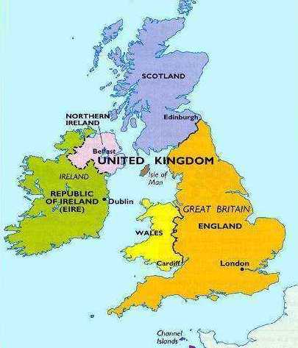 | 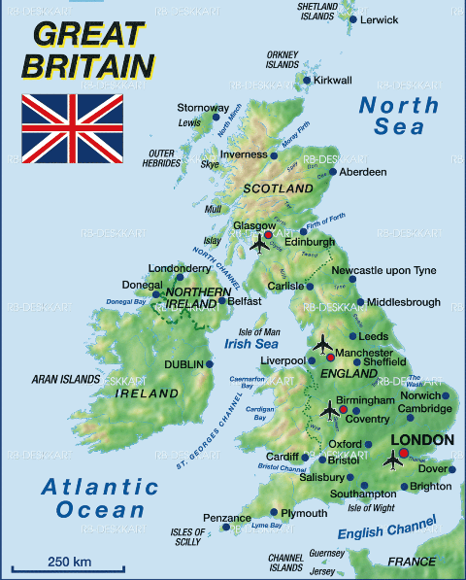

Exercise 1. Read the text and complete the following sentences:
- … is the official name of the state which is situated on the British Isles.
- The capital of Great Britain is …
- The capital of Scotland is …
- The capital of Northern Ireland is …
- The capital of Wales is …
- Ireland and Great Britain are separated by …
- The UK is separated from the continent by …
- The UK is washed by… in the west.
- The UK is washed by … in the east.
Exercise 2. Complete the following sentences making the right choice.
- The Union Jack is …
  - the flag of the UK
  - the flag of the USA
- English is spoken …
  - all over Britain
  - only in England
- The UK is the official name of the country situated …
  - on the island which is called Great Britain
  - on the British Isles
- Edinburgh is the capital of …
- Wales
- Scotland
- The independent Irish Republic is situated …
  - in Northern Ireland
  - on the smaller of the two biggest islands of the British Isles
- Great Britain and Ireland are separated by …
- the North Sea
- the Irish Sea
- The nearest point to Europe is …
  - the Strait of Dover
  - Dover
The UK is washed by the Atlantic Ocean in …
  - the north
  - the west

Exercise 3. Fill in articles where necessary.
(1) ________ United Kingdom is situated on (2) ________ British Isles which are separated from (3) ________ continent by (4) _________English Channel and (5) _________Strait of Dover. (6) __________two main islands of (7) _________ British Isles are (8)_________Great Britain and (9) ________Ireland. (10) _______ England is situated in (11)________ south of (12) _______ Great Britain and (13) _______ Scotland in its (14) ________ north. (15)_______ two big islands are separated by (16) _______ Irish Sea.

GreenvilleList of references
Greenville was a small town in the middle of England. Most of it was full of houses and shops, but in the middle of the town there was a small park, which contained, among other things, a playground for small children. The park had always been closed at six every evening, and this had meant that the playground closed at that time too, but now the town council was discussing whether, in the summer, the playground should be left open till later. There was a lot of discussion about this among the members of the town council. A few of them thought that children should not be encouraged to stay out late in the evenings; others said that it was healthy for children to have a change from television to get some fresh air, and to be able to play in the playground instead of perhaps doing things that were either dangerous or harmful. At last one of the council members who was a woman, asked, «Have any of you ever gone to the playground on a summer evening? If you had, you would have seen that there are groups of children playing there after six every evening».
«But the playground isn't open then!» others cried.
«I know» the woman answered, «but it's no mystery that there are plenty of small holes in the fence round the playground through which the children can climb. And when they have to get in that way, they're much more eager to do so than if the gates are open. It's much more exciting for them to do things they think are forbidden, you sec, and it does no harm, does it?»
The other members of the town council laughed, and they all agreed that the gates should continue to be closed at six for the children's sake, so as not to spoil their fun.

A Write down whether the following statements are true or false.
1. There were a lot of houses and shops in the park of Greenville.
2. The town council was thinking of closing the park before six.
3. Some members did not want to change the time.
4. Others wanted the park to remain open to encourage children to stop going out.

В Answer the following questions.
1. At what time had one member seen children playing in the playground? …………….
2. How had they got in? …………………………………………………………………
3. Why was it a good thing? ……………………………………………………………..
4. Why did the town council agree to continue closing the park at six?

Additional Vocabulary
Слово | Транскрипция | Перевод
To abolish | [əˈbɒlɪʃ] | Отменять, уничтожать, упразднять
To approve | [əˈpruːv] | Утвердить, одобрить
To boast | [bəʊst] | Гордиться, хвастаться
To contribute | [kənˈtrɪbju(ː)t] | Жертвовать, вносить свой вклад
To deliver | [dɪˈlɪvə] | Доставлять, поставлять, приносить
To descend | [dɪˈsɛnd] | Спуститься, сходить, снизойти
To concentrate | [ˈkɒnsəntreɪt] | Сосредотачиваться
To distract | [dɪsˈtrækt] | Отвлечь, отвлекать
To torture | [ˈtɔːʧə] | Мучить, терзать
To torture | [ˈtɔːʧə] | Мучить, терзать
To confuse | [kənˈfjuːz] | Путать, запутать, сбить с толку
To abandon | [əˈbændən] | Покинуть, бросить, оставить
To escape | [ɪsˈkeɪp] | Совершить побег, убежать, сбежать
To distribute | [dɪsˈtrɪbju(ː)t] | Распространять, распределить
To elaborate | [ɪˈlæbərɪt] | Разрабатывать, прорабатывать
To construct | [kənˈstrʌkt] | Строить, построить
To humiliate | [hju(ː)ˈmɪlɪeɪt] | Унижать
To maintain | [meɪnˈteɪn] | Поддерживать
To squeeze | [skwiːz] | Сжимать, выжимать, сжать
To delegate | [ˈdɛlɪgɪt] | Делегировать, посылать
To transfer | [ˈtrænsfə(ː)] | Передавать, перечислять
To employ | [ɪmˈplɔɪ] | Нанимать, использовать, работать
To catch | [kæʧ] | Поймать, ловить
To commit | [kəˈmɪt] | Совершить, зафиксировать, поручить
To arrange | [əˈreɪnʤ] | Организовать, устроить
To implement | [ˈɪmplɪmənt] | Внедрить, реализовать, осуществить
To insulate | [ˈɪnsjʊleɪt] | Ограждать
To encourage | [ɪnˈkʌrɪʤ] | Стимулировать
To foster | [ˈfɒstə] | Поощрять
To boost | [buːst] | Повышать
To optimize | [ˈɒptɪmaɪz] | Оптимизировать
To rank | [ræŋk] | Ранжировать
To identify | [aɪˈdɛntɪfaɪ] | Определить, идентифицировать
To empower | [ɪmˈpaʊə] | Наделить полномочиями, расширять
To ensure | [ɪnˈʃʊə] | Обеспечить, убедить, гарантировать
To accomplish | [əˈkɒmplɪʃ] | Выполнить, завершить, осуществить
To customize | [ˈkʌstəˌmaɪz] | Настроить, сделать
To localize | [ˈləʊkəlaɪz] | Локализовать, определить
To tailor | [ˈteɪlə] | Приспособить
To validate | [ˈvælɪdeɪt] | Удостоверять
To reserve | [rɪˈzɜːv] | Резервировать
To estimate | [ˈɛstɪmɪt] | Оценивать
To consulate | [ˈkɒnsjʊlɪt] | Консультировать
To regard | [rɪˈgɑːd] | Рассматривать, учитывать, относиться
To indicate | [ˈɪndɪkeɪt] | Указывать, обозначать, показывать
To unify | [juːnɪfaɪ] | Объединять
To digitalize | [ˈdɪdʒɪtəlaɪz] | Оцифровать, перевести в online-формат
To expose | [ɪksˈpəʊz] | Подвергать
To idealize | [ aɪˈdɪəlaɪz] | Идеализировать
To navigate | [ˈnævɪgeɪt] | Ориентироваться
To sustain | [səsˈteɪn] | Выдерживать
To constrain | [kənˈstreɪn] | Сдерживать
To evade | [ɪˈveɪd] | Обойти
To purchase | [ˈpɜːʧəs] | Приобретать
To earn | [ɜːn] | Зарабатывать
To make sure | [meɪk ʃʊə] | Убедиться
To prototype | [ˈprəʊtəʊtaɪp] | Создать протопит, план
To endeavour | [ɪnˈdɛvə] | Стремиться
To blend | [blɛnd] | Смешивать
To prioritize | [praɪˈɒrɪˌtaɪz] | Расставить приоритеты
To mitigate | [ˈmɪtɪgeɪt] | Смягчать, принимать
To emphasize | [ˈɛmfəsaɪz] | Подчеркнуть, придать акцент
To observe | [əbˈzɜːv] | Наблюдать, замечать
To evolve | [ ɪˈvɒlv] | Развиваться, расти, проявляться
To incentivize | [ɪnˈsen.tɪ.vaɪz] | Стимулировать, побуждать
To respond | [rɪsˈpɒnd] | Реагировать, отвечать
To connect | [kəˈnɛkt] | Соединить
To command | [kəˈmɑːnd] | Командовать
To check-out | [ʧɛk-aʊt] | Проверить, оформить
To extend | [ɪksˈtɛnd] | Продлить, расширить, увеличить
To retain | [rɪˈteɪn] | Оставить, удержать, сохранить
To exhibit | [ɪgˈzɪbɪt] | Показывать
To invent | [ɪnˈvɛnt] | Изобретать
To abridge | [əˈbrɪʤ] | Ограничивать
To self-express | [sɛlf-ɪksˈprɛs] | Самовыражаться
To neglect | [nɪˈglɛkt] | Пренебрегать
To negotiate | [nɪˈgəʊʃɪeɪt] | Договариваться, вести переговоры
To upgrade | [ʌpˈgreɪd] | Повышать, улучшать
To renew | [rɪˈnjuː] | Обновить
To specialize | [ˈspɛʃəlaɪz] | Специализироваться
To balance | [ˈbæləns] | Уравновешивать
To absorb | [əbˈsɔːb] | Поглощать
To overwhelm | [əʊvəˈwɛlm] | Переполнять
To align | [əˈlaɪn] | Выравнивать
To withdraw | [wɪðˈdrɔː] | Отстраниться
To whistle | [ˈwɪsl] | Свистеть
To suspect | [ˈsʌspɛkt] | Подозревать
To surrender | [səˈrɛndə] | Сдаваться
To depend on | [dɪˈpɛnd ɒn] | Зависеть от
To correct | [kəˈrɛkt] | Исправлять
To define | [dɪˈfaɪn] | Определить
To visualize | [ˈvɪzjʊəlaɪz] | Визуализировать
To design | [dɪˈzaɪn] | Проектировать
To minimize | [ˈmɪnɪmaɪz] | Минимизировать
To disturb | [dɪsˈtɜːb] | Нарушить, беспокоить
To integrate | [ˈɪntɪgreɪt] | Интегрировать
To exchange | [ɪksˈʧeɪnʤ] | Обменивать, менять
To organize | [ˈɔːgənaɪz] | Организовать
To collaborate | [kəˈlæbəreɪt] | Сотрудничать
To embed | [ɪmˈbɛd] | Встраивать
To generate | [ˈʤɛnəreɪt] | Генерировать
addiction | [əˈdɪkʃ(ə)n] | Зависимость, пристрастие
amateur | [ˈæmətə(ː)] | Любитель
ambivalence | [æmˈbɪvələns] | Нерешительность
commission | [kəˈmɪʃən] | Комиссия, поручение, заказчик
confidence | [ˈkɒnfɪdəns] | Доверие, уверенность, достоверность
craving | [ˈkreɪvɪŋ] | Желание, тяга, стремление, жажда
district | [ˈdɪstrɪkt] | Район
evidence | [ˈɛvɪdəns] | Доказательство, признак, факт
honesty | [ˈɒnɪsti] | Честность
circumstance | [ˈsɜːkəmstəns] | Обстоятельство, случай, событие
kindness | [ˈkaɪndnɪs] | Доброта
justice | [ˈʤʌstɪs] | Справедливость
disgust | [dɪsˈgʌst] | Отвращение, брезгливость
А suggestion | [səˈʤɛsʧən] | Предложение, суждение, идея
А nobility | [nəʊˈbɪlɪti] | Благородство, достоинство
commotion | [kəˈməʊʃən] | Суета
adherence | [ədˈhɪərəns] | Приверженность
devotion | [dɪˈvəʊʃən] | Преданность
enticement | [ ɪnˈtaɪsmənt] | Приманка, соблазн, заманивание
attractiveness | [ əˈtræktɪvnəs] | Привлекательность
freedom-loving | [ˈfriːdəm-ˈlʌvɪŋ] | Свободолюбие
rebel | [ˈrɛbl] | Бунтарь
influence | [ ˈɪnflʊəns] | Влияние
sway | [sweɪ] | Колебание
willpower | [ˈwɪlˌpaʊə] | Сила воли
inequality | [ˌɪni(ː)ˈkwɒlɪti] | Неравенство
А violence | [ˈvaɪələns] | Насилие, жестокость
А bullying | [ˈbʊliɪŋ] | Издевательство, травля
А godliness | [ˈgɒdlɪnɪs] | Благочестие, бодрость
А compassion | [kəmˈpæʃən] | Сострадание
inclusivity | [ɪnˌkluːˈsɪvətɪ] | Инклюзивность
А reciprocity | [rɛsɪˈprɒsɪti] | Взаимность, обоюдность
friskiness | [ˈfrɪskɪnəs] | Игривость, раскованность, живость
fervor | [ˈfɜːvə] | Пылкость, задор, рвение
А youth | [juːθ] | Молодежь, юноша, молодость
adolescence | [ædəʊˈlɛsns] | Подростковый возраст, отрочество

Irregular verbs

Infinitive | Past Simple (V2) | Participle II (V3) | Перевод
be | was (were) | been | Быть – бoлy
become | became | become | становиться
begin | began | begun | Начинать – бастау
break | broke | broken | Ломать – сындыру
bring | brought | brought | Приносить – алып келу
build | built | built | Строить – строить
buy | bought | bought | Покупать – сатып алу
burn | burnt | burnt | Гореть – жандыру
catch | caught | caught | Ловить – ұстау
choose | chose | chosen | Выбирать – таңдау
cut | cut | cut | Резать – кесу
cost | cost | cost | Стоить ө бағасы болу\туру
come | came | come | Приходить – келу
do | did | done | Делать – істеу
drive | drove | driven | Водить машину -
drink | drank | drunk | Пить – ішу
eat | ate | eaten | Кушать – тамақтану
fall | fell | fallen | Падать – құлау
fight | fought | fought | Бороться – күрес
find | found | found | Находить – табу
fly | flew | flown | Летать – ұшу
forget | forgot | forgotten | Забывать – ұмыту
freeze | froze | frozen | Замораживать\замерзать
feel | felt | felt | Ощущать – сезу
get | got | got (gotten) | Получать – алу
give | gave | given | Давать – беру
go | went | gone | Идти – бару
have | had | had | Иметь – бар
hear | heard | heard | Слышать – есту
know | knew | known | Знать – білу
make | made | made | делать, мастерить жасау,
meet | met | met | Встречать – кездесу
put | put | put | класть, ставить – қою
read | read | read | Читать – Оқу
say | said | said | Сказать – айту
see | saw | seen | Видеть – көру
send | sent | sent | Отправлять – жіберу
sell | sol | sold | Продавать – сату
sing | sang | sung | Петь – ән айту
sit | sat | sat | Сидеть – отыру
sleep | slept | slept | Спать – Ұйықтау
speak | spoke | spoken | Говорить – Сөйлеу
spend | spent | spent | Тратить\проводить время – ақша жумсау\ уақыт өткізу
stand | stood | stood | Стоять – Тұру
swim | swam | swum | Плавать – жүзу
steal | stole | stolen | Украть – ұрлау
spoil | spoil | spoilt | Портить – бұзу
take | took | taken | Брать – Алу
tell | told | told | Рассказывать – айту
think | thought | thought | Думать – ойлану
understand | understood | understood | Понимать – Түсіну
wake | woke | woken | Просыпаться\ будить – ояну
win | won | won | Побеждать – жеңу
write | wrote | written | Писать – жазу

List of references

- C. Redston, J.Cunningham. Face2Face Student’s book.Elementary. – Cambridge University Press. – 21st printing, 2013. – 170p.
- C. Redston, J. Cunningham. Face2Face Workbook. Pre-intermediate. – Cambridge University Press. – 10th printing, 2010. –88p.
- Clive Oxenden, Shristina Latham-Koenig, Paul Seligson. New English File. – Pre-intermediate students book. – Oxford University Press. – electronic resource[www.oup.com/elt/englishfile/pre-intermediate]
- Clive Oxender,Christina Latham-Koenig,Paul Seligson with Lindsay Clandfield.-New English File. – Pre-intermediate.Teacher’s book. – Oxford University [electronic resource]// www.oup.com/elt/englishfile/pre-intermediate
- Агабекян И.П. А23 Английский язык / И.П. Агабекян. – Изд. 16-е, стер. – Ростов н/Д: Феникс, 2010. (Среднее профессиональное образование).
- Listening comprehension task https://englishworksheets.net/practice/a2_l1-families.html
- Grammar comprehension task https://fs.onclass.com/storage/49db87a1-571d-4610-91c1-ea8b5561c2d5/1961ffdb-e3f8-442c-bcf5-2e8c6fd2ea08/2259881-lgX2.jpg
- Stuart Redman English vocabulary in use pre-intermediate and intermediate – Cambridge university Press fourth edition- electronic resource
- Listening comprehension task [electronic resource] https://englishworksheets.net/practice/b1_l1-shopping.html
- А.А. Ионина,, А.С. Саакян. Английская грамматика XXI века.универсальный эффективный курс. – Изд. Эксмо, 2011г.
- Караванова Наталья Борисовна. Реальный самоучитель английского языка. Начальный близкий). уровень / Н.Б. Караванова. – Москва: Эксмо, 2015. – Английский понятный.
- Raymond Murphy.-Essential Grammar in Use. A self study reference and practice book for elementary learners of English.Fourth edition.-Oxford University Press,2015. – 319p.
- Караванова Н.Б. К 21 Английский с нуля : элементарный практический курс английского языка / Н.Б. Караванова. – М.: Эксмо, 2012. – (Иностранный язык: шаг за шагом).
- Вся грамматика английского языка с упражнениями/ сост.И.М.Гиндлина. – М.: ООО «Издательство Астрель»:ООО «Издательство АСТ»,2002
- Голицынский, Ю.Б. Грамматика:сборник упражнений / Ю.Б. Голицынский . – С.-Петербург, 2009.
- Голицынский, Ю.Б.Говорим по – английски: пособие по разговорной речи/ Ю.Б. Голицынский. – С.-Петербург,2011.
- http://tonail.com/ 11.http://window.edu.ru/catalog/
СОДЕРЖАНИЕ

Unit 1 Getting to know each other (Greeting) 3

Unit 2 My family (Family relations) 12

Unit 3. Modern family. Family problems (B 1) 16

Unit 4. My daily routine 21

Unit 5. Food & Drinks 27

Unit 6. I enjoy shopping 34

Unit 7. Helth is essential 41

Unit 8. Are you friends with sports? 47

Unit 9. LEisure activities 52

Unit 10. Kazakhstan is my Motherland 55

Unit 11 Why do people travel? 61

Unit 12. Planning holidays. Places of interest (Достопримечательности) 73

UNIT 13. Welcome to my hometown. My house 82

Unit 14. Environmental protection 87

Unit 15. Types of houses. Modern design 92

Unit 16. Advantages & disadvantages of Gadgets 98

Unit 17. Cultural heritage of Kazakhstan. Celebration of nauryz 103

Unit 18. State Structure of the Republic of Kazakhstan & the United KIngdom 109

Unit 19. The System of Education in Kazakhstan and Great Britain 117

Unit 20. My dream is to be an officer 123

List of references 152

Верстка:
Туренова Б.Ю.

Отдел организации научно-исследовательской и редакционно-издательской работы
Алматинской академии МВД Республики Казахстан
имени М. Есбулатова 050060 Алматы, ул. Утепова, 29

Подписано в печать 22 мая 2025 г.
Формат 60х84 1/16 Бум. тип. №1. Печать на ризографе. Уч.-изд. п.л. 7,5.
Тираж 100 экз.

